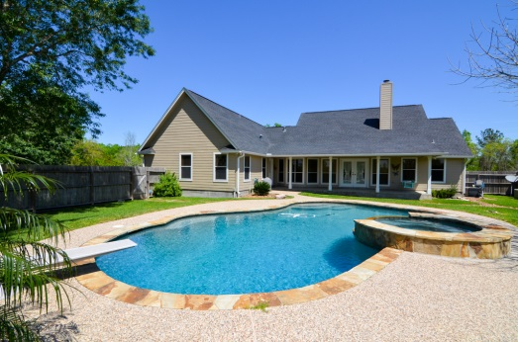
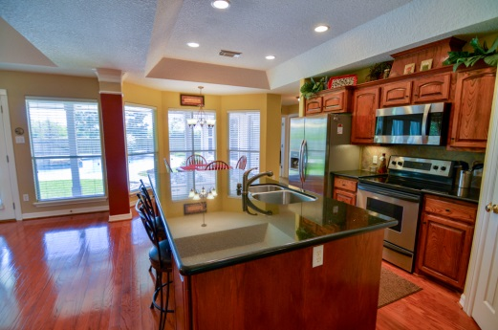
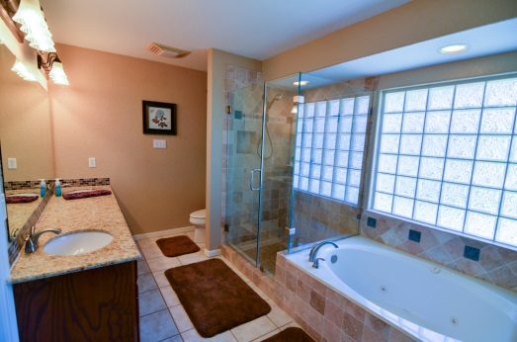
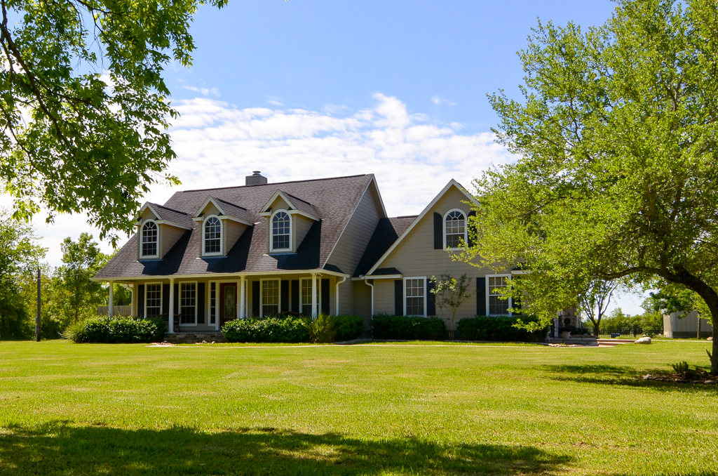

You know that unicorn you've been looking for that has EVERYTHING? This is it. Idyllic setting on 4 ac featuring the most PERFECT country home with covered front and back porches, sparking pebbletec pool/spa, detached 450 sf apt with no detail spared (full kitchen, full bath w/frameless glass shower, laundry rm, granite), oversized 2 car attached garage, 20x24 detached garage/workshop w/2 car carport for rv/boat storage. All of that and there is still room for your horses in the fenced pasture!
Call Jamie Headley
office 713.909.0202
jamie@freeseandcompany.com
7018 JORDAN RD, MANVEL
$489,500



4 acres of idyllic country charm

