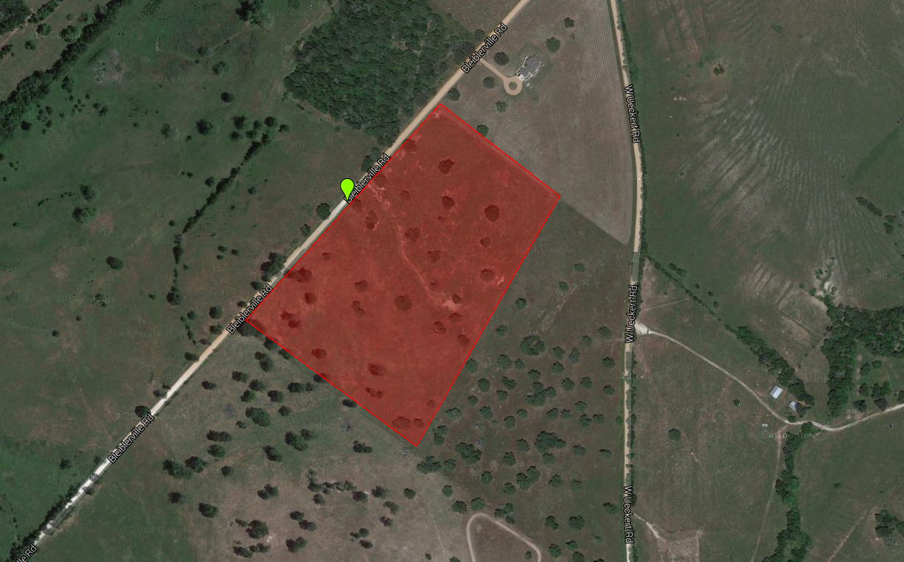

OAK LAND ACRES
Approximately 25.68 Acres
7928 Bleiblerville Road – Bleiblerville, TX 78931

