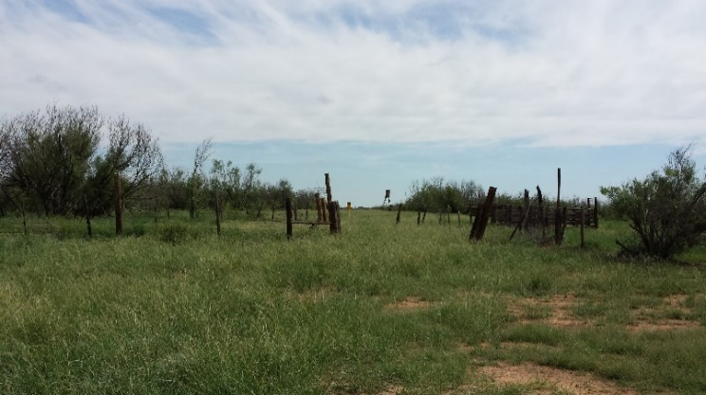**Overview of Muddy Creek Ranch**

Total on Survey: 672.0 Acres  
Total FSA: 664.7 Acres  
CAD – Tract 1: 231.0 Acres  
CAD – Tract 2: 451.0 Acres

Farm 3697  
 - Cultivation: 59.7 Acres (56.2 CRP)  
 3.5 Acres in actual cropland

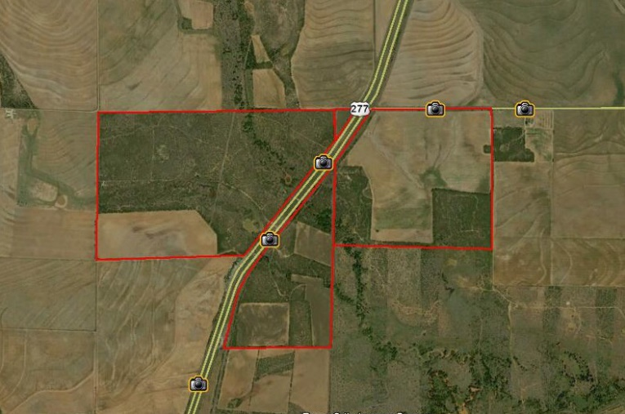 - Pasture: 397 Acres

- CRP: 56.2 Acres

Farm 3696  
 - Cultivation: 208.0 Acres  
 - Pasture: None  
 - CRP: None

Muddy Creek is at home in the California Creek   
watershed, a tributary to the Brazos Clear Fork,   
and meanders throughout the property, as do   
several seasonal creeks that also feed into California   
Creek.

Water on the property includes 1 large lake and 4 tanks, all of which hold water.

**Improvements to Muddy Creek Ranch Include:**

- Gates and roads  
- Established food plots  
- Brush management  
- Increased native vegetation on Sendero  
- Increased vegetation on tank dams  
- Increased herd growth  
- Kupatt Lake: increased capacity to 5+ acres and depth to 25 ft., also increased vegetation on dam with   
 wildlife blend. Stocked with Crappie, Hybrid Bluegill, and Fathead Minnows  
- Other tanks: increased volume by 30%, rebuilt spillway, and increased vegetation with wildlife blend.  
- CRP improved and maintained.

|  |  |
| --- | --- |
|  |  |
|  |  |
|  | |