Rental Property Duplex

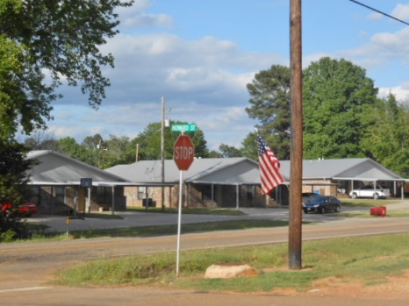
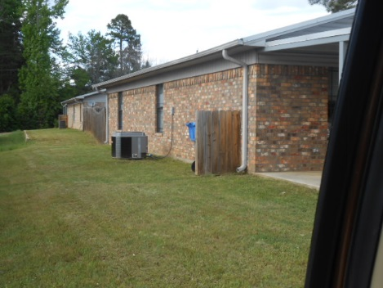

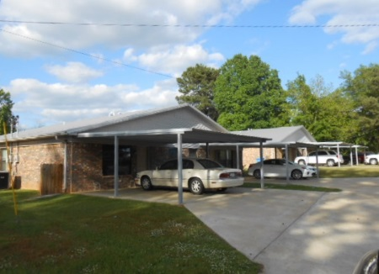
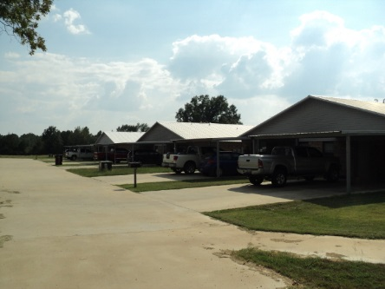

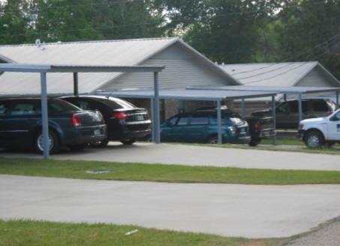
11 Total Duplex Buildings Giving You 22 Rented Apartments
8 Units On Judy St In Queen City
6 Units On Houston St In Queen City
8 Units On Hickory St In Queen City
All Units Were Built Between 2005 and 2012
All Units Are 100% Rented At All Times
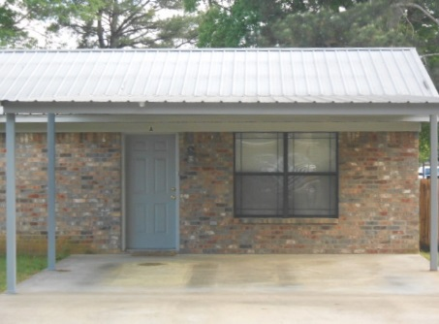
The Exterior of the Buildings Are All Low Maintenance
The Hickory St Location Has Enough Land With It To
Build 12 more Duplex Units For 24 More Apartments

