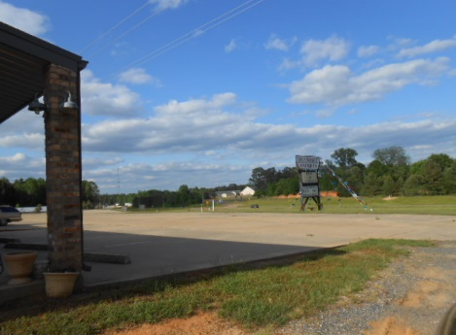
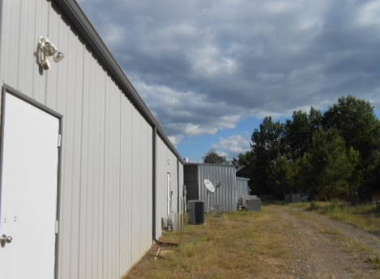
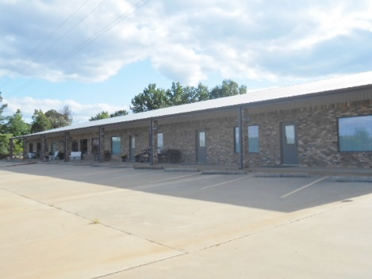
16879 US HWY 59 QUEEN CITY TX 75572
LOCATION, LOCATION, LOCATION, THIS 13,192 SQ FT BUILDING HAS A LOT TO OFFER. IT IS LOCATED ON THE EXTREMELY BUSY US HWY 59 AND VERY CLOSE TO LAKE WRIGHT PATMAN. IT HAS 13,192 SQ FT UNDER ROOF AND 11,312 HEAT AND COOLED. THE POSSIBILITIES ARE ENDLESS WITH WHAT YOU COULD DO WITH THIS ONE. WITH ITS LOCATION IT WOULD MAKE THE PERFECT CLIMATE CONTROLLED STORGE FACILITY, AND BEING ON 9 ACRES YOU COULD ALSO ADD MORE MINI STORAGE UNITS WITH RV AND BOAT STORAGE AS WELL. THE BUILDING HAS 3 FINISHED UNITS WITH 1 PARTIALLY FINISHED UNIT. ALL HAVING THEIR OWN RESTROOMS, HEAT AND AIR, AND ELECTRICITY. IT IS CURRENTLY BEING USED AS AN ANTIQUE MALL AND OFFICE. 1 UNIT HAS A FULL COMMERCIAL KITCHEN WITH A WALK IN COOLER, FREEZER, CATERING UTENCILS, DISHES AND MUCH MUCH MORE. THE BUILDING IS A METAL CONTRUCTION WITH BRICK FRONTS. EACH UNIT HAS ITS OWN ENTRANCE AND HAVE LOW E SAFETY GLASS WINDOWS. THE PARKING LOT IS CONCRETE AND HAS 2 CURB CUTS FROM HWY 59. HANDICAP PARKING IS AVAILBLE AND 40 TO 49 OTHER SPACES. A SURVEY IS AVAILABLE ON THIS.

