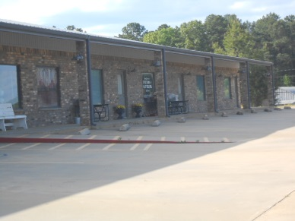
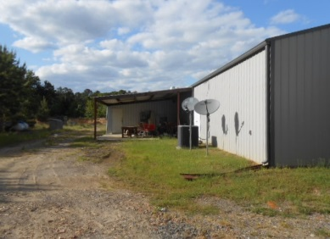
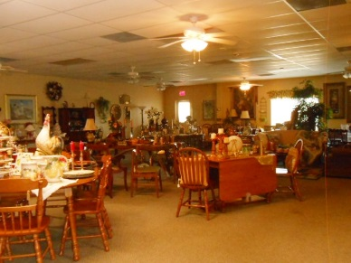
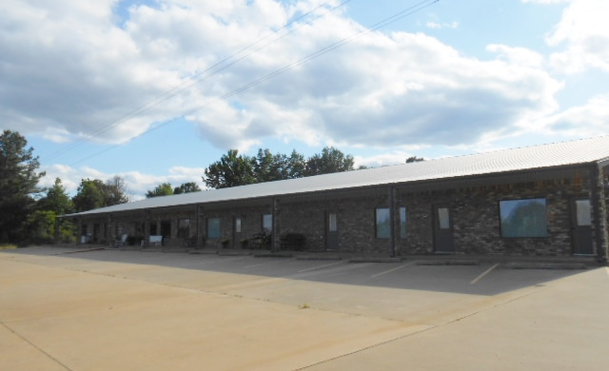

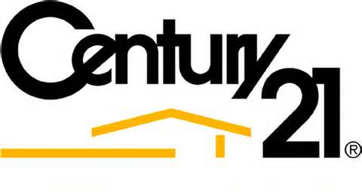
Platinum Partners
Also Included With This Package is 11 Duplex Apartments Built From 2005 to 2012. 4 Of Which Are On Judy St in Queen City, 3 On Houston St In Queen City, And 4 On Hickory St In Queen City. On The Hickory St Location There is Room For 12 More Units. As Well As 2 Rent Houses in Atlanta, 2 Rent Houses In Queen City, And 1 Rent House In Texarkana.
16879 Hwy 59 Queen City, Tx 75572
$2,650,000.00
Potential Climate Controlled Dry Storage Facility On 9 Acres+-.
Plenty Of Room To Add Mini Storage As Well As Rv And Boat Storage.
Located On Hwy 59 And Very Close To Lake Wright Patman.
Year Built: 2004
13,192 Sq Ft Under Roof
11,312 Sq Ft Heated
This Building Features 3 Finished Units and 1 Partially Finished Unit With Separate Meters, Heat and Air.
Additional Information: Complete Package: 22 Duplex Units, 5 Rent Houses, All 100% Rented. One 11,312 Sq Ft Building with endless possibilities on 9 acres+- of land located on the ever busy Highway 59.

Call Today For Complete Details: Hagan 903-806-6011, Susan 903-720-7517 www.c21platinumpartners.com
Exceptional Investment Opportunity
SALE
For

