

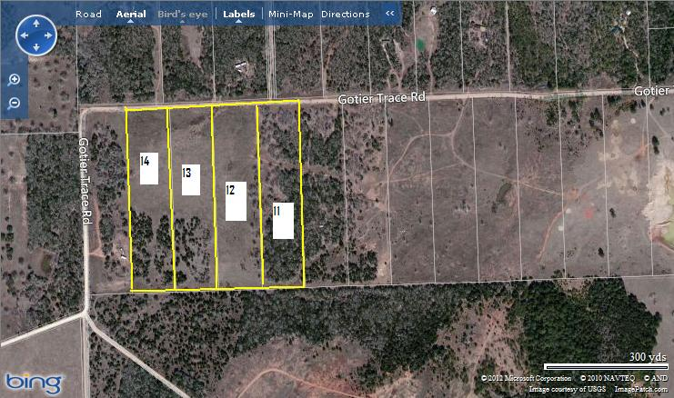

The BING map above shows 40 acres of contiguous property. This property may be sold in several different parcels:
PRICING

Entire 40 Acre Tract with water well and pond - $ 299,995
30 Acre Tract with water well and pond - $ 249,995
20 acre Tracts:
Tracts 14 + 13 = $190,000
Tracts 11 + 12 = $ 159,000

The most easterly lot, Lot #14 10+ Ac has a water well - $ 105,000
Lot #13 10+ Ac has a pond - $ 99,000
Lot #12 10+ Ac is mostly cleared - $97,000
Lot #11 10+ Ac is mostly treed – $ 85,000
________________________________________________________

Barbara Allbright, Realtor®, ABR Barbara: 512.921.6350
Jana Hellbusch, Realtor® Jana: 512.284.0220
BastropFarmandHome.com
National Association of Realtors
Bastrop County Board of Realtors
KELLER WILLIALS REALTY

