

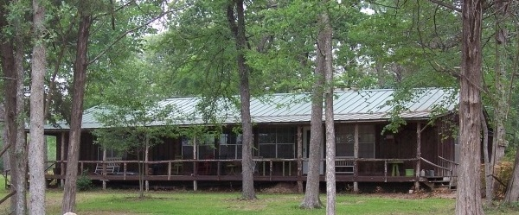

FOR SALE: 43.72 acres, Frances Slaughter Survey
Ab 335; 1265 S. FM 46 Franklin, TX 77856
Robertson County

HOME: 50/50 wooded/open, ponds; 2,039 sq ft. 4B/2B house with metal roof, central HVAC, carpet & tile; Large shop with studio apt & bath; City water and electricity; approx. 600’ road frontage; Franklin ISD

PRICE: $ 348,900

