**3 Acres – CR 355 Loop near Gause**

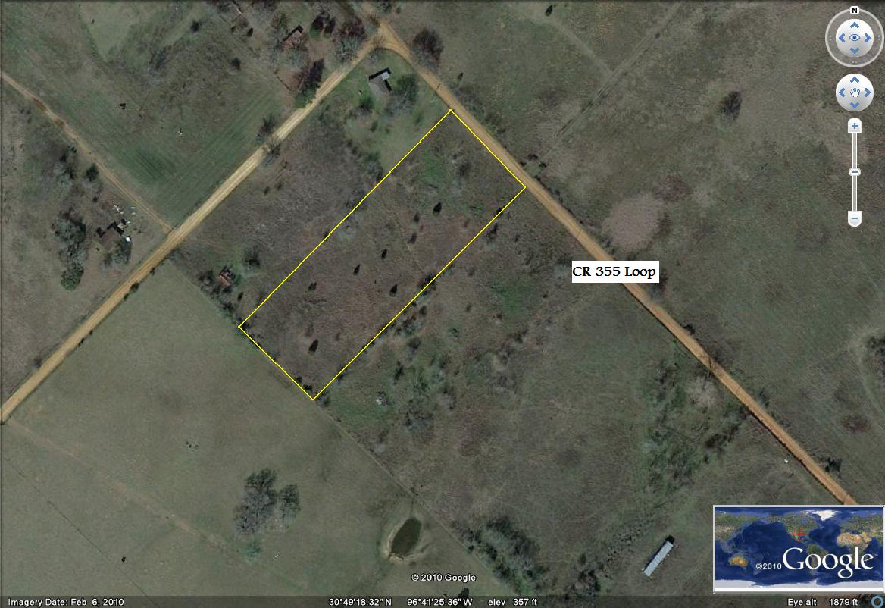

Mostly open, scattered mature trees, community water and power nearby.

Offered at $ 19,900.00

