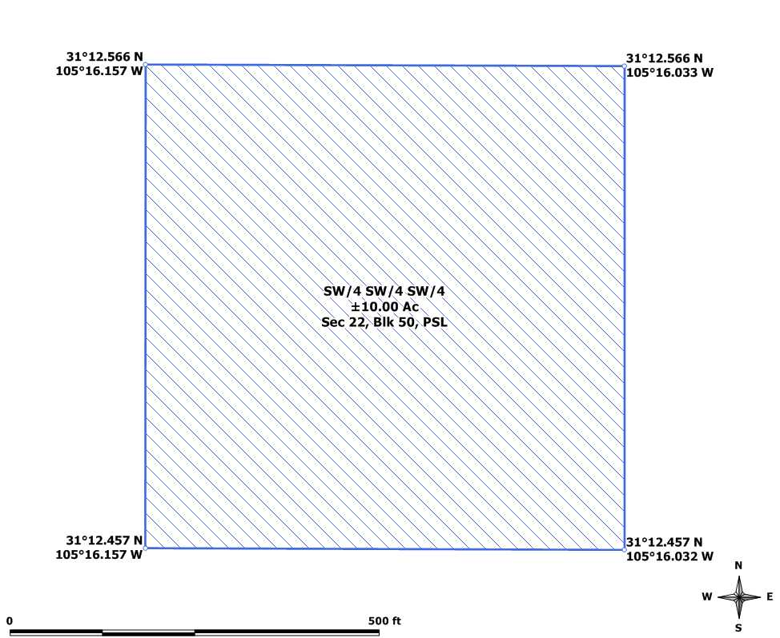

GPS Coordinates presented here are in the Universal Transverse Mercator (UTM) Zone 13 N coordinate system using the North America Datum for 1983 (NAD83).

Note that these coordinates are based upon the best data we have accumulated, but are not exact. This information is for the purpose of locating your property only. Prior to building a fence or any structures on your land, you should contact a Texas licensed surveyor to mark the exact corners of your property.

