4057 Rendon Rd.
Fort Worth, TX 76140
$1,895,000.00

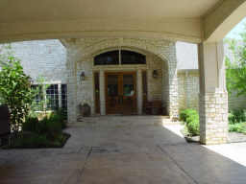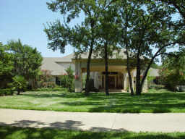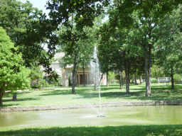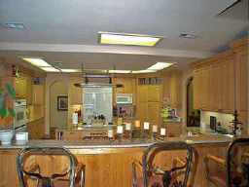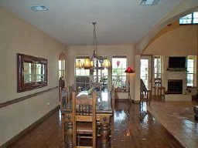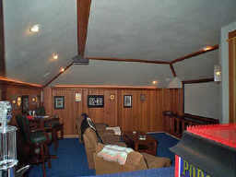
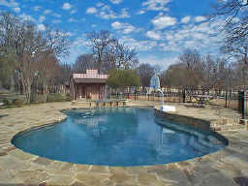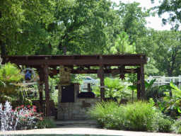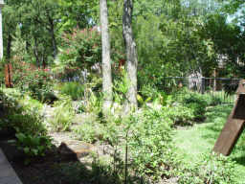

Treat yourself to this Magnificent and incredibly breath taking 7500 sq. ft. home. 6 Bed Rooms, 4.5 Baths, 3 Living,
2 Dining, Wet Bar, and Media Room. This gorgeous gated property sits on 10 acres with an abundance of trees, pond
with fountain, play pool, pool house, and so many amenities that I can’t list them all. Easy access to all the major
freeways and only minutes to downtown Fort Worth, Dallas, Airports, Hospitals, Shopping, and Schools. Centrally
located to anywhere you need to be in the metroplex. There is an additional 22 acres that joins this property.
$475,998 MLS # 11258035 and can be used for horses or a place to build. The land has many possibilities.

