 |  | MLS#02623450
 |  | FOR SALE
SALES, LEASES, RESIDENTIAL, COMMERCIAL, FARMS & LANDS |  | OWNER: |  | Mitchell Cousins
14 JACKSON STREET  NEWNAN, GEORGIA 30263  SINCE 1948 | TELEPHONES:  NEWNAN - (770) 253-6990  FAX - (770) 253-6843  WEBSITE - www.lindseysrealtors.com | LOCATION: |  | College Street, Luthersville
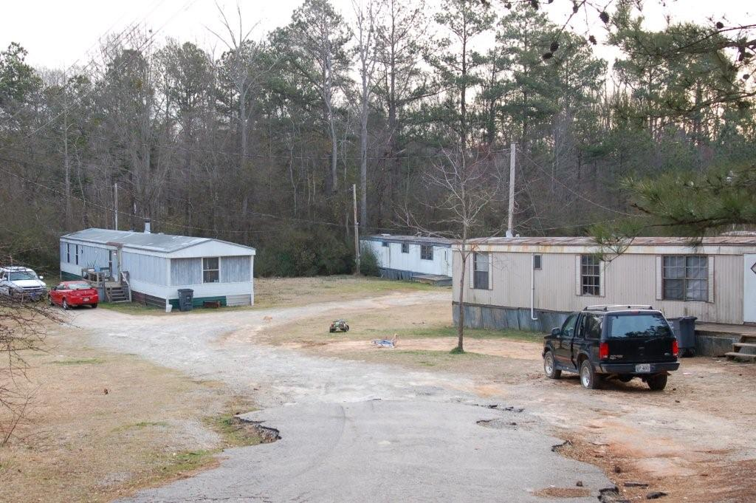 |  | LISTED BY: |  | Elena Dickerson
 |  | SALE PRICE: |  | $90,000
 |  | POSSESSION DATE: |  |  | Negotiable
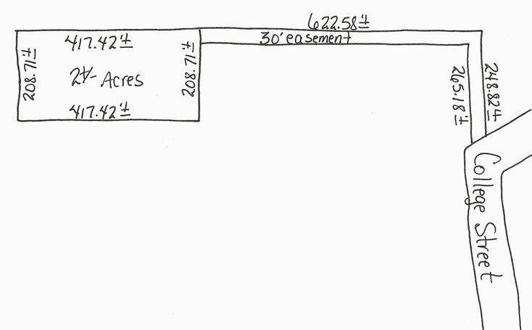 |  | WATER: | City of Luthersville water |  | SEWER: | Septic tank
 |  | ZONING:
 |  | AD VALOREM TAXES: |  |  | City - $98.23 2008  County - $381.27 2008
 |  | HOW TO SHOW: |  | Call agent for showing instructions  Elena – 404-379-1206
IMPROVEMENTS: | Small trailer park in Luthersville. Six spaces available total. One lot currently has a 3 bedroom 1 ½ bath trailer rented for $300/mo. One space is currently occupied by a trailer that is privately owned and is leasing the space only. Each space has septic tank. Trash and water included in rent. Each space rents for $300/mo.
TERMS OF SALE: | Cash to seller
OTHER: | Dump pile in back will be cleaned up by Seller.
DIRECTIONS: | Exit 41 at Moreland, stay on Hwy 27 to Luthersville. At light take a right, left on first street – College Street, property is down on the left, see sign.
NOTE: Although every effort has been made to provide accurate information, some of the above was supplied by others and therefore we do not guarantee or accept responsibility for the above. Price and terms subject to prior sale and change without notice.

