NEXT TO THE COUNTRY CLUB GOLF COURSE

CLUB HOUSE AND VIEWS OF GOLF COURSE ACROSS THE FENCE
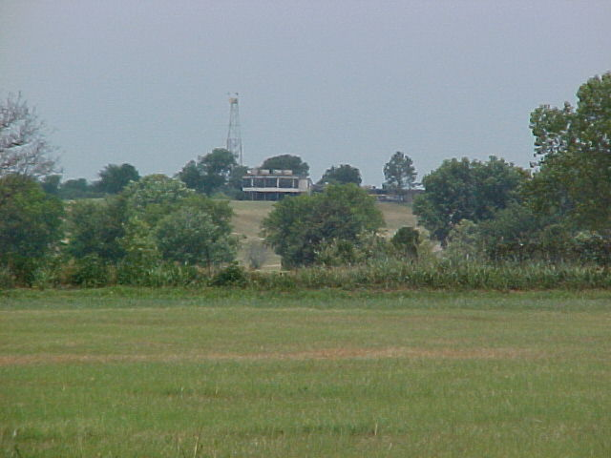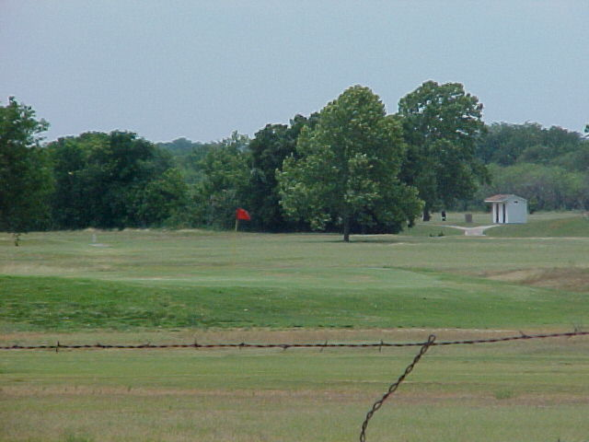

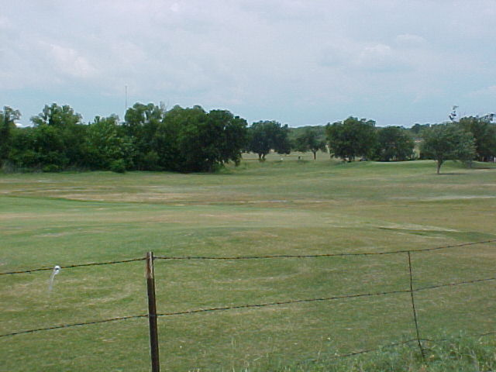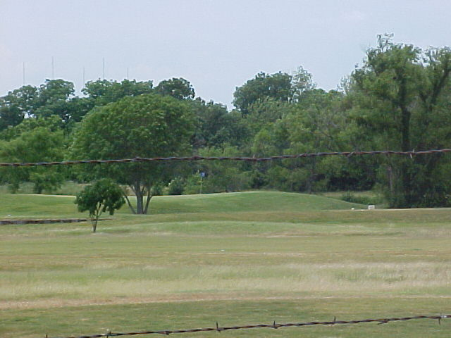
VIEW OF HOME FROM PASTURE
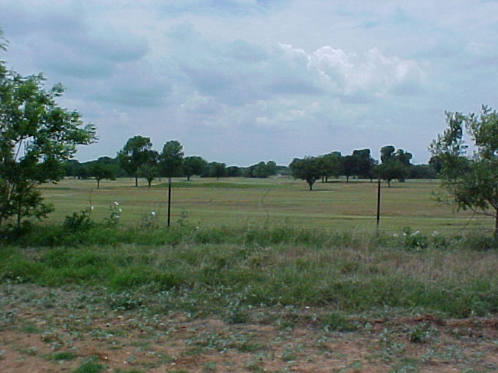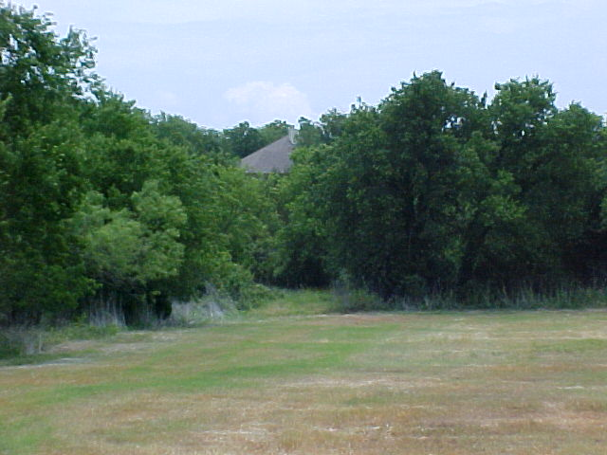

THERE’S DEVELOPMENT POTENTIAL HERE FOR THIS FAST GROWING COUNTY POPULATION. THE NATURAL GAS INDUSTRY HAS REALLY STIMULATED OUR ECONOMY, ANDS IT’S JUST GETTING STARTED.

