HOME EXTERIOR

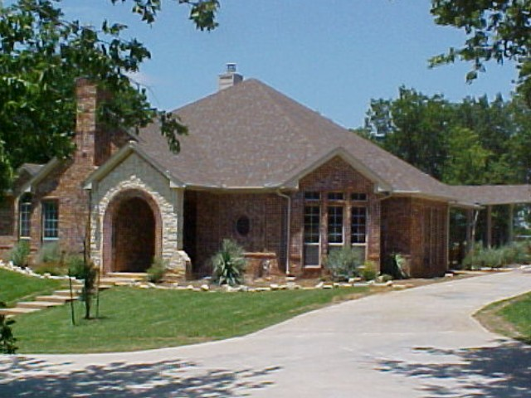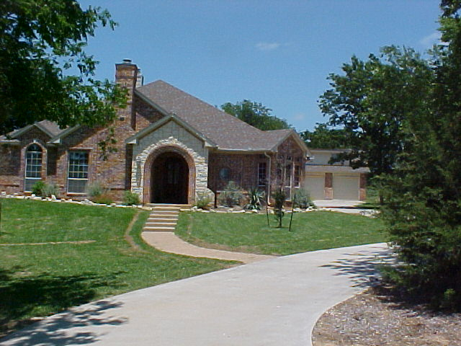

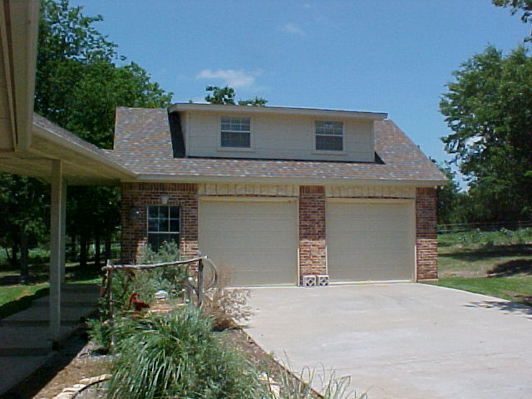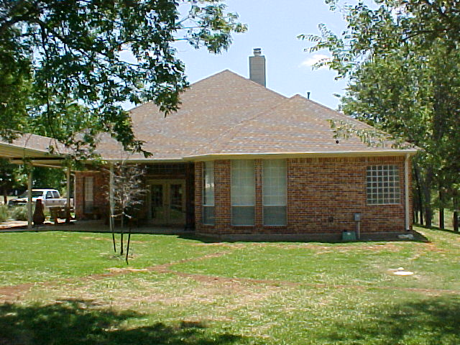

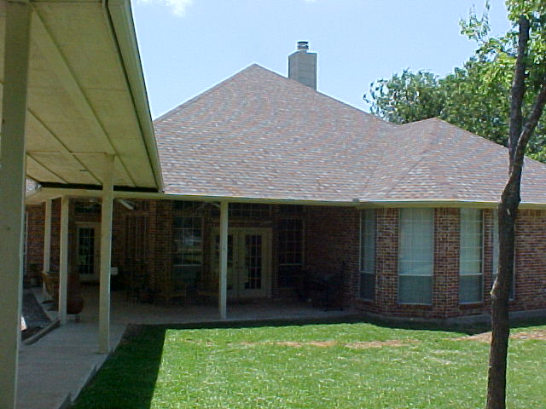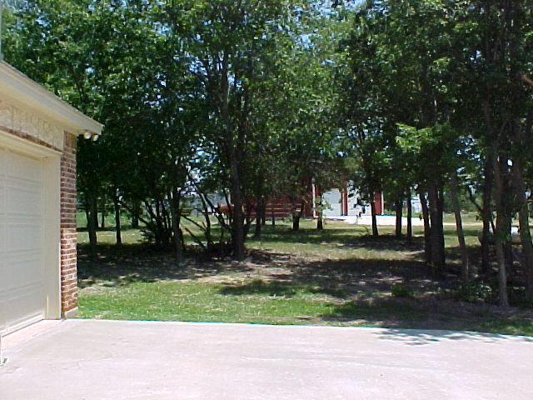

THE EXTERIOR OF THIS HOME IS BRICK WITH CUT STONE ACCENTS AND SOUTHWESTERN LANDSCAPING. THE GARAGE IS ATTACHED WITH A COVERED BREEZEWAY AT THE CORNER PATIO, AND THERE IS A GAME ROOM ABOVE THE GARAGE WITH HEAT AND AIR. THE YARD IS IN AND HAS A SPRINKLER SYSTEM PLUS THE HOME HAS RAIN GUTTERING TO HELP THE FOUNDATION AND WITH EROSION.

