IN THE HOUSE

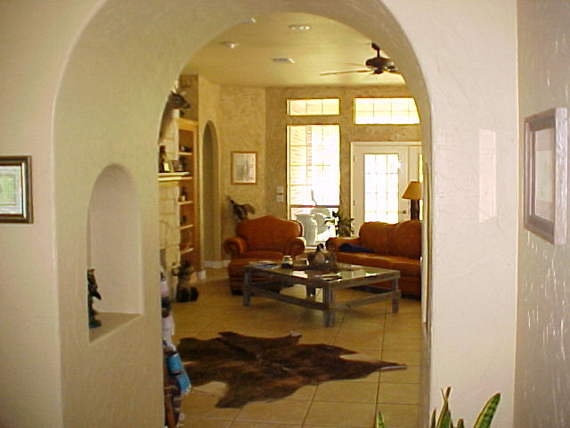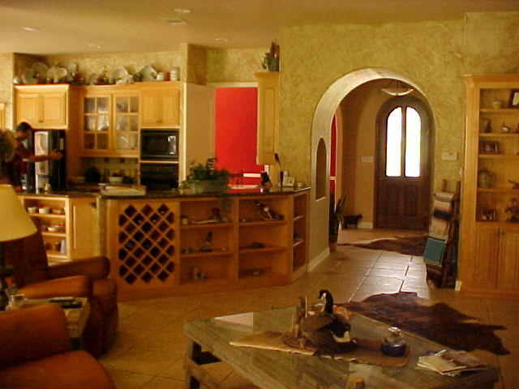

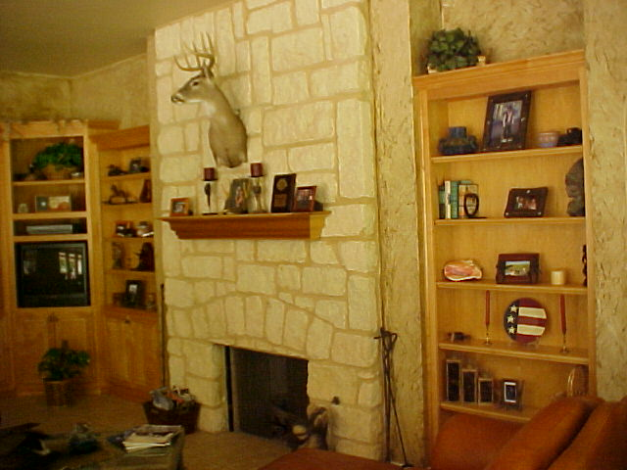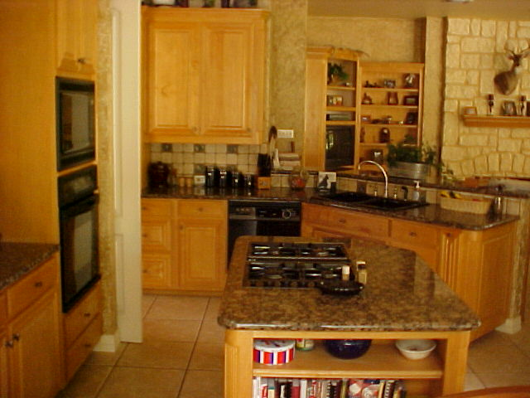

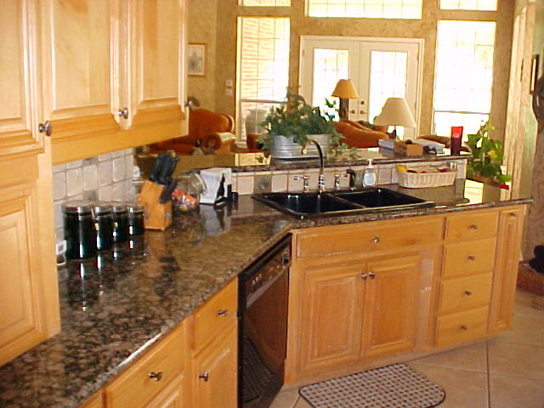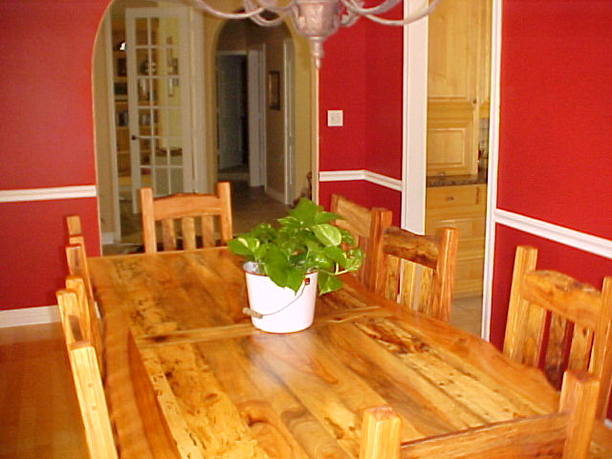

THE GENEROUS SIZED, OPEN LIVING/KITCHEN COMBINATION MAKES FOR GREAT FAMILY TIMES AND THE WARM FEELING OF THE DINNING ROOM WELCOMES ANY GUEST. THE LARGE PATIO AROUND THE LIVING ROOM ALSO ADDS TO THE ENTERTAINMENT CHARM OF THIS PROPERTY.

