WORKSHOP

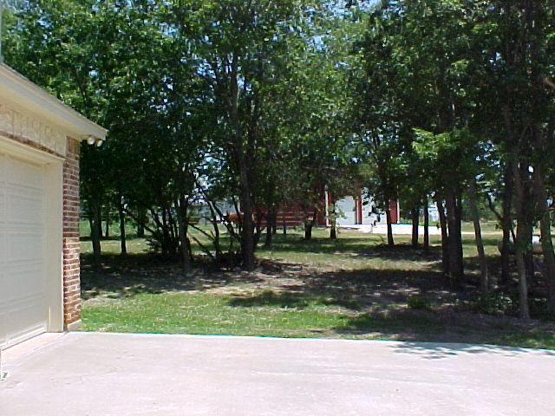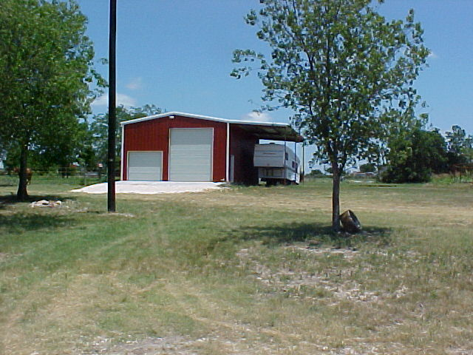

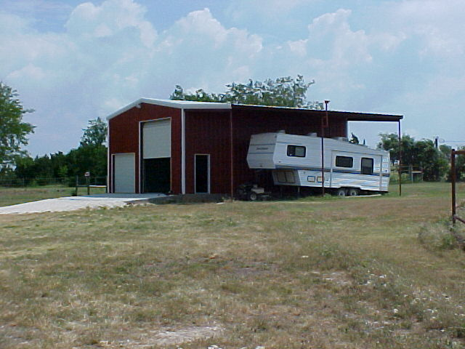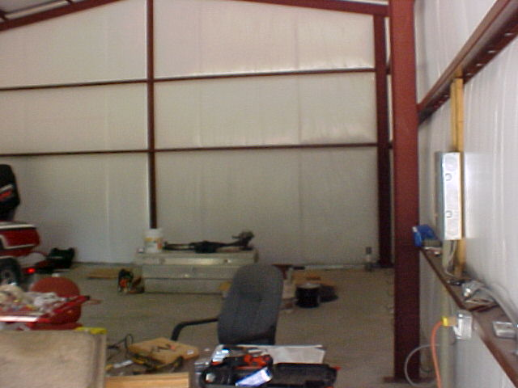

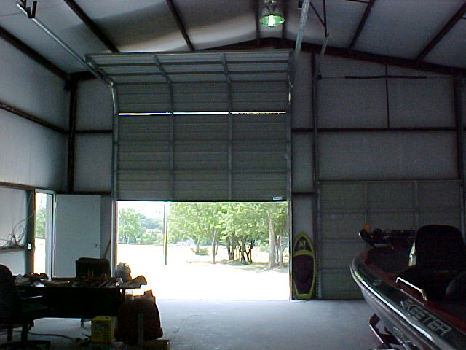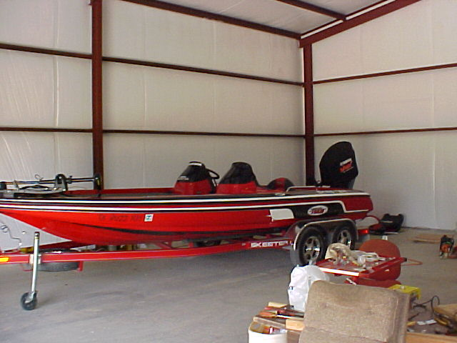

THE NEWER WORKSHOP IS METAL WITH INSULATION AND ELECTRICITY PLUS A CONCRETE SLAB FLOOR AND GREAT VIEWS. IT SITS ACROSS THE DRIVE FROM THE HORSE BARN ADJACENT TO THE HOUSE NEAR THE NEWER ROUND PEN, MAKING EVERYTHING CENTRALLY LOCATED FOR CHORES AND REPAIRS.

