MASTER AREA

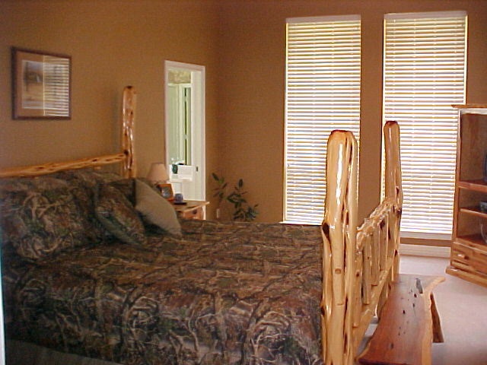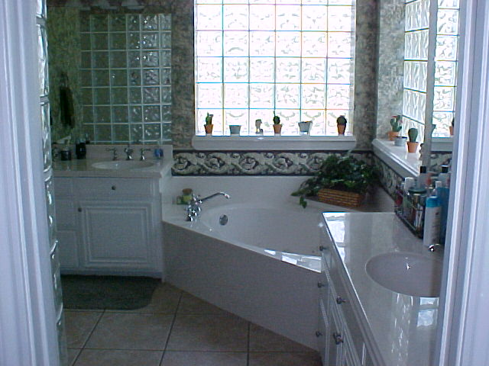

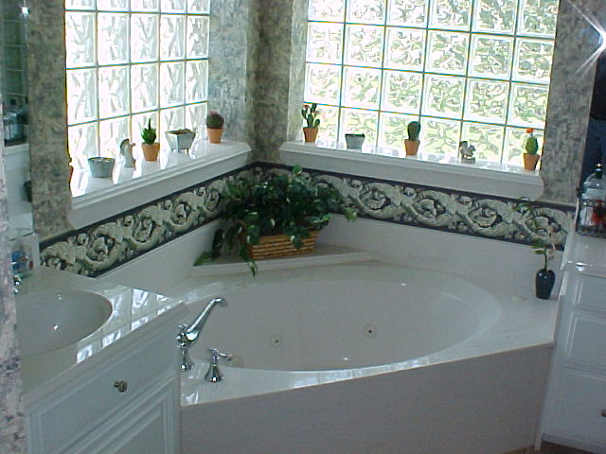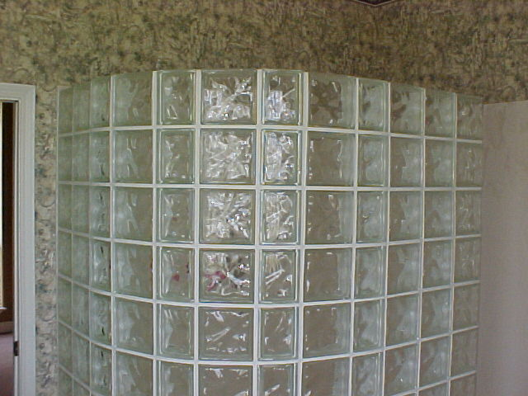

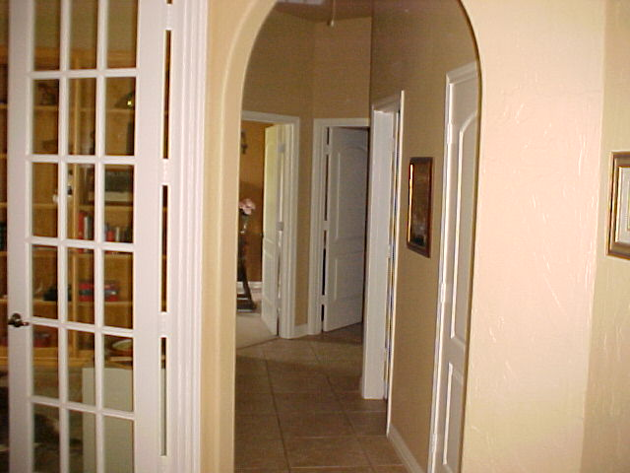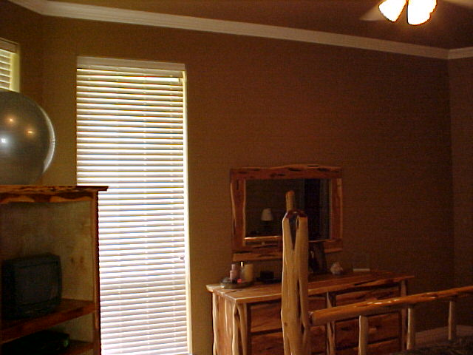

GREAT MASTER BED AND BATH AREA WITH GLASS TILE SHOWER AND WINDOW, A MUST SEE FOR HER. MASTER IS NEAR THE UTILITY AND ALSO ANOTHER BEDROOM THAT COULD BE USED FOR NURSERY OR OFFICE.

