**Neighborhood Map**

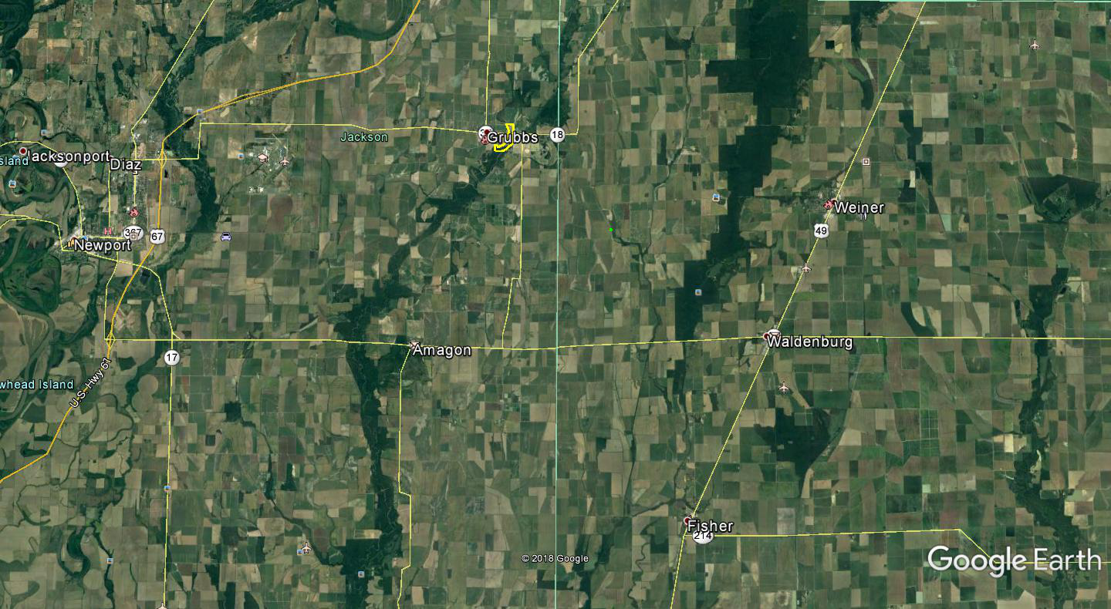

**← Village Creek**

**← White River**

**Bayou DeView →**

**Claypool Reservoir ↗**

**Mallard Pond →**

**↙ Canale’s Duck Hunting**

**Cache River ↘**

**Sitzer Woods →**

**← Bayou DeView WMA**

**↖ 104.71 Acres For Sale**