**Site Map**

**104.71 Acres for $492,000**

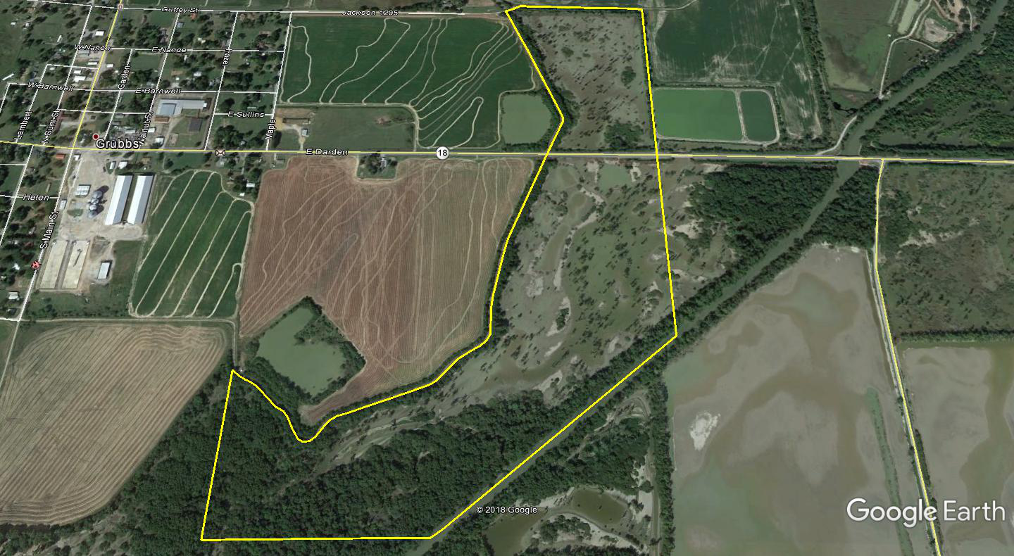

**↖ Cache River**

**For Sale →**