MMJ Farm, Greenhouses, Drying Sheds/Grow Rooms, Lab and Butane/CO2 Extractors

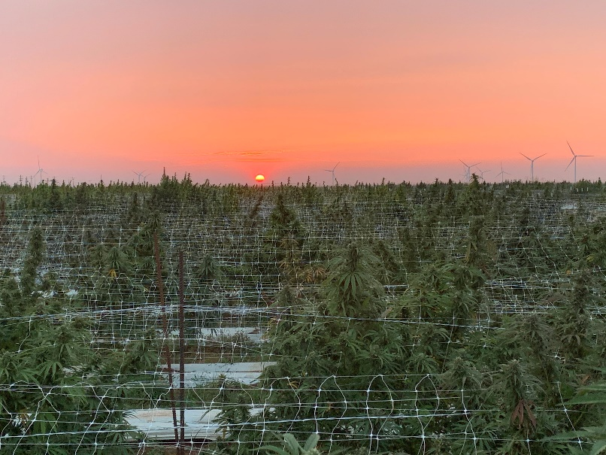

228 acres for sale in Okarche, OK …. (Or 25 acres)

Both acreages will include:

* 2 Insulated Drying sheds (soon to be turned into grow rooms) 30’x61’ (1830 square feet each).
* 2 Greenhouses (3300 square feet each)
* Lab 64' x 24' (1,536 square feet) 1/2 is used for Clones and the other half has 2 processors and distillation equipment.
  + Elf Butane Extractor (Halo 20.  34 Liter bho)
  + CO2 Extractor
  + 15 Cubic Feet SoLo Deep freezer
* Well (10 gallons/minute)
* Pond/ponds (pump to greenhouses and outdoor grows)
* 5,000 gallon water tank
* Dirt mixing shed

Please see the pictures and videos at the google link below:

[https://drive.google.com/drive/folders/1AwOHBPZ1RL54MHnBBUwW_a749gmyuTv1?usp=sharing](https://nam12.safelinks.protection.outlook.com/?url=https%3A%2F%2Fdrive.google.com%2Fdrive%2Ffolders%2F1AwOHBPZ1RL54MHnBBUwW_a749gmyuTv1%3Fusp%3Dsharing&data=02%7C01%7C%7C3a3cd263e01844a0253d08d86bb58804%7C84df9e7fe9f640afb435aaaaaaaaaaaa%7C1%7C0%7C637377774692568264&sdata=jXmPn3NWi8lhtGODD4UDicuMfQUNGJsqaJWB15aD2nE%3D&reserved=0)

**Asking Price:**

$2,950,000 = 228 acres with everything mentioned above.  
$2,250,000 = 25 acres and everything mentioned above