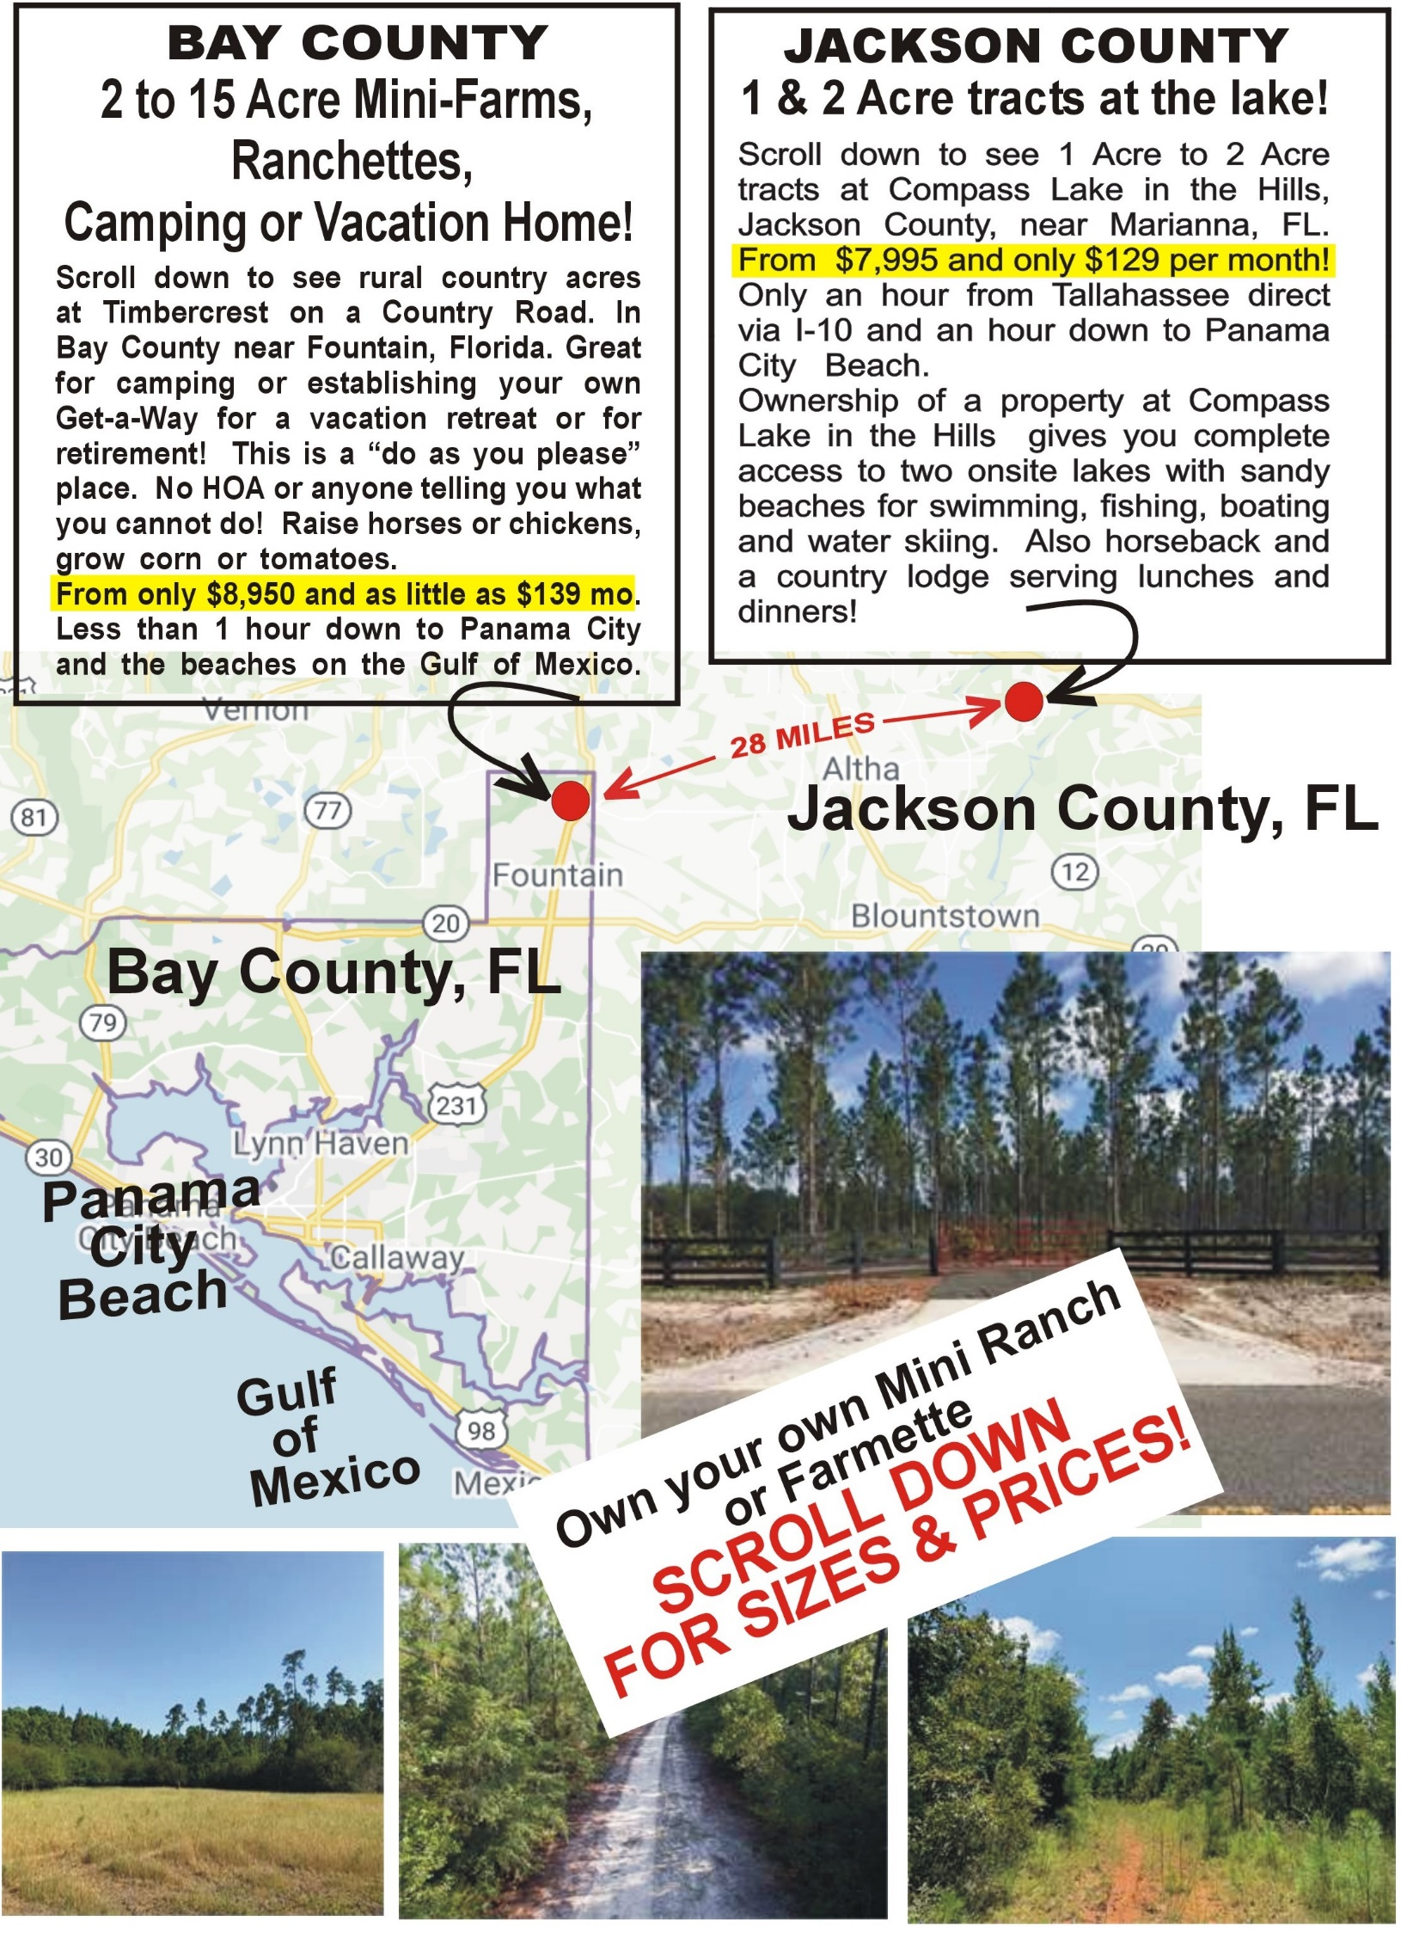

JACKSON COUNTY, FL
JACKSON COUNTY, FL (half-way Between Panama City & Tallahassee) OWN ONE FULL ACRE to OVER 1 1/2 ACRES now only $129 to $169 per month!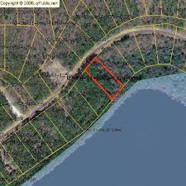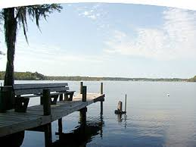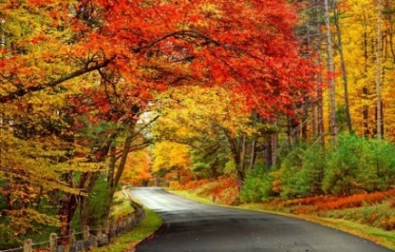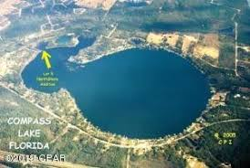 2 Private boating and fishing lakes! Private Boat Docks -- 4 Seasons wiith mild Florida winters -- Lakes hidden up in the hills! G GROUND FLOOR OPPORTUNITY TO ACQUIRE ACREAGE! Hidden in the rolling hills of Northern Florida, near Marianna, FL and exactly 50 miles north of Panama City on the Gulf of Mexico, and 55 miles via I-10 to Tallahassee, lies COMPASS LAKE IN THE WOODS!. ACREAGE IS NOW AVAILABLE AT UNBELIVABLY LOW PRICE AND TERMS……………………...………. The community already has approximately 400 homes established and boasts a Country Club ambiance with voluntary club membership at only $135.00 per year! Taxes are less than $40.00 year! ..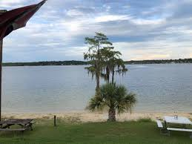 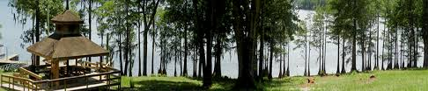 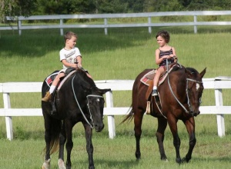 For more information,call us at (800) 341-9958 for information on the properties and more details about the community!................................................................................... Come down to Florida.and enjoy the Autumn leaves and the mild Florida winters! There are huge lakes on site for fishing, swimming, sailing and water-skiing. Boat docks, community swimming pool, tennis courts and country lodge serving lunch & dinners! All properties have electric service available and are approved for septic system. Build a home, a cabin, a pole barn or a mfg modular, or build nothing at all and just come up camping or rent a cabin onsite for a weekend or for the winter! 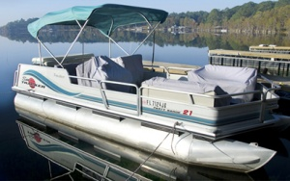 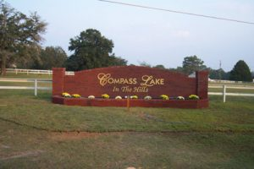 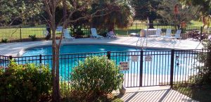
MAP REF | CITY or AREA  SUBDIVISION | SIZE | SHORT  DESCRIPTION | ADDRESS & DIRECTIONS | TOTAL  PRICE | ZERO  DOWN | MONTHLY  PAYMENT | MISC  I INFO
JC  2018 | ANDREW CT  Lake Compass  Alford, FL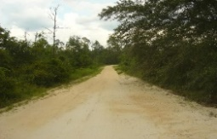 | 1.2  Acre | 180 ft front  X 1 ¼ Acre  (go south from 1283 Edison Ave, Jackson County, FL | East side of Andrew Court (near end of cul-de-sac) 600 ft from Edison Ave. | $8,995 | $0 | $139 | Unit 5  Blk 156  Lot 28
JC  2013 | CABRILLO AVE  Lake Compass  Alford, FL | 1.5  Acre | 189 ft frontage x  296 ft deep (avg) | 200 ft south of Black Canyon St and 4 lots north of Capulin St  On west side | $10,900 | $0 | $149 | Unit 5  Blk 162  Lot 11
JC  2021 | PUTNAM AVE  Lake Compass  Alford, FL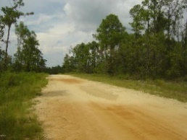 | 1.3  Acre | 170 ft front x 330 ft deep  (go 6 lots north of  896 Wells Street) | Located on west side of Putnam Ave, at end of Genesso Ave | $9,450 | $0 | $139 | Unit 6  Blk 246  Lot 52
JC  2037 | Mayflower Drive  Lake Compass  Marianna, FL | 1.14  Acre | Borders 130 acres of deer filled, wooded wilderness! | From 460 Cinnamon Drive, Marianna, FL,  Go 560 ft south on Mayflower Drive to property on left. | $7,495 | $0 | $129 | Unit 3A  Lot 5
JC 2039 | Olivia Drive  Lake Compass  Alford, FL | 1.35  Acre | Electricity now avail @ “front door” | Located at south end of Olivia drive (cul-de-sac) on the east side. Approx. 450 feet east of residence at 2721 Trinity Street. | $9,450 | $0 | $139 | Unit 6  Blk 228  Lot 28
JC  2040 | Red Road  Lake Compass  Marianna, FL | 1.13  Acre | Just 400 ft north of Nortek Blvd  (main paved road) | Located on east side of Red Road,  400 ft north of Nortek Blvd across from east end of Rim Ct | $7,495 | $0 | $129 | Unit 3  Blk 79  Lot 6


