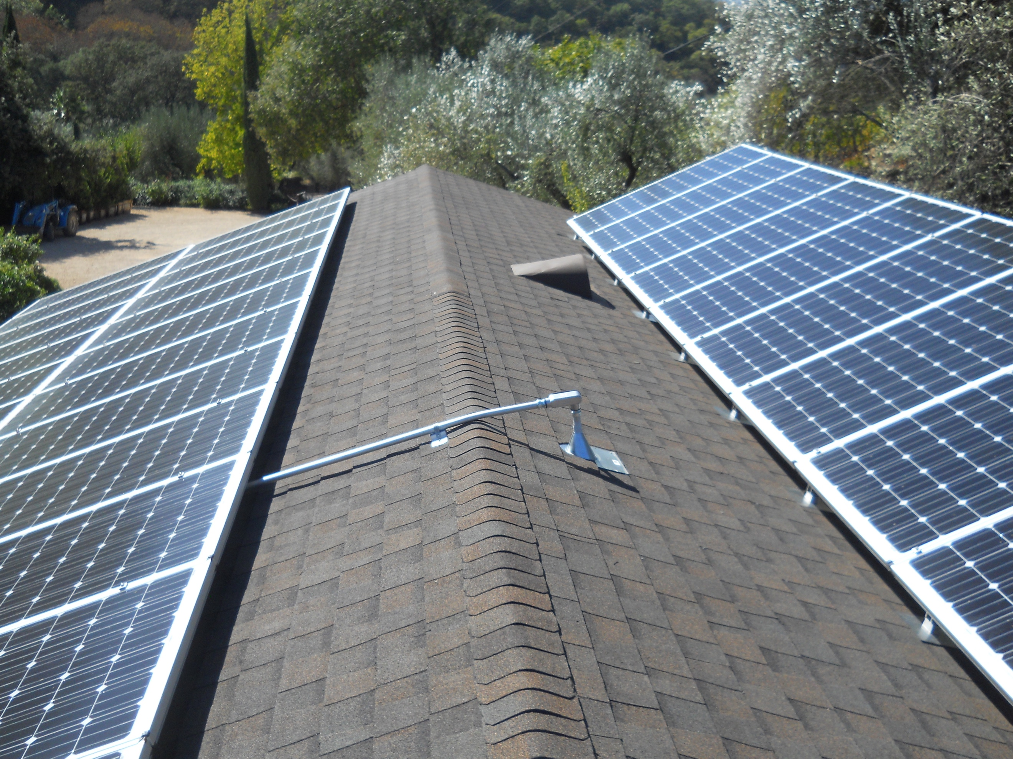CROSS VALLEY CONSTRUCTION

3335 SCENIC DRIVE NAPA CA 94558

CALIFORNIA LICENSE 584644 B C36 C46

[crossvalleyconstruction@gmail.com](mailto:crossvalleyconstruction@gmail.com)

crossvalleyconstruction.com

707-494-3811

Dear Dan and Marguerite, 3/4/21

Here is what PG&E won’t do for the property in Wooden Valley……….

1. They will not do an overhead/underground combination power supply
2. To come across the creek you must choose overhead or underground. Underground requires an engineered bridge to carry the pipe.
3. To carry the power up to the site, PG&E will do the underground for around $500/ft. If you want to go overhead, they will set the poles, transformers and other necessary gear but don’t know what it will cost.
4. They won’t consider an application for residential power without complete architectural plans. They will take your application, but it will expire in 90 days without the plans.

Here is one idea that can accomplish something:

Bring the power across the creek overhead to run your pumped water up the hill. We can get a permit for that, and PG&E will install. We could apply for 225A or 320A 3phase service. That pump has to do heavy lifting.

After the service is installed, dig a trench up the road and put the water pipe and a couple of other pipes in the ditch. Bring power to the site temporarily for construction purposes in one of the empty pipes. Install a transformer at the top to boost voltage to usable levels.

There may be a solar/ battery solution here as well, but this would at least get the water up the hill. Generators can run the construction work if you had to.

I got all this from the PG&E service person who helped with the pond power project. If you want to talk to her I will send her contact info.

Best, R