Details about 144 & 145 Engh Rd in Omak, WA

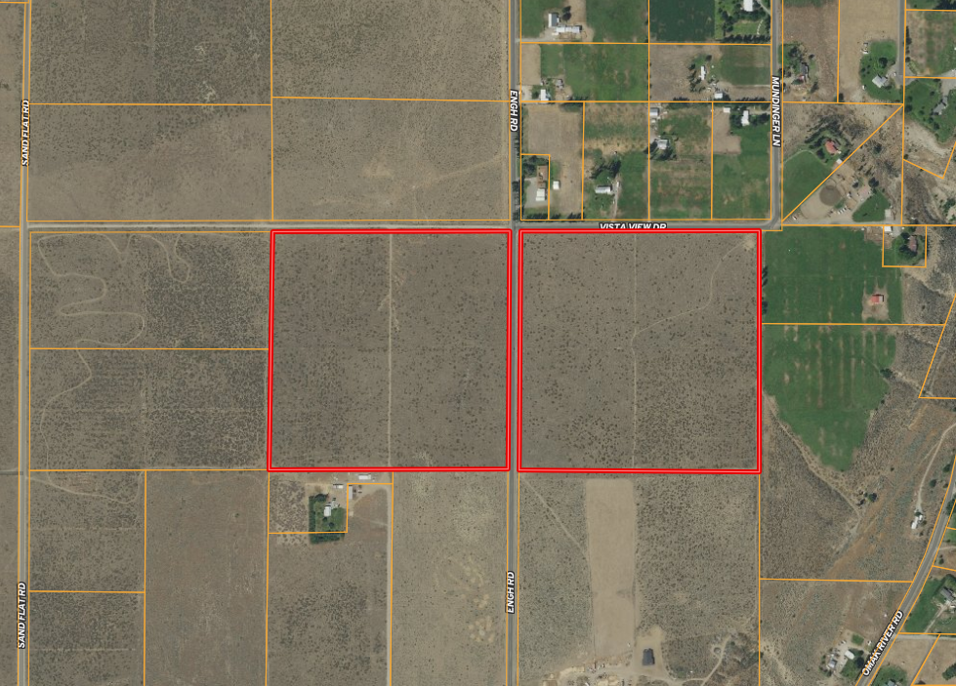

144 Engh Rd  
Parcel 3427301004

145 Engh Rd  
Parcel 3427304013

These address numbers are for GPS travel purposes, they are not the assigned addresses for these parcels.

145 Engh (the westerly parcel) is within the city limits of Omak.

In order to determine costs to have city water or sewer connected to this parcel, please contact the City of Omak Building Inspector, Tyler Wells at 509-826-1170

You can also fill out this form to request a specific quote to have city utilities brought to the property: <https://www.omakcity.com/sites/default/files/fileattachments/utilities/page/2291/2021_water-sewer_connection_request_form_-_new_construction.pdf>

For Zoning information see the City of Omak’s zoning map here: <https://www.omakcity.com/sites/default/files/fileattachments/building_and_planning/page/2071/zoning_map_2017.pdf>

For the city’s definition of the zoning for this property click here: <https://www.codepublishing.com/WA/Omak/#!/Omak18/Omak18.html>

For information on subdividing or splitting the city parcel click here: <https://www.codepublishing.com/WA/Omak/#!/Omak17/Omak17.html>

For information on future growth plans of the city of Omak refer to the Greater Omak Area Comprehensive Plan Update here: <https://www.omakcity.com/sites/default/files/fileattachments/building_and_planning/page/2091/2019_june_update_-_omak_comp_plan.pdf>

144 Engh Rd (the easterly parcel) is not in the city limits. For information about land use and zoning for this parcel contact Stephanie “Pete” Palmer, the County Planner.   
[spalmer@co.okanogan.wa.us](mailto:spalmer@co.okanogan.wa.us) or 509-422-7218

Here is the Okanogan County Zoning map: <https://caltopo.com/m/ASRA> You can zoom into the location of the property & left-click on it to bring up a little box that displays “R1” – that’s the zoning. This map has many additional pieces of information you can explore as well.

Here is the Okanogan County Zoning definition: https://www.codepublishing.com/WA/OkanoganCounty/#!/OkanoganCounty17A/OkanoganCounty17A40.html#17A.40