

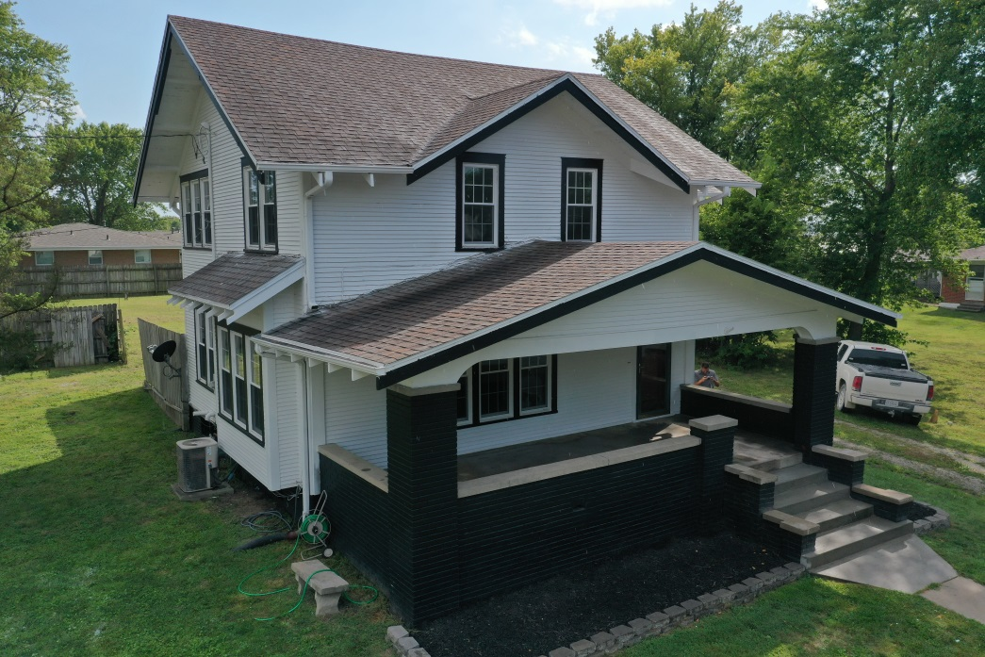
Listing # 7331

Listing Price: $158,900.00

Listing Agent:
Dylan Heitz
816-604-8747
Heitz.ucrealestate@gmail.com

School District: South Harrison

Closest City:
Kansas City, MO - 90 miles
Des Moines, IA - 95 miles

Square Footage: 2169
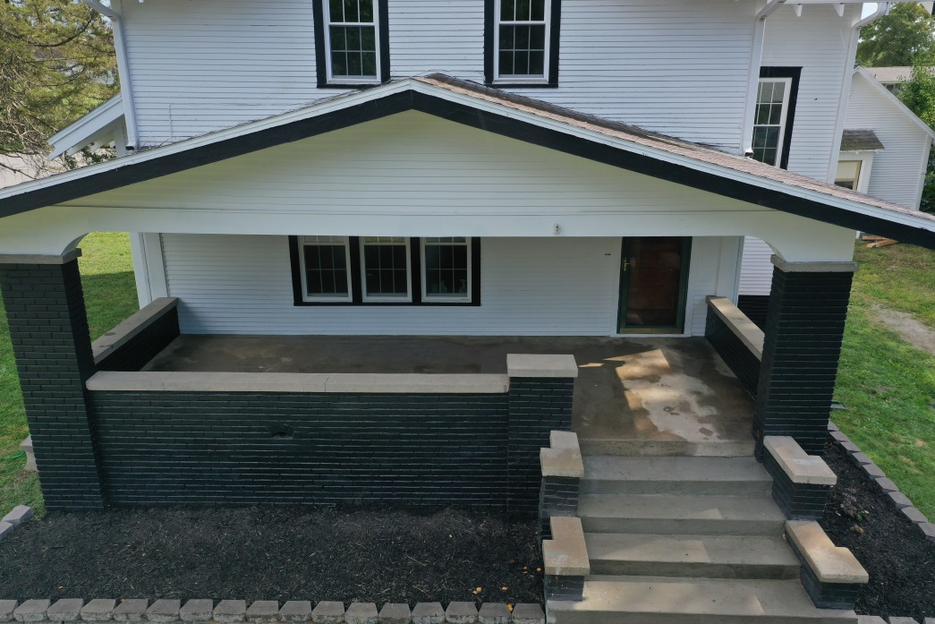
Acreage: .4525 acres

Property Taxes: $678.59

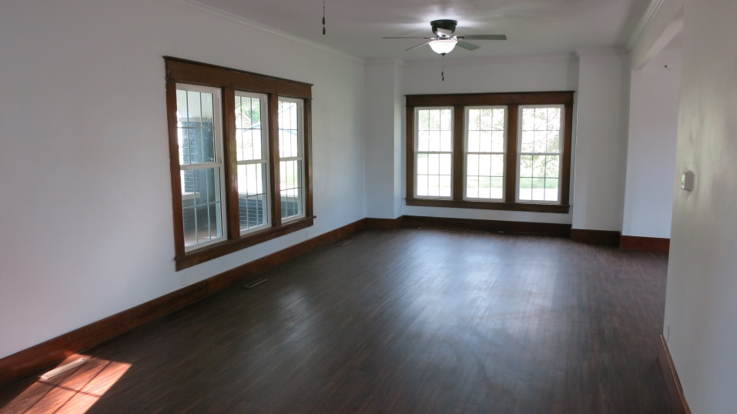
Features of Property:

- Newer Roof
- New Double Hung Windows
- New Exterior Doors
- Fresh Exterior Paint
- New Interior doors
- New flooring, fixtures, & paint
- Completely remodeled kitchen, laundry & powder room on main level
- Upstairs has undergone updates
- Nice front porch and back deck
- Newer furnace
- 2169 sq. ft. house
- 3 Bedroom 1.5 Bathroom
- Detached 1 Car garage
- 1044 sq. ft. basement

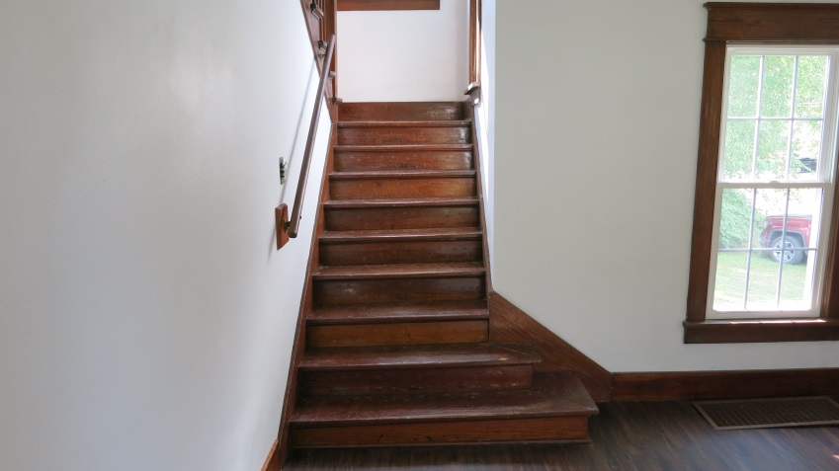
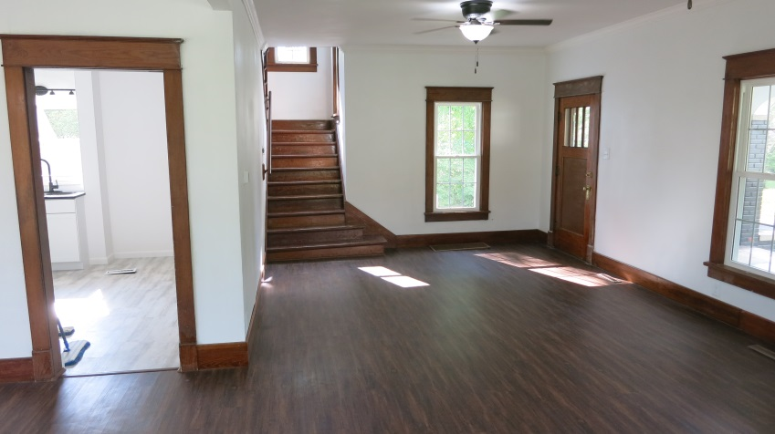

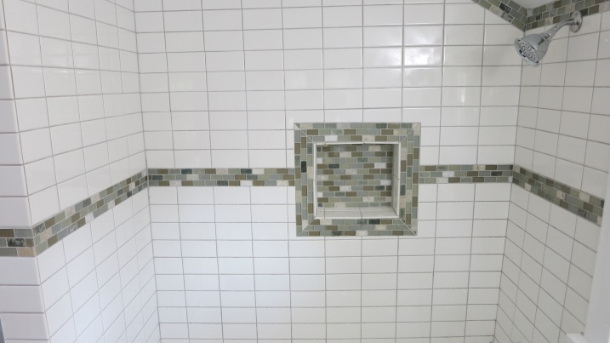
Main Level Room Sizes:
- Living Room: 28' x 12.5'
- Dining Room: 12' x 13.5'
- Kitchen: 10' x 11'
- Laundry: 7' x 5'
- Powder Room: 7.5' x 2.5'
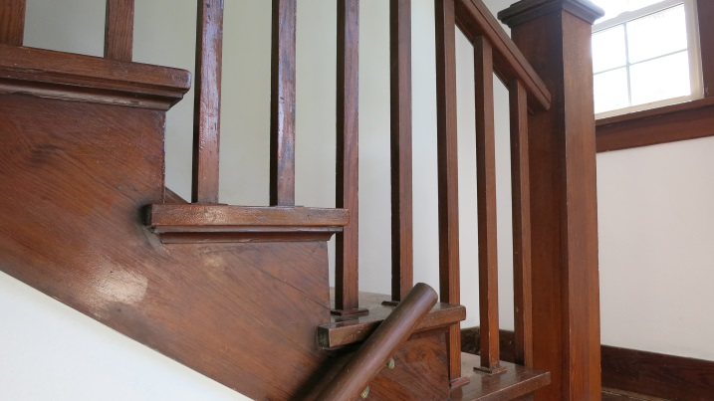
Second Level Room Sizes:
- Bedroom 1: 12' x 12'
- Bedroom 2: 10' x 12'
- Bedroom 3: 9' x 11'
- Bathroom: 7' x 7'
- Office: 7' x 8'
