

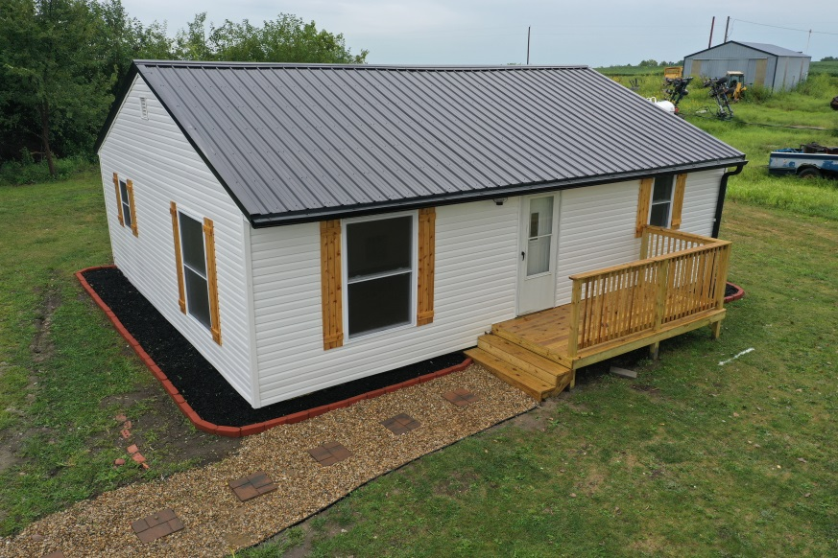
Listing # 7341

Listing Price: $108,900.00

Listing Agent:
Dylan Heitz
816-604-8747
Heitz.ucrealestate@gmail.com

School District: Cameron

Closest City:
Kansas City, MO - 50 miles

Square Footage: 768
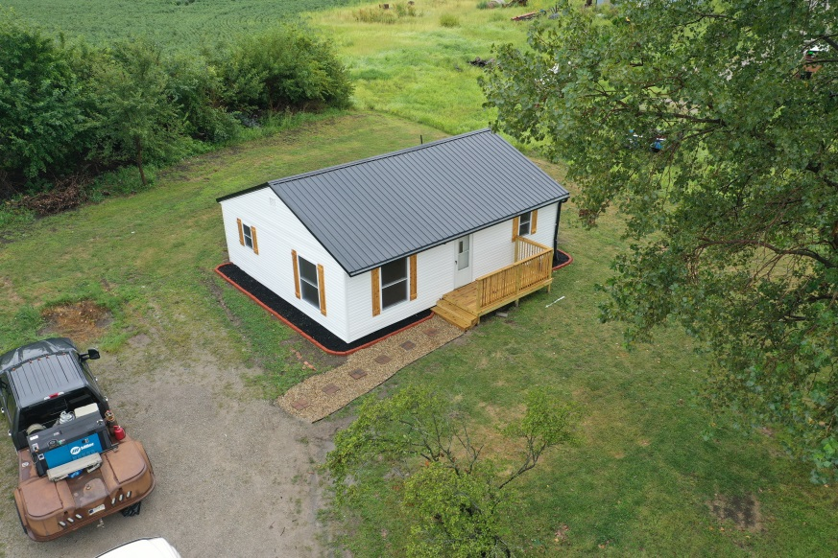
Acreage: .4 acres

Property Taxes: $288.96

This quaint 2 bedroom, 1 bathroom ranch style home is a perfect place to call home for someone who wants out of town! It has been taken down to the studs and received a full renovation from the outside in.

As you walk into the door you are greeted with an open living and dining area with a couple of large windows that give it great natural light. The kitchen has a sleek new look with slate gray cabinets, white subway tile backsplash, farmhouse sink & stunning custom butcher block countertops. The bathroom is right off of the kitchen and has a very clean looking sliding barn door that opens up to a large space. The bathroom features a walk in shower, tankless instant water heater that services the house & washer and dryer hookups.

On the exterior, a new tin roof & guttering, fascia & soffit, siding, doors & windows & 2 new decks have been installed. In addition, a brand new HVAC system has been put in with new ducting throughout the house.

On the interior, new electrical, plumbing, lighting, sheetrock, flooring, interior doors, trim, cabinets & vanity, & so much more have been installed. Call Dylan Heitz today to set up your showing! $119,900.00

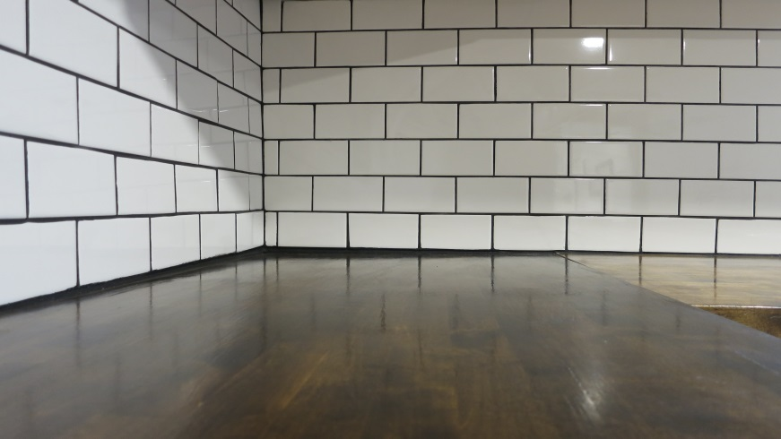
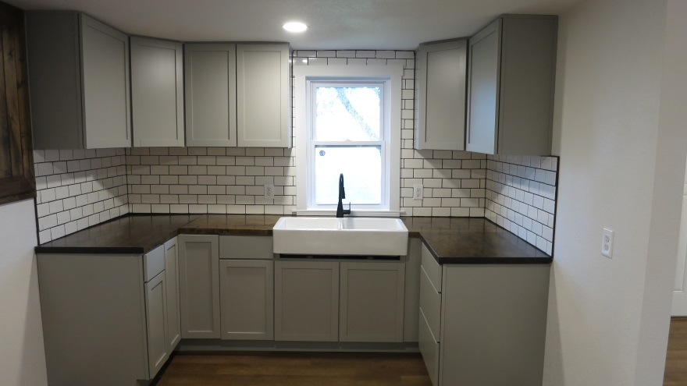
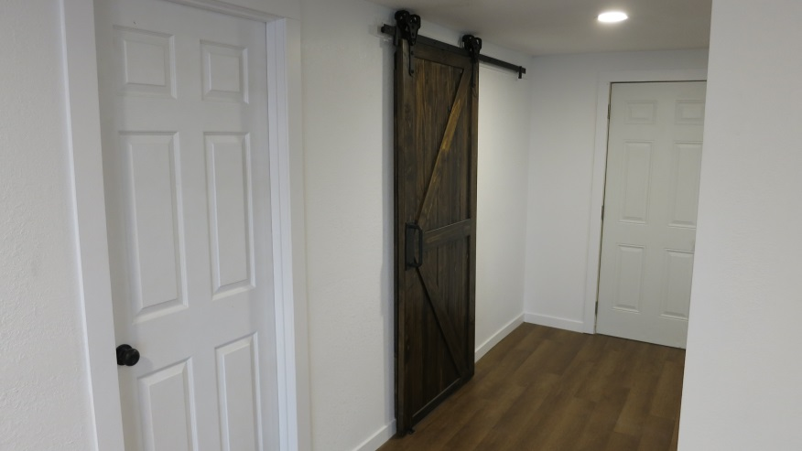
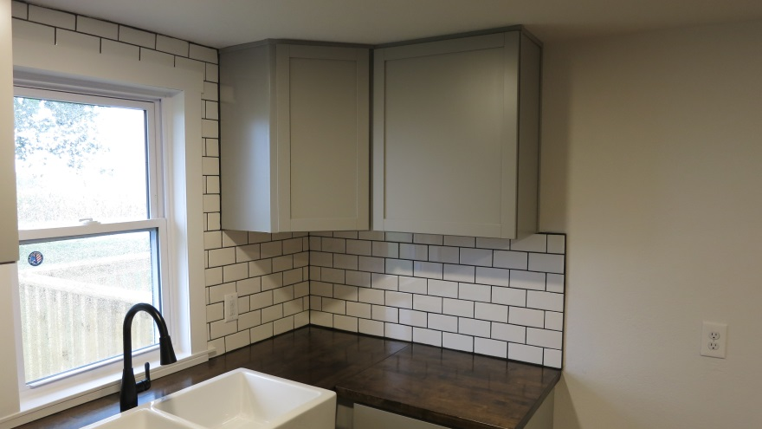

Features of Property:

- New Roof, Guttering, Fascia & Soffit
- New Vinyl Siding
- New HVAC
- New Flooring & Trim
- New Sheetrock, Recessed Lighting & Fixtures
- All New Plumbing & Electrical
- New Kitchen Cabinets, Countertops, Backsplash & Farmhouse Sink
- All New Bathroom with Tankless Instant Water Heater
- Fresh Paint
- Beautiful Barn Door in Kitchen Area
Main Level Room Sizes:
- Living Room: 21' x 11'
- Kitchen: 9' x 11'
- Bedroom #1: 8.5' x 11'
- Bedroom #2: 11.5' x 11'
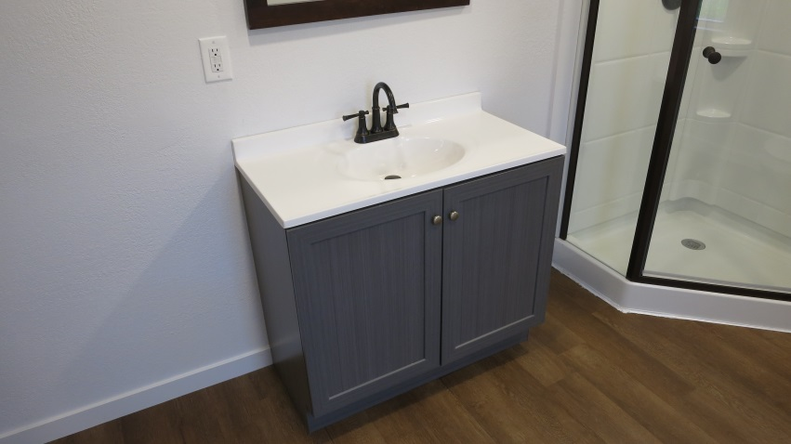
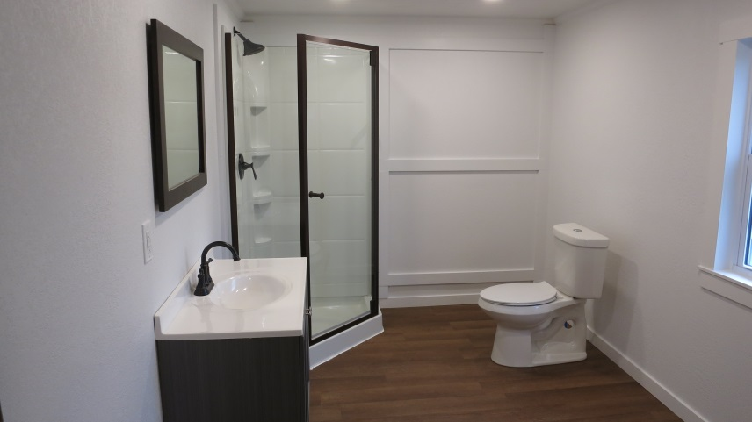
- Bathroom 11' x 7'

