

Listing # 7310

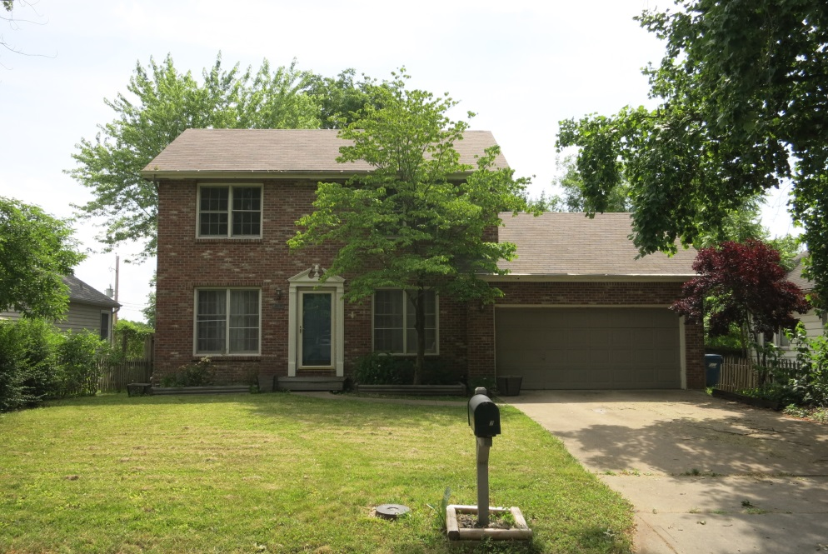
Listing Price: $244,900.00

Listing Agent:
Dylan Heitz
816-604-8747
Heitz.ucrealestate@gmail.com

School District: Liberty Schools

Closest City:
Kansas City, MO 5 miles

Square Footage: 1773

Acreage: .21

Property Taxes: $ 3,024.37

Looking for a fantastic opportunity to own a property in tremendous area near downtown Liberty? Look no further! This property features tremendous location, just minutes from all the amenities you could need or want!

This 3 bedroom, 2.5 bathroom house offers boundless potential. It boasts a colonial look and vibe. It has an attached 460 sq. ft. 2 car garage and a 546 sq. ft. basement. It has a nice fenced in back yard with a handy shed to store your tools. There is what could be very cool patio just outside the back door. This could be brought back to life and become a fabulous entertaining area.

The inside is in need of some TLC. Flooring, fixtures & paint would take this place a long ways. There are a number of other small things that need replaced/fixed. The house features a large open living room area with good light and electric fireplace. Also on the main level are a formal dining area, office, laundry, and half bath. The house is being sold in "As Is Condition." Call today to set up your showing! $244,900.00

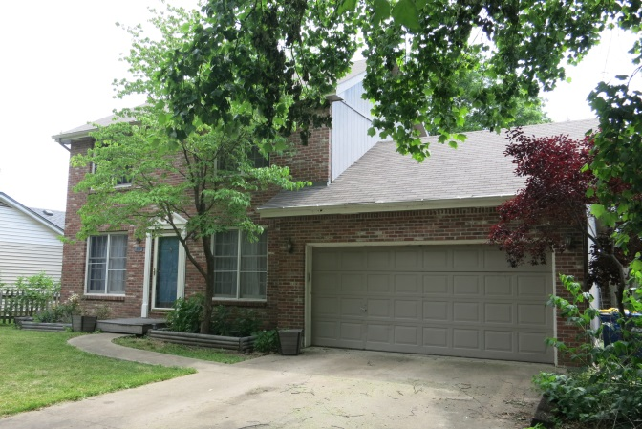
Features of Property:

- Colonial Style House
- Fenced in backyard
- 460 sq. ft. attached two car garage
- Tremendous location & neighborhood
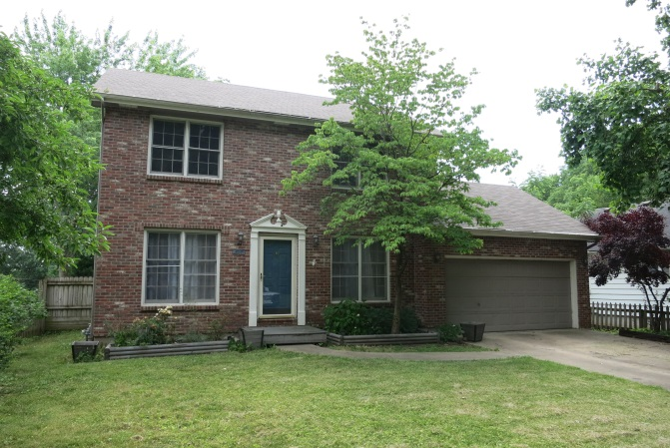
- Patio in the backyard perfect for entertaining
- 546 sq. ft. basement
Main Level Room Sizes:
- Living/Dining: 27.5'x19'
- Kitchen: 13'x8'
- Formal Dining Room: 11'x12'
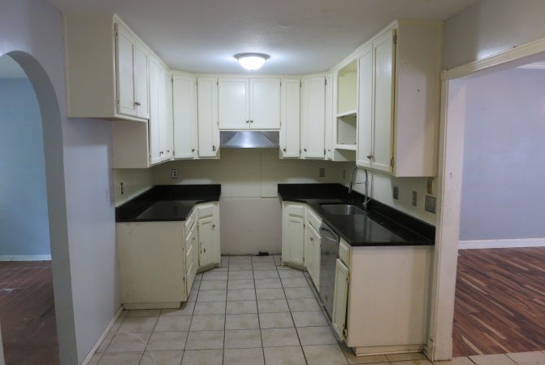
- Utility Room: 3'x15'
- Bathroom: 3'x5'
Upper Level Room Sizes:
- Bedroom #1 (Master): 13'x13'
- Master Bathroom: 8'x4'
- Master Closet: 3'x4'
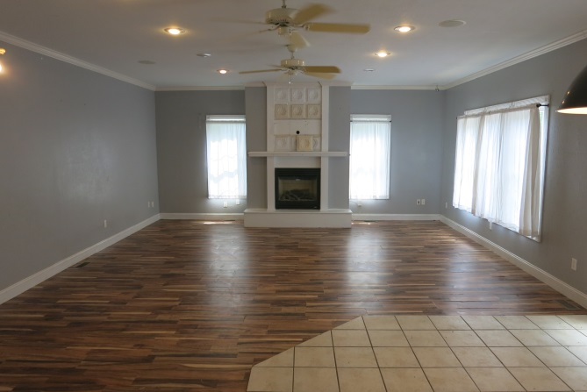
- Bedroom #2: 9'x11'
- Bedroom #3: 8.5'x10'
- Bathroom: 4.5'x3'

