11307 S COLLEGE AVE

Regarding items in the property that remain with the property (items remaining please write in offer, supplement or separate bill of sale:
- TV & mount in Master Bathroom
- Window Treatments
- Exterior Pergola
- Curtains on exterior pergola
- Large rectangular exterior firepit
- Back patio TV Mount
- Safe in Master Closet
- Back patio speakers
- Back patio Heaters
- Exterior back patio landscape & pergola lights
- Outdoor living cooktop
- Kitchen TV & Mount
- Security system, camera & pad
- Theater Room fridge
- Downstairs guest bed large wall mirror
- Garage Shelving & cabinets
- Fog-resistant mirror in Master Shower
Regarding items in the property that will go with Sellers but ARE NEGOTIABLE to remain:
- Downstairs ice machine
- Back Patio TV
- Outdoor living fridge
- Bar Fridge
- Bike holders on ceiling
- 2 exterior firebowls
- Back patio umbrella for bar top
- Credenza in Living Room with AV equipment
- Popcorn machine
- 48” Grill in backyard outdoor living
- Fireplace balls to remain with sellers, gas logs will be installed prior to closing at sellers expense
- Large Lava Rocks in backyard landscaping
- Any furniture in the home is negotiable to remain
- Large wall shelf in Office
- Metal Palm Trees in backyard
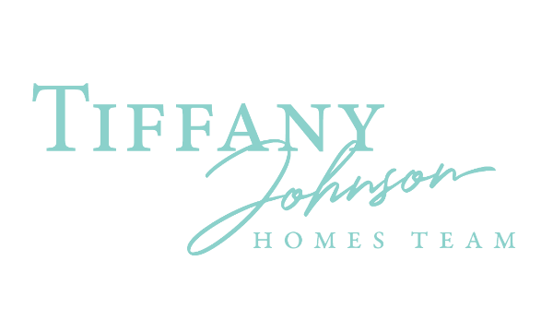
- Large wall shelf/detached in upstairs landing area
- TV & mount in front living room/formal dining
- Kitchen refrigerator
- Theater room popcorn machine
- Surround sound/music Receivers
- Washer/Dryer

