**SITE DATA**

* 108 acres of merchantable Loblolly Pine
* Abundant deer and turkey
* Mature hardwood forest
* Great interior road system.
* Established food plots
* 1.1 mile frontage along Little River

Putnam County, GA • +/- 237 ACRES • $689,000

A remarkable property for the avid outdoorsman and timberland investor located less than two miles from Eatonton, GA. Has paved road frontage along Loblolly Drive with two access points. Beautiful rolling uplands and well established interior roads lead to the bottomlands of the 1.1 mile frontage along Little River. This property has substantial timber value with professionally managed stands of pine plantations and hardwoods.

**LOCATION**

Located along Loblolly Drive less than two miles west of Eatonton. **Shown by Appointment Only**

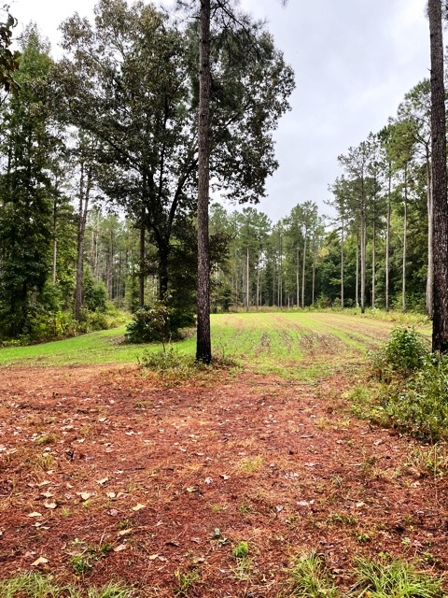

**OPPORTUNITY**

* Turnkey hunting property
* Close proximity to Eatonton.
* Timber inventory revealing significant timber value.
* Endless options for use and enjoyment
* Multiple potential sites for building

**F. SCOTT BROOKINS**

**FRC LAND CO., LLC**

**REAL ESTATE AGENT**



**Putnam 237 Tract**

Information on this property is believed reliable but is not warranted or guaranteed.





For more information,

478-745-4910

912-682-0268

Scott.brookins@frcemail.com

frclandsales.com