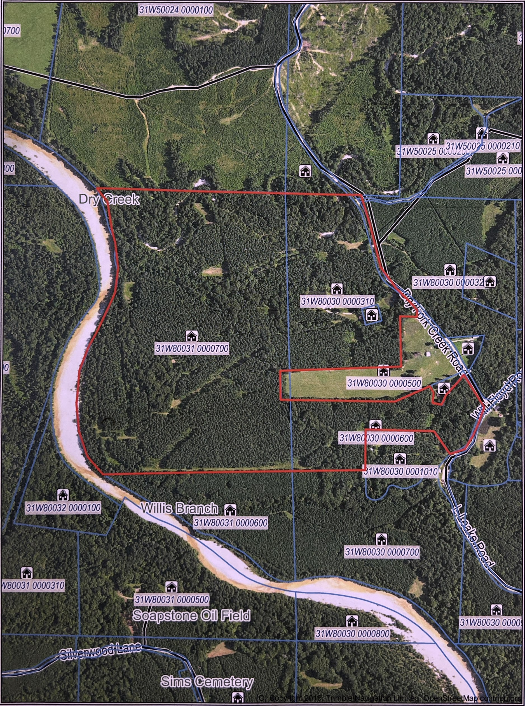

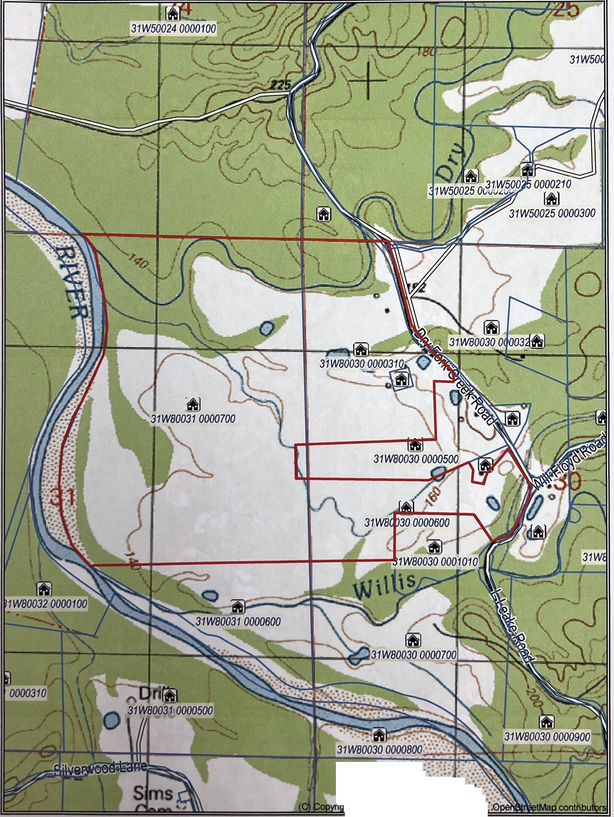

.......
•• •• .•• ..-<t :.... ..... ..
. ·:--:..••.,.:.·:
...
. ht2016,Trlmble D°mited

