**Special Features of 387 MC 7049, Flippin**

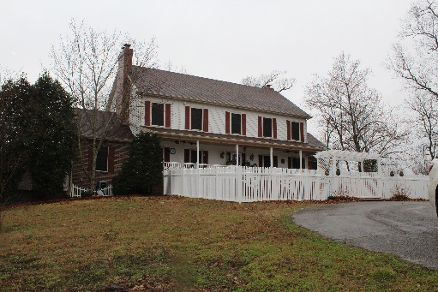

**1st Floor**

* Kitchen –
  + All stainless steel appliances
    - Commercial Grade Sub Zero Refrigerator/Freezer
    - Raised Dishwasher
    - Trash Compactor
    - Double Oven
    - Warming Oven
    - Viking Gas Range with Griddle/Grill
    - Osmosis Water Filter
    - Built in Deep Fryer, Steamer, with Specialized Vent
    - Combo Microwave/Convection Oven
    - Small Dishwasher under Coffee Station
    - Built in Bew Master Coffee Maker
    - Pull Out Refrigerator Drawer and Freezer Drawer to side of range
    - Commercial Grade Vent-A-Hood
  + Pot Filler above Range
  + 3 Bay Undermount Sink
  + Porcelain Undermount Sink
  + Granite Countertops with Custom Built Breakfast Nook
  + Custom Cabinetry
    - Extra Deep Drawers
    - Storage under Bar
    - Multi-Directional Pull Outs in Blind Corner Cabinets
  + Cook Book Rack Mounted next to Range
  + Walk in Full Room Pantry
    - Commercial Grade Frigidaire Refrigerator/Freezer Combo
    - Tons of Storage
    - Book Shelves for many many cook books
  + Custom Crown Molding
  + Solar Screens on All Windows
* Formal Dining Room –
  + Gas Log Fireplace
  + Recessed Lighting
  + Solar Screens on All Doors and Windows
* Master Suite 2/Currently used as Home Office –
  + Cedar Lined Walk-In Closet
  + Full Bath
  + Sky Light
* Utility Room/Mud Room –
  + ½ Bath
  + Built-in Storage
* Living Room –
  + Gas Log Fireplace
  + Remote Controlled Wood Blinds
  + Recessed Lighting
* 2 Car Attached Garage
  + Extra Large Parking on One Side for Extended Cab Vehicles

**2nd Floor**

* Main Master Suite
  + Electric Fireplace
  + Wood Blinds
  + Cedar Lined Extra Large Walk-In Closet
    - Custom Built-Ins
      * Custom Hanging Racks
      * Jewelry Drawers
      * Delicate Drawers
      * Shoe Racks
  + Master Bath –
    - Etched Glass Door
    - His/Her Vanity
    - Makeup Vanity
    - Jetted Jacuzzi Tub
    - Walk-In Double Head Shower
    - Private Water Closet
* Master Suite 3 –
  + Full Bath with Tub/Shower Combo
  + Cedar Lined Walk-In Closet
  + 2 Additional Cedar Lined Closets
* Master Suite 4 – Located Above the Garage
  + Double Sky Light
  + 2 Large Closets
  + Full Bath with Shower
  + Remote Controlled Wood Blinds

**Basement**

* Game Room –
  + Kitchen/Bar Area
    - Oak Cabinets
    - Wine Storage
    - Stainless Steel Ice Maker and Small Refrigerator
    - Locking Liquor Cabinets
    - Glass Front Display Cabinets
* Family Room/Den
  + Wood Burning Stone Fireplace
  + Recessed Lighting
* Utility Storage Room –
  + 2 Marathon Hot Water Heaters
  + Water Softener
  + 2 Pressure Tanks
  + Sprinkler System Controls
  + Walk-in Vault Safe Behind Lockable Door
* Master Suite 5 –
* Walk-In Closet
  + Full Bath with Shower

**Additional Features:**

Lighted Tennis Court

Salt Water Swimming Pool with Diving Board – Pool Can be Heated

Geo Thermal Home with 3 Designated Zones

6 Foot Cyclone Fence around Garden Area

Custom Tile Imported from Spain

Gun Range/Target Practice Area

Two Ponds and a Tractor Shed

Outdoor Kitchen with: Smoker, Grill, Sink, Refrigerator & Ice Maker with Custom Cover for Winter Months

Surveillance Cameras and Coded Automatic Gate at end of Drive