Website property notes

LONG VIEW ON SUNSET RIDGE (91 acres +/-)

WYOMING cOUNTY, wEST vIRGINIA
Price: $299,000.
ID:
Acres: 90.9 +/-
Address: 1737 Milam Fork Black Road, Herndon, WV 24726
Agent Contact:
Randy S. "Riverbend" Burdette, 304-667-2897 OR David Sibray, 304-575-7390
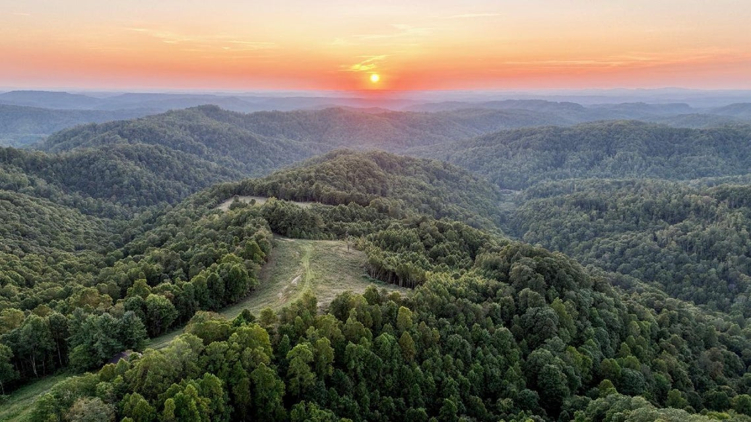
This 91-acre (+/-) woodland property on the summit of Great Flat Top Mountain includes more than eight acres of pasture with exceptional sunset views. Private, though not remote, it's a 30-minute drive to the nearest small cities, Mullens and Princeton. An ideal location for an outdoor getaway, nearby recreational attractions include parks, hunting lands, and ATV trails, and one of the most popular ski resorts in the southeast, Winterplace, is a 45-minute drive away. Two state parks are within 35 minutes, and national parks and forests are within 60.
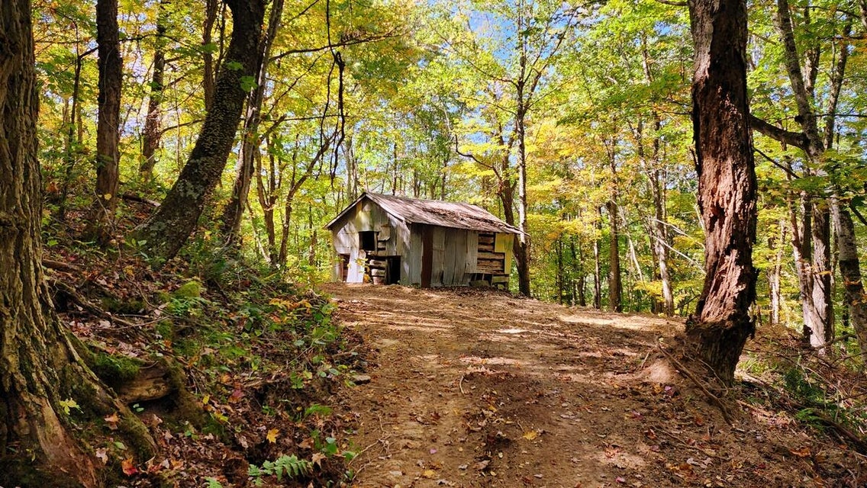
HIGHLIGHTS
- 91 acres (+/-), approximately 82 in forest
- Approximately eight acres of pasture
- Exceptional views northward and westward
- Electric service, cellular service, Starlink not confirmed
- Suited to development as home sites and lodging rentals
- Convenient to ATV trails, hunting lands, historic sites
- Adjoining hunting land for grouse, deer, and turkey
- Cove hardwood forests with mature stands, not surveyed
- Interior trails for hiking, biking, equestrian, and ATV riding
- Source of Milam Creek catch-and-release trout hatchery
- Low light pollution, excellent stargazing
- Bold spring water source and spring-fed pond
- 45 minutes from Winterplace ski area
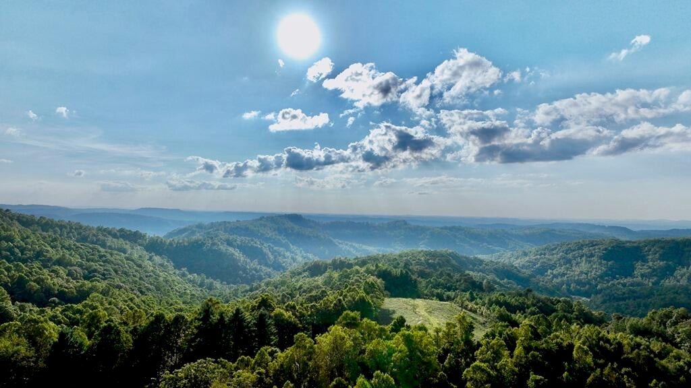
ABOUT THE VIEWS
Hilltop fields at the heart of the property afford remarkable views to the north and west. Mountain peaks as far as 27 miles away suggest the view includes more than 70 square miles. The farthest confirmed peaks include Ivy Knob, at nearly 23 miles away, and Burning Rock, at 27 miles. Ideally suited for star-gazing and night observation, remarkably few light sources interrupt the view.
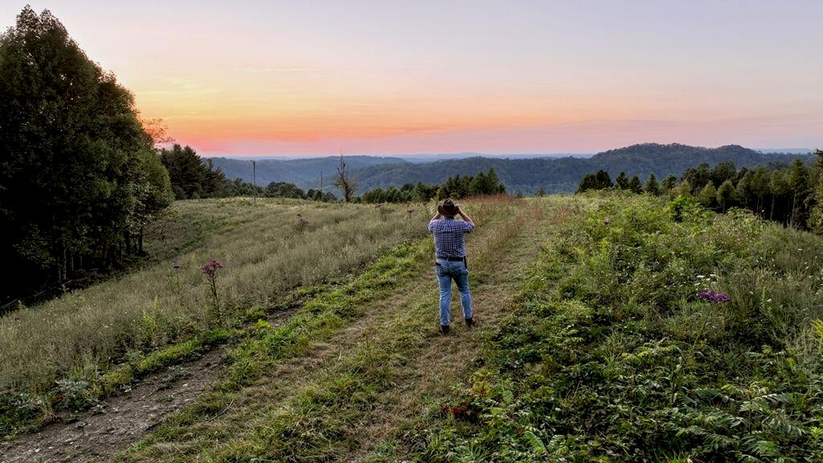
LOCATION
Google Coordinates: 37.499912, -81.261543
Address: 1737 Milam Fork-Black Road, Herdon, WV 24726
Elevation Range: 2,689 to 3,195 feet above sea level
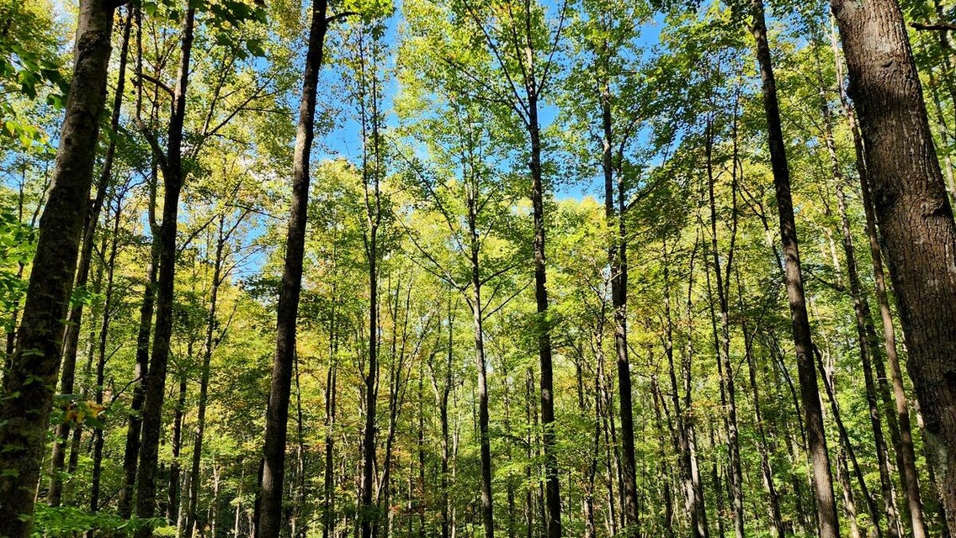
FOREST / TIMBER RESOURCES
An assessment of timber resources has not been performed. Large stands of mature tulip poplar have been observed throughout the property. The forest is a tremendous producer of Oxygen and Carbon Sequester. Carbon sequestration is the act of processing carbon dioxide through sinks and stores and releasing it into the atmosphere as oxygen. With 91 acres, the vigorously growing forest sequesters approximately a quarter million tons of carbon dioxide annually. On average, one tree produces nearly 260 pounds of oxygen each year.
WILDLIFE
The property and region are home to abundant wildlife. A drive of at least 30 miles from the nearest population centers, it is surrounded on all sides by vast forests, notably Camp Creek State Forest, which protects more than 5,269 acres for public hunting and recreation. Wildlife include bear, deer, grouse, fox, mink, squirrel, raccoon, turkey, beaver, bobcat, and muskrat. Songbirds and waterfowl are common, as are larger birds of prey, including owls, hawks, and the occasional bald eagle. The cool streams that descend off the mountain support trout. Hunting is a favorite pastime in the region, and hunting is permitted in the thousands of acres surrounding the property.
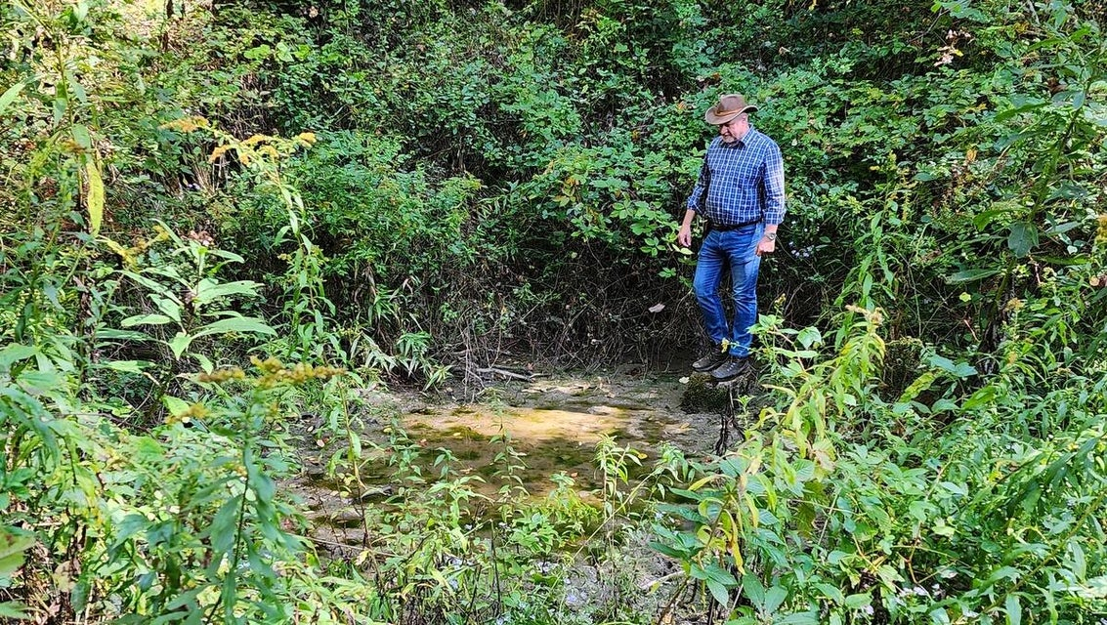
WATER
On the headwaters of Milam Fork of Barkers Creek, the property includes a dashed blueline stream, which carries water much of the year. It is fed by a bold spring, which provides water year-round and feeds a quarter-acre woodland pond. Other small springs are located elsewhere on the property.
STAR GAZING
Ideally suited for star-gazing and planet observation, the ridge-top fields on the property provide exceptional views north and west across a region of more than 70 square miles. The viewshed includes remarkably few light sources.
MINERAL RESOURCES
West Virginia is one of the states in the U.S. that have two ownership titles, those being SURFACE RIGHTS and MINERAL RIGHTS. A title search for mineral rights ownership has not been conducted. All rights the owner has will convey with the property. A mineral title search could be performed by a title attorney simultaneously with the surface title search..
BOUNDARIES AND SURVEY
The property is being sold by the boundary and not by the acre.
UTILITIES
Water: Springs
Sewer: None
Electricity: American Electric Power
Telephone: Cellular Carriers
Internet: Starlink, Satellite
ACCESS/FRONTAGE
The property’s access road connects to Egeria Road (Rural Route 1).
ZONING
Wyoming County is subject to some zoning and subdivision regulations. All prospective buyers should consult the county commission and its health department for details regarding zoning, building codes, and installation of septic systems.
PROPERTY TYPE/USE SUMMARY
Two ridge-top fields near the center of the property contain roughly eight acres. Two vintage log barns are located on the property, as well as a log spring house. The balance of the property is in various-age forestland.
DEED and TAX INFORMATION
Deed Information: Deed book 452, Page 502
Wyoming County, West Virginia
Acreage: 90.9 acres +/-
Real Estate Tax ID/Acreage/Taxes:
Wyoming County (55), West Virginia
Barkers Ridge District (2)
Tax Map 129 Parcels 2,3,4; Class 3;
2023 Real Estate Taxes: $218.50

PUBLIC SCHOOLS
Students living on the property are located within the Wyoming County School District and may attend Herndon Consolidated Elementary & Middle School, Wyoming County East High School, and Wyoming County Career & Technical Center.
HIGHER EDUCATION
The property is within an hour's drive of several institutions of higher education, including Concord University, Bluefield State College, Southern West Virginia Community College, New River Community and Technical College, and West Virginia University Institute of Technology.
AIR TRAVEL
Kee Field Airport near Pineville is a 35-minute drive from the property and includes an asphalt runway, 08/26, which is 3,701 by 60 feet. Mercer County Airport near Bluefield is a 50-minute drive and includes an asphalt runway, 5/23, which is 4,743 by 100 feet. Raleigh County Memorial Airport near Beckley is an hour's drive and includes two runways, 5,000 feet and 6,750 feet. The nearest large airport is Yeager International Airport, a two-hour drive from the property. Delta, Spirit, United, and American serve the airport. Its busiest domestic routes are Charlotte, Atlanta, Chicago, Orlando, and Washington.

ABOUT THE REGION
Flat Top Mountain is located in southern West Virginia, a region now best known for its national parks and high-mountain scenery. The area is bounded to the north and south by the headwaters of the Bluestone and Guyandotte rivers. Coal mining attracted thousands of miners and their families to the region in the early 1900s. However, much of the coal was mined out by the late 1900s, and the area has since become a preferred destination for outdoor adventure and leisure residency. The US-460 and I-77 expressways bound the region to the east and west, providing easy access to interstate commerce. Princeton (population 5,798 in 2021) is the largest nearby city, a drive of some 35 miles away. Bluefield (population 9,499 in 2021) is an hour's drive to the south. Beckley (population 17,024 in 2021) is an hour's drive to the north.
HISTORY AND PREHISTORY
Long before settlers of European descent arrived, the region had been an essential part of a prehistoric travel route across the Appalachian Mountains between the Atlantic Coast and the Ohio Valley. Several important trails used by Native Americans for more than 12,000 years led across the low gaps on Flat Top Mountain. Among the most important was a trail that crossed the mountain about two miles northeast of the property, leading between the waters of the Bluestone and Guyandotte rivers. The Shawnee in the 1700s notoriously used the trail to raid Virginian settlements in the New River valley.
Through the 1800s, the Flat Top Mountain region was settled by families that established farms throughout the highlands. Their descendants still account for a large part of the local population. Walker, Mills, McKinney, Milam, Reed, Lusk, Graham, Shrewsbury, and Shrewsberry are all familiar names in the region. Many small farms followed the wagon road that led along the summit of Flat Top.
In the early 1900s, the pastoral nature of the region was interrupted by the discovery of rich coal seams, and in 1909, the Virginian Railway tunneled through Clark's Gap, four miles southwest of the property, opening the region to a period of mining that would continue through recent decades. Small mining towns sprang up along the streams in the valleys below the highlands. Though mining continues in some areas, many former mining towns have become ghost towns and now attract tourists.

TOURISM & RECREATION
The area is now a chief destination for outdoor recreation and leisure living. Hiking, biking, hunting, paddling, and off-road motor touring are now primary draws to the area. State-designated all-terrain vehicle (ATV) trails attract thousands of vacationers to the region annually. Three sections of the Hatfield-McCoys Trail System converge near the property. Trout fishing has also become a popular draw in the area, and the nearby Bluestone and Guyandotte rivers have become well-known paddling streams ideal for kayaking and canoeing. The New River Gorge National Park and Preserve, the newest national park in the U.S., is a 45-minute drive east of the property. Winterplace Ski Resort, a 45-minute drive, attracts more than a million skiers annually.
DIRECTIONS
From Mullens, West Virginia, follow WV-16 west 2.3 miles to a left turn onto WV-10. Follow the latter south 12.4 miles to a left turn onto Flat Top-Egeria Road, a one-lane rural route. Follow east 2.8 miles to a left onto an unnamed gravel route. Follow the latter approximately 2,500 feet to a left turn into the driveway. (Approximate drive time: 30 minutes)
From Princeton, West Virginia, follow WV-10 north 18.3 miles to a right turn onto Flat Top-Egeria Road, a one-lane rural route. Follow east 2.8 miles to a left onto an unnamed gravel route. Follow the latter approximately 2,500 feet to a left turn into the driveway. (Approximate drive time: 35 minutes)
From Ghent (Winterplace), West Virginia, follow Odd Road west 5.4 miles to a right turn onto Flat Top-Egeria Road, a one-lane rural route. Follow west 10.6 miles to a right onto an unnamed gravel route. Follow the latter approximately 2,500 feet to a left turn into the driveway. (Approximate drive time: 40 minutes)

