Soils Map
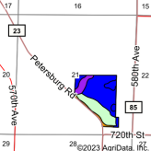

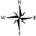
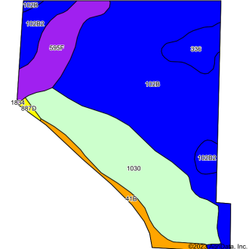
State: Minnesota
County: Jackson
Location: 21-101N-34W
Township: Petersburg
Acres: 75.6
Date: 12/11/2023
Soils data provided by USDA and NRCS.
Area Symbol: MN063, Soil Area Version: 20
Code Soil Description Acres Percent of field Non­Irr Class Legend Non­Irr Class *c 102B Clarion loam, 2 to 6 percent slopes 37.61 49.7% IIe 1030 Udorthents­Pits complex 20.25 26.8%
595F Belview loam, 22 to 40 percent slopes 7.00 9.3% VIIe 102B2 Clarion loam, 2 to 6 percent slopes, moderately eroded 4.24 5.6% IIe 336 Delft clay loam, 0 to 2 percent slopes 3.52 4.7% IIw 41B Estherville sandy loam, 2 to 6 percent slopes 2.66 3.5% IIIs 887D Clarion­Swanlake loams, 12 to 18 percent slopes 0.32 0.4% IVe Weighted Average *­
*c: Using Capabilities Class Dominant Condition Aggregation Method
*- Non Irr Class weighted average cannot be calculated on the current soils data due to missing data.
Soils data provided by USDA and NRCS.

