POPPE REALTY & MGMT LLC
1810 HARLAN ST
FALLS CITY, NE. 68355
402-245-5808 work, 402-245-0866 mobile
bpoppe@popperealty.com
www.popperealty.com

LAND FOR SALE

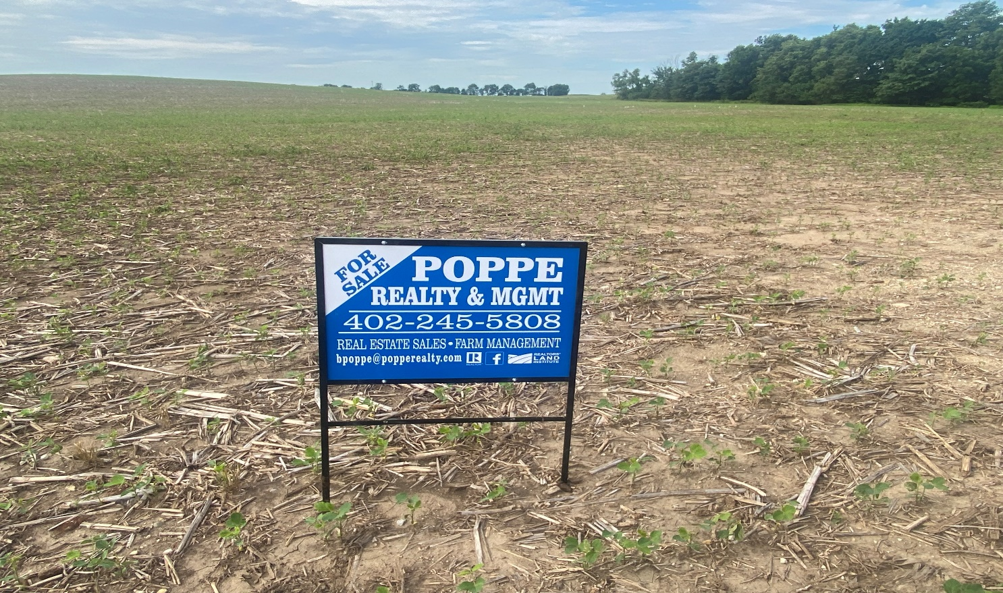

SELLER: Leattrice Ann Smith
- LISTED AT $830,000
- NE\4 Section 1 T-1-S, R-16-E Less RR ROW Brown County, Ks
- 124.82 Deeded Acres +\-
  - 108 Certified Crop Acres
- Terms:
  - Selling the property with the 2024 cash rent assigned to the buyer if closing occurs prior to August 1, 2024.

