

Terry A. Cheney Dre 01258906
Cell 530-624-2395 terrelalan@hotmail.com
Wesellagland.com
46.6 acres 4 parcels may be 5 with a parcel split 10-acre minimums
299 Thermalands Road Lincoln, CA. Placer County

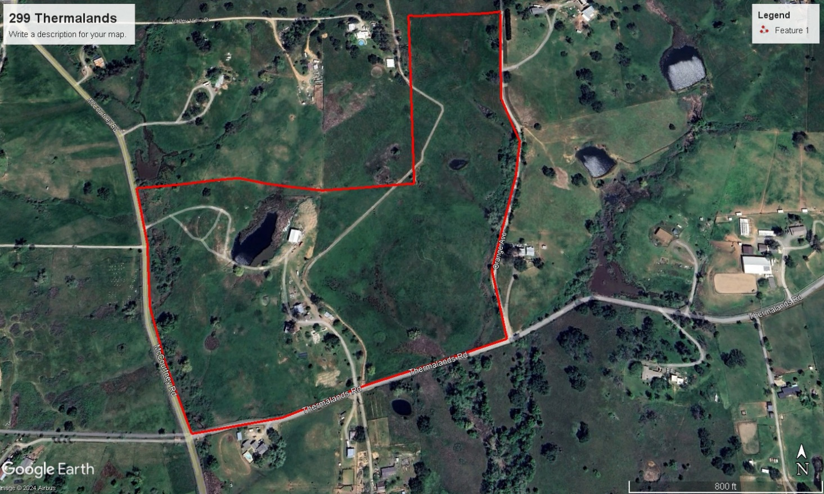
Spectacular property to build your dream home or homes on. 46.6 gross acres M/L in 4 legal parcels, could be 5 with a parcel split. Located in the desirable Thermalands community, which is known for its thermal climate that makes it a great place to grow crops. There are vineyards nearby. The property has a perimeter fence which allows for grazing animals. One parcel has an existing 1 bed/1 bath rustic home built in 2021, a 6-stall horse stable with a concrete breezeway and upstairs storage. Water for irrigation is supplied by Nevada Irrigation District (NID) and each parcel has its own diversion box. There are 3 ponds with water supplied by the NID. Zoning is P-B-X which allows for commercial agriculture, agriculture, and residential 10 acre minimums. The property has a 60X40 ft. shop with thick concrete floors and power. Buyer to verify all information. Short distance to Camp Far West Lake and Lincoln. Parcels may be sold separately. Asking $1,795,000.00

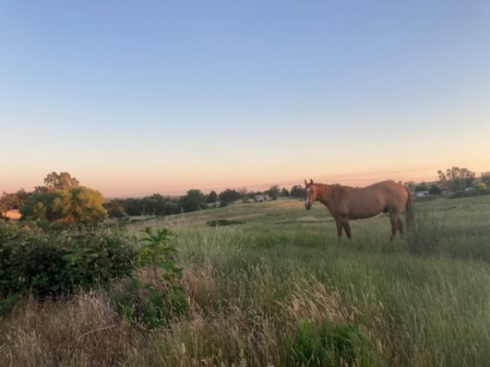 Perfect for horses or cattle.
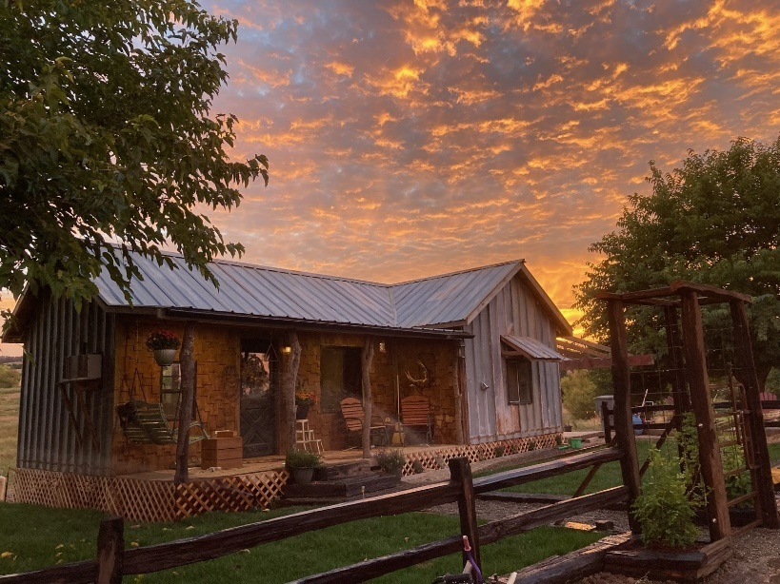500 Sf 1 bed 1 bath home
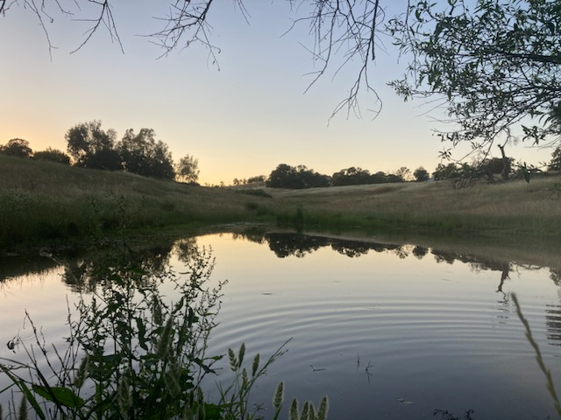 One of 3 ponds

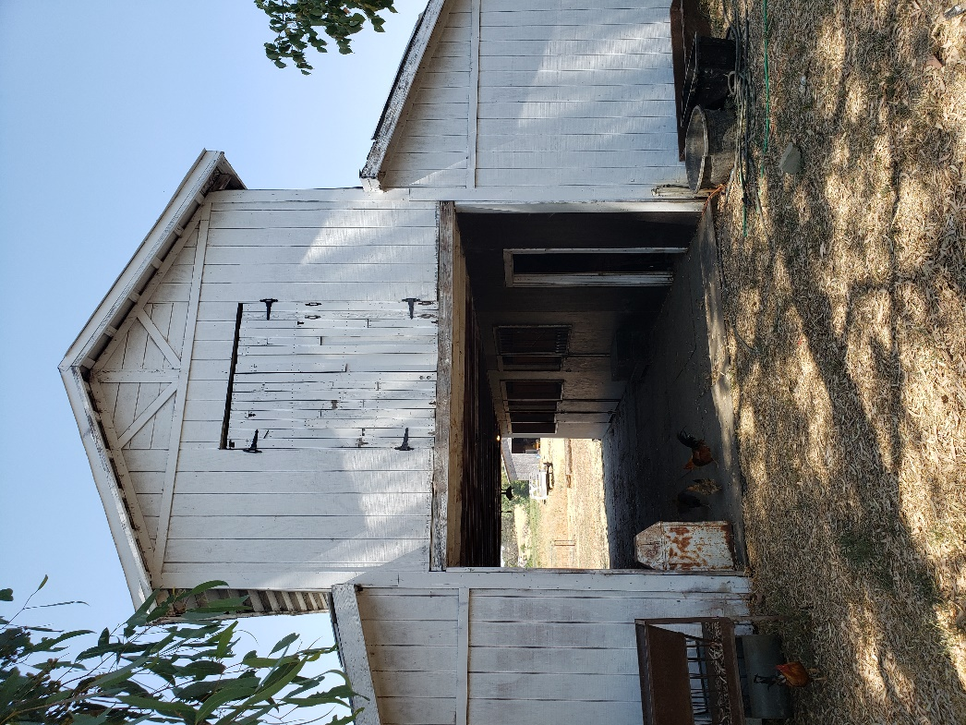 6 stall horse stables

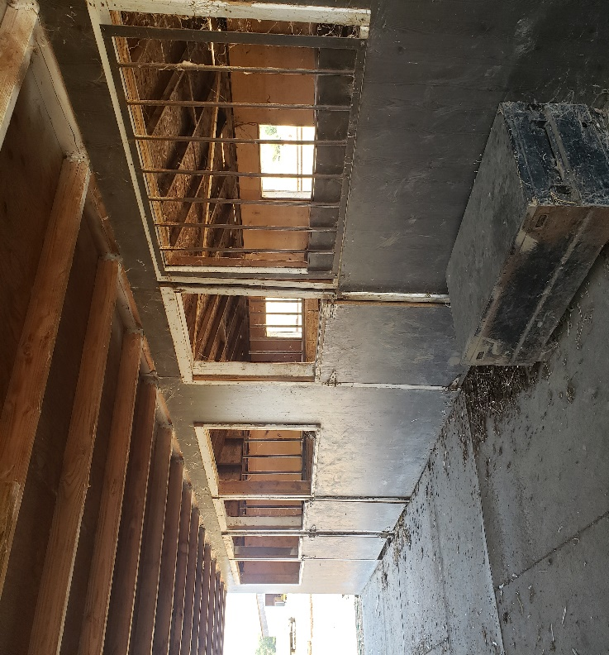 Stalls, concrete breezeway, upstairs storage
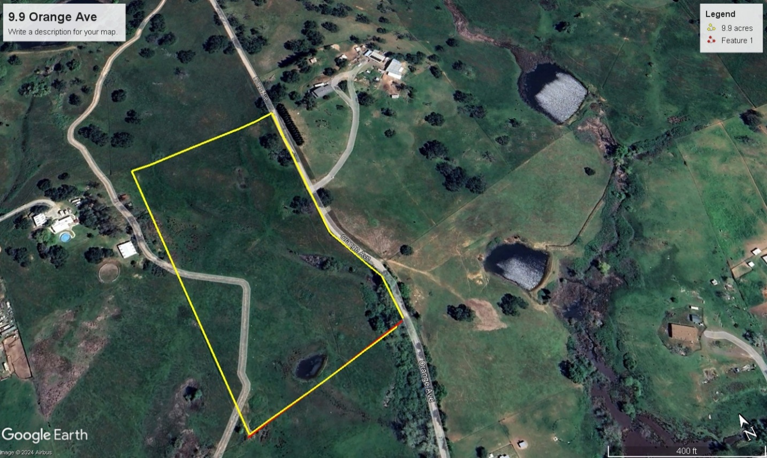

This 9.9-acre parcel can be sold separately. AP# 020-080-038 Located in the NE corner of the 46.6 acres road frontage on the west side of Orange Avenue. The parcel has irrigation water from the Nevada Irrigation District (NID). The 2 ponds are fed by NID. Asking $435,000.00

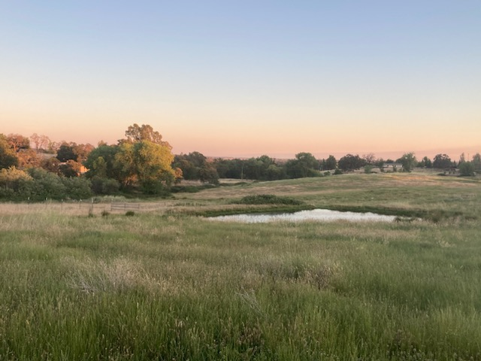

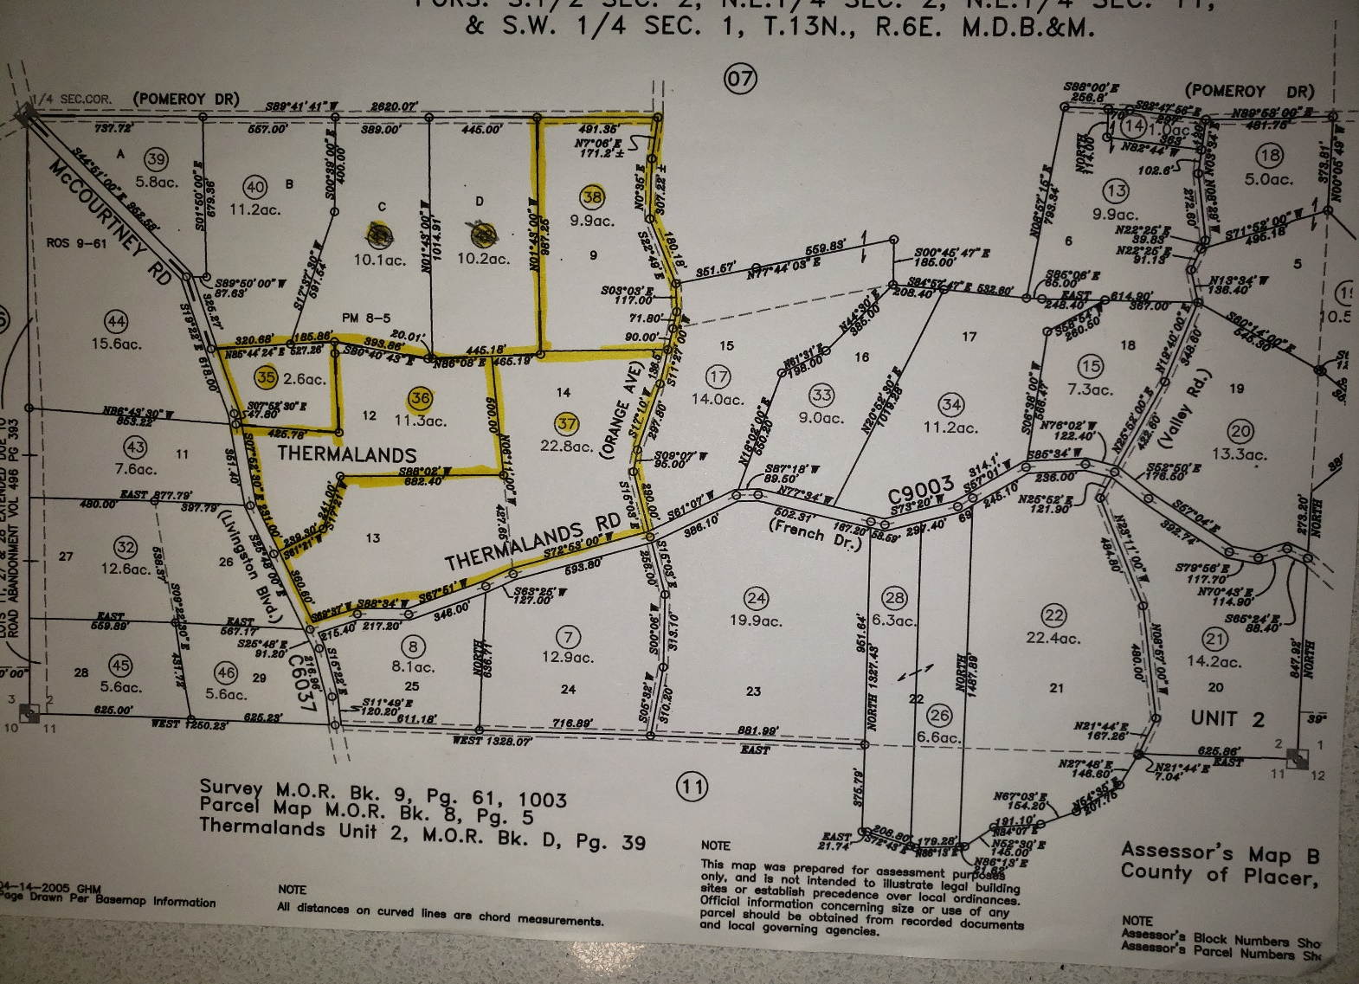

AP 020-080-035 (2.6 acres) No improvements
AP 020-080-036 (11.3 acres) Pond and 60X40 Shop
AP 020-080-037 (22.8 acres) (May be split, buyer to verify). Home, horse stable, outbuildings, and additional homesite.
AP 020-080-038 (9.9 acres) No improvements, 2 ponds
All parcels have irrigation water from NID and separate diversion boxes.

