Wagoner 180
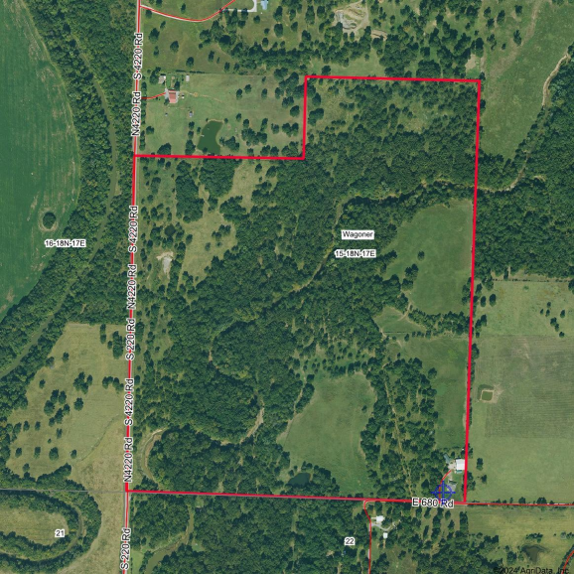

Boundary Center: 36° 2' 10.13, -95° 29' 20.95 15-18N-17E
0ft 640ft 1280ft
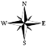


Wagoner County
Oklahoma
8/9/2024

