POPPE REALTY & MGMT LLC

1810 HARLAN ST

FALLS CITY, NE. 68355

402-245-5808 work, 402-245-0866 mobile

[bpoppe@popperealty.com](mailto:bpoppe@popperealty.com)

[www.popperealty.com](http://www.popperealty.com)

LAND AUCTION

SELLER: KEITH GERWECK ESTATE

TO BE SOLD AT PUBLIC AUCTION; NOVEMBER 8, 2024

10:30 AM FALLS CITY ELKS CLUB 1417 STONE ST FALLS CITY, NE

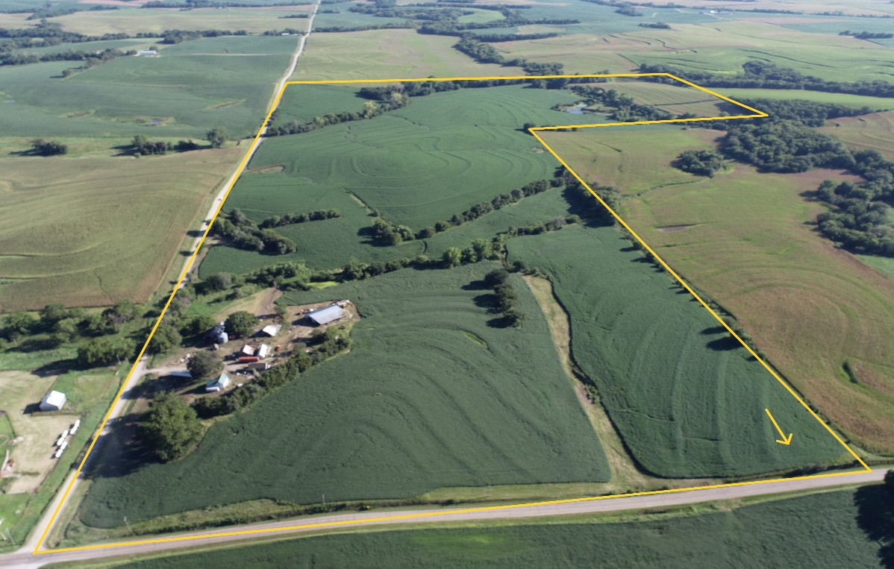

* TRACT 1: 160 Acres more or less
  + E\2 NE\4 and N\2 SE\4 Section 18 Township 2 North, Range 17 East
  + 124.0 Certified crop acres; 8.03 Acres Grass
  + Soil Types: 104.96 Ac Monona
  + 4 Acres farmstead with 3 BR home and outbuildings
  + 2023 Real Estate Taxes: $5,921.78
  + FSA Information: Corn Base Acres: 56.4 PLC Yld 96

Soybean Base Acres: 8.6 PLC Yld 30

* Driving Directions: From Falls City: 6 Miles North on Hwy 73; Turn right on 712 Road (dustless highway); Go 3 1\2 Miles East on 712 Road to 655 Ave. Farm is located on South side of 712 Road.

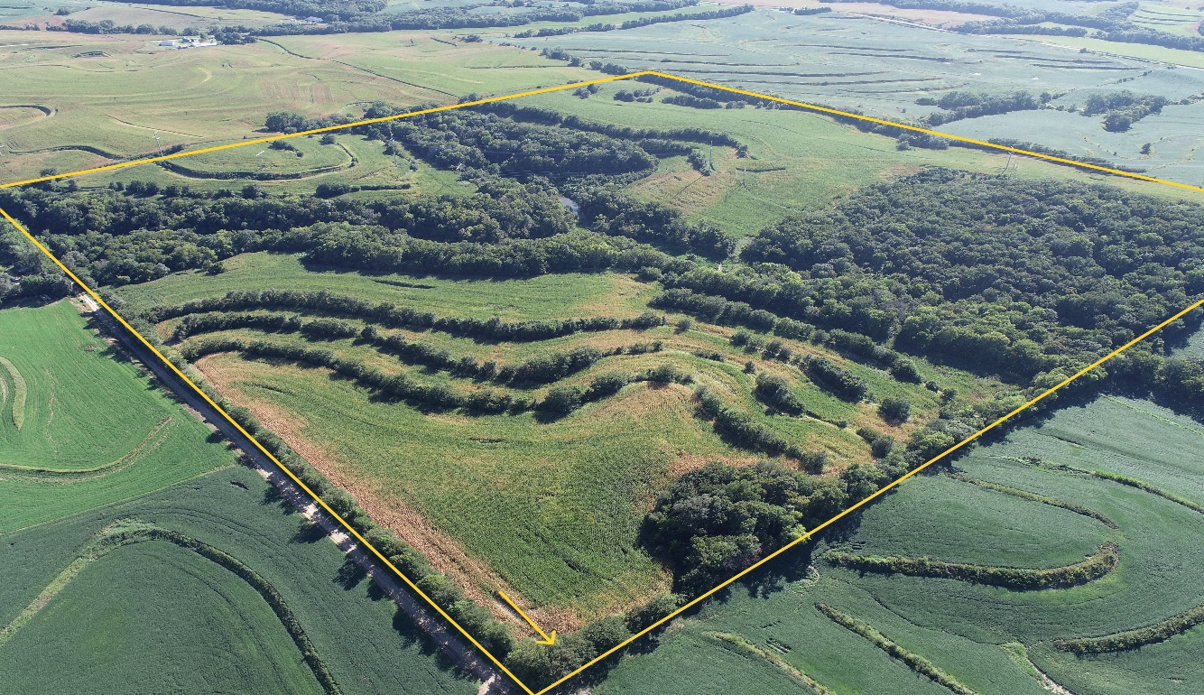

* + TRACT 2: 160 Acres more or less
  + NE\4 Section 11 Township 3 North, Range 16 East
  + 90.83 Certified crop Acres; 56.02 +\- Acres Timber
  + Soil Types: 87.25 Monona, 6.1 Ida
  + 2023 Real Estate Taxes: $4,582.30
  + FSA Information: Corn Base Acres: 67.9 PLC Yld 96

Soybean Base Acres: 26.9 PLC Yld 30

* Driving directions
  + From Falls City: 6 miles North on Hwy 73 to 712 Road; Go 1\2 mile East, turn left on 652 Ave; Travel 5 miles North to 717 Road, turn right, Go 1 mile East on 717 Road to Barada, turn left on 653 Ave; Go 1 1\2 miles North on 653 Ave, this will be the SE corner of the farm.
  + From Shubert: Beginning at Hwy 67 and 718 Road; Go 5 miles East on 718 Road (Note: the last mile of 718 road is a minimum maintenance road); turn left on 653 Ave and go 1\2 mile to the SE corner of the farm.
* Terms of the Auction:
  + A 15% non-refundable earnest deposit is required the day of the sale. The balance due will be at closing on December 10, 2024. A cashier’s check, money order, or wired funds will be required at closing. All mineral right owned by the seller will be conveyed to the buyer. The sale is subject to all easements, covenants, and restrictions of record.
  + The property will be Sold to the highest bidder, subject to Seller’s approval.
  + Possession: The buyer will receive full possession for the 2025 crop year. Possession is subject to the rights of the current lessee until February 28, 2025. The 2024 real estate taxes will be paid by the seller. The 2025 and subsequent years will be paid by the buyer. The seller will provide an owner’s title insurance policy on the property. The cost of the title insurance will be split equally between the seller and the buyer. The buyer is responsible for all loan policies.
  + The information provided was obtained from reliable sources but the accuracy of the information is not guaranteed. All interested parties are encouraged to inspect the condition of the property and rely on their own information. Announcements the day of sale take precedence over printed information. Poppe Realty & Mgmt is the agent for the seller.