Pemberton Management Plan
Owner(s) Names: American Stave Company
Owner(s) Mailing Address: PO Box 104, Lebanon, MO 65536
Owner(s) Email Address: garret.nowell@independentstavecompany.com
Owner(s) Phone Number(s): 662-212-3496
Owner(s) Signature:
Plan Author: Jeffrey F. Lewis
Plan Author Mailing Address: 10 Cave Run Court, Morehead, KY 40351
Plan Author Email Address: jeffrey.lewis@independentstavecompany.com

Plan Author Phone Number: 606-548-7594
Plan Author Signature:
Date of Original Plan Completion: 09/12/2024Revision date(s):
Please note: Informal updates to the plan can be made with handwritten notes. Be sure to include a date and initial these notes throughout the management plan.

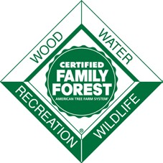

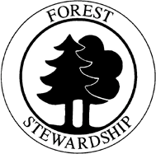

TABLE OF CONTENTS
Contents
Property History and Existing Condition 4
Forest Management Goals: 7
Property Map 8
Forest Natural Resources Enhancement and Protection 9
Protect Special Sites & Social Considerations 9
Air, Water, and Soil Protection 10
Fish, Wildlife, & Biodiversity 14
Management of Forest Resources 15
Stand Level Information 17
Stand 001, 002, 003, 004 Objectives 17
Stand 001, 002, 003, 004 Current Conditions 17
Stand 001, 002, 003, 004 Desired Future Stand Conditions 18
Stand 005 Objectives 21
Stand 005 Current Conditions 21
Stand 005 Desired Future Stand Conditions 22
Monitoring 25
Management Activity Schedule for Tracking 27
Signatures and Approvals 28

This template should be used in association with the landowner and the forester guides which include detailed instructions on how to correctly complete the template to develop a management plan that will meet the requirements for the American Tree Farm System (ATFS), Natural Resources Conservation Service (NRCS) and the US Forest Service. Please refer to the guide when working with your forester or natural resource professional to develop your plan.

This template was developed by the US Forest Service, Natural Resources Conservation Service (NRCS), and the American Forest Foundation’s American Tree Farm System (ATFS) using information from the following state joint Forest Stewardship, ATFS and NRCS templates:
- Mississippi Forest Stewardship Management Plan developed by the Mississippi Stewardship Forest, Mississippi Forestry Commission and the US Forest Service
- Missouri Common Forest Plan Format developed by the Missouri Department of Conservation and NRCS
- Montana Forest Stewardship Plan/Tree Farm Plan developed by the Montana Forest Stewardship Program, Montana Tree Farm Program, Montana State University Extension, Montana DNRC, US Forest Service and NRCS
- Oregon Forest Stewardship Plan Template develop by Oregon State University Forestry Extension Program

Thanks to the following reviewers: Tim Albritton, Dean Berry, Karen Bennett, Jill Butler, Dave Casey, Linda Casey, Jim Cathcart, Bill Chaney, Wade Conn, Dean Cumbia, Robert Etheridge, Jonas Feinstein, Carri Gaines, Nate Goodrich, Andy Henriksen, Joe Holmberg, Debra Huff, Gary Johnson, Bob Logar, Leah MacSwords, Naomi Marcus, Carol Nielsen, James Poole, Robert Radspinner, S.R. Raymond, George Rheinhardt, Steve Smith, Raymond Sowers, Rich Steensma, Pam Synder, Rob Wait, Doug Wallace, and Daniel Wand.
Property Description
Legal Property Description: This plan will assess forested and unforested conditions on approximately 302 acres in Calloway County, Missouri. The land is a contiguous tract lying and being in Calloway County, Missouri situated on a ridge between Crows Fork, Race Hollow and Lawrence Hollow in the south half Section 25 and east half of Section 36 all in Township 47 North, Range 09 West.
Nearest City or Town: Fulton, Missouri
Tax Parcel Number (optional): 13-07.0-25.0-00-000-010.000, 13-07.0-36.0-00-000-001.000, 13-07.0-36.0-00-000-004.000
FSA Farm and Tract Number (if applicable):
GPS Coordinates (optional): 38.8091722°N, 91.8764669°W
Total Ownership Acreage: 302 Total Forested Acreage: 261
Total acreage covered by this plan: 247
Number of unique forest stands in this tract: 2
Do you reside on the property ☐ ☒
Yes No
Basic topography (estimate percent of total acreage that is)
- Complex topography (many steep ravines and aspects): 10
- Simple topography (few ravines and changes of aspect): 90

Percent of land that is:
- Flat (<5% grade) 0
- Gentle Slope (6 to 20% grade) 92
- Steep Slope (> 21% grade) 8
Road Conditions (check):
☒ Excellent (80% Accessible) ☐ Good (50% Accessible)
☐ Fair (25% Accessible) ☐ Poor (10% Accessible)
Estimated improved road length (bulldozed with graveled surface): 0.6 mile
Estimated unimproved road length (bulldozed with but original soil/bedrock): 1.5 mile
Which watershed is the property located in (include appropriate watershed unit for your state): 103001021507, Crows Fork Creek

Property History and Existing Condition
History: This tract was part of a larger ownership that has been owned by the same owner for the last several decades. Those owners managed the land farm-lot property and would selectively harvest timber, hunt, and produce hay for their benefit. The presence of many old fences crossing the forested portion of the property indicates a history of grazing.
The effects of this ownership history have resulted in this tract containing a variety of forest and land cover conditions. Approximately, 67 acres could be considered non-forest as the result of clearing for pasturage, hay production, and for a powerline right-of-way several decades ago. (See Figure 3, Stands 2 and 4) There is also one pond on the property. (Figure 3, Stand 5)
The remaining 261 acres are forested and will be the focus of this plan. 247 acres are covered by sawtimber-sized stands with a history of free-thinning. (Figure3, Stand 1) This stand will be the focus of management for the next decade. The remaining 14 acres are low-stocked riparian forest adjacent to Crows Fork and will not be managed this decade. (Figure 3, Stand 3) The fully stocked upland forests will be the focus of the rest of this plan.
Inventory and Assessment Process: Inventory for the overstory trees (5 inches DBH and greater) on the property included the establishment of twenty-four (24) horizontal point sampling locations and using a 20 basal area factor (BAF) prism for selection of sample trees. This sampling yielded a 30.6 percent standard error at the 95% confidence level.
Trees less than 5 inches DBH down to one foot tall were assessed using thirty-two 1/100-acre fixed area plots. This sampling yielded a 26 percent standard error at the 95% confidence level.
Existing condition: The following will discuss various aspects of tract as a whole. Some discussion related to individual stands will be discussed as appropriate.
Tree Species composition: The species composition of the upland portion of the property (Stand 1) according to the current inventory is presented in Figure 1. The area is current a mixed oak community.
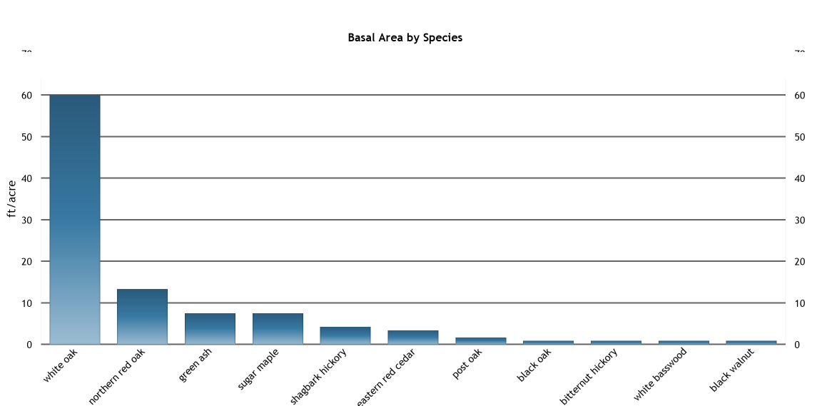
Figure 1: Species composition of the upland forest
Since the majority of the species on the tract are species that rely upon advance reproduction for successful regeneration, understanding the composition and density of seedling and sapling populations is needed to understand the existing condition of the forests. Figure 2 presents the density and size of the regeneration on the tract.
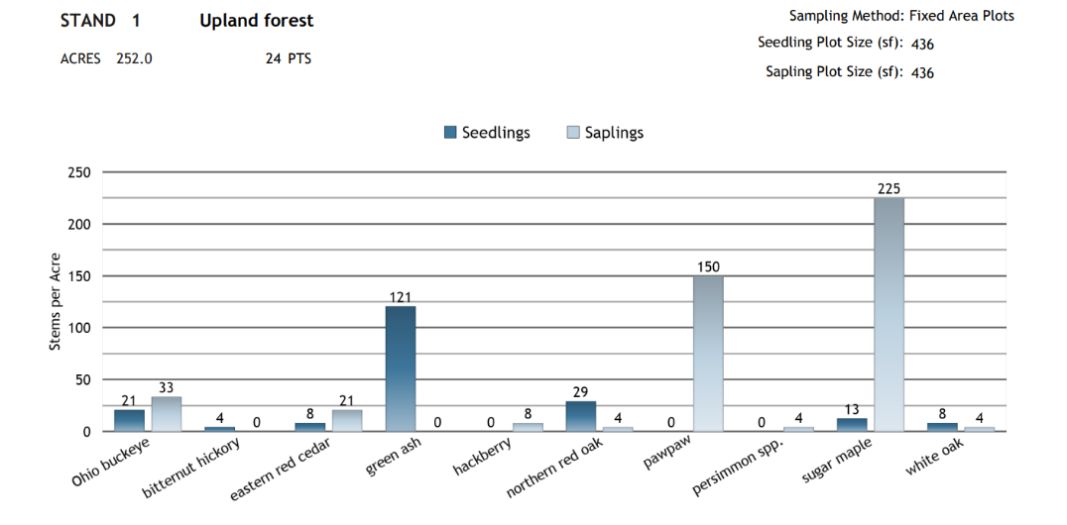
Figure 2: Seedling and sapling composition and density on the upland forest
The current populations of advanced regeneration are fairly sparse except for sugar maple, mainly due to the lack of sunlight reaching the forest floor. Based upon the current population of advanced regeneration, absent any management to expose the forest floor to more sunlight the upland forested areas will move toward a northern hardwood species mix (sugar maple dominated). The current species mix can be encouraged by management that exposes the forest floor to more sunlight to encourage seedling establishment or stump or root sprouting.
Landcover: The current property level inventory records the landcover for the property in broad categories. These are:
- Non-forest: grassland, utility line, corridors, and other areas not covered by trees.
- Open bottomland forests: sparse canopied forested areas where the majority of trees are bottomland hardwoods.
- WO, BO, NRO: forested areas where the majority of trees are oak species.
Overall, 82% of the property is covered by oak forests. Followed by non-forested areas, consisting of a grasslands and a utility corridor, that cover 12% of the property. The remaining 6% is in open bottomland forests.
Forest age: Inventory data collected estimates and effective overstory age of 94 years for the upland forest. Maturity is expected with 22 years.
Merchantable class: The current inventory for the property tracks forested areas tree-size by merchantability class. This variable also presents some tree density information. These are tracked by:
- Merchantable: Areas where the average diameter of the trees is over 12”. Tree density is fully stocked or higher.
- Merch-thinned: Areas where the average diameter of the trees is over 12”. Tree density is less than fully stocked but over non-stocked.
- Premerchantable: Trees are less than 12” diameter.
Currently, 100% of the area is Merchantable.

Forest Management Goals:
This property is to be managed for the following goals over the next decade:
The desired condition of this property is a healthy forest consisting of tree species adapted to the site, resilient enough to respond to predicted changes in the environment, and able to provide periodic harvests of wood products while providing for the enjoyment of the wildlife and sustaining water quality.
- Harvest timber is support of company’s goals in a sustainable manner.
- Lease land for hunting and agriculture where compatible with other goals.
- Ensure that existing oak forests continue to be oak forests.
- Increase amount of oak present on appropriate locations.
- Bring road system to Kentucky BMP standards as part of management.
- Certify land as sustainably managed under a third-party certification system.
Planned activities:
The goals will be attained by a mixture of commercial harvest, forest stand improvement, and various lease agreements. The amount of each planned for the decade includes:
- Commercial timber harvest: 247 acres
  - Improvement harvest: 0 acres
  - Regeneration harvest: 247 acres
- Forest Stand Improvement: 247 acres
  - Midstory removal: 0 acres
  - Crop tree thinning/release: 247 acres
- Leases 302 acres
  - Hunting: 267 acres
  - Agriculture 35 acres

Property Map
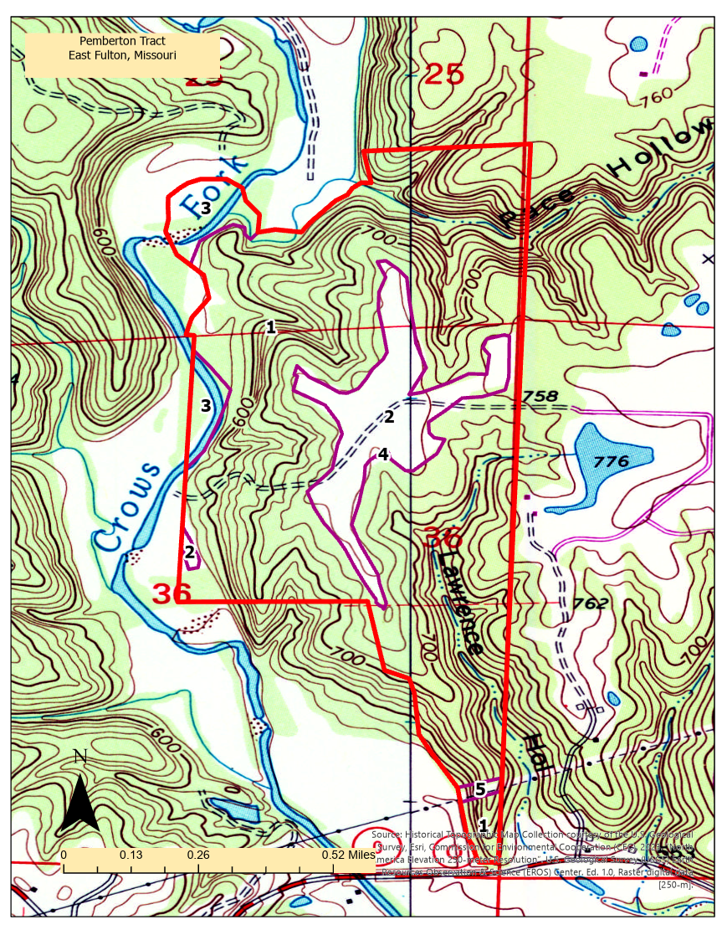
Figure 3: Landcover and merchantability class

Forest Natural Resources Enhancement and Protection
This section relates to the natural resource elements found throughout the entire property. Some of the treatments related to these resources may qualify for federal and state assistance programs. For this section, include appropriate activities and treatments in the Management Activity Schedule and Tracking table as well as on the map(s). Complete the Activity Schedule and draw and label the areas of management on the map if using this plan as part of an assistance program application. There is no need to repeat this information in the stand specific section.
For each resource element, consider:
- What treatments/monitoring/protection are planned?
- When will you implement treatments (season, year), follow-up activities, etc?
- Where will the management take place: entire stand, part of a stand, acres?
- Do you have applicable permits, professional assistance, and applications for the assistance programs?

Protect Special Sites & Social Considerations
Special Sites and Forests of Recognized Importance:
Special sites: This tract does not contain known special sites like old homesites, old roadbeds, and cemeteries. The older USGS mapping (1900 to 1930 vintage) for the area identifies a homesite near the middle of the pastureland on the ridge. A ground survey of the area found no current evidence of that structure. Management activities are and will be designed to avoid damage to these resources if any are found during management.
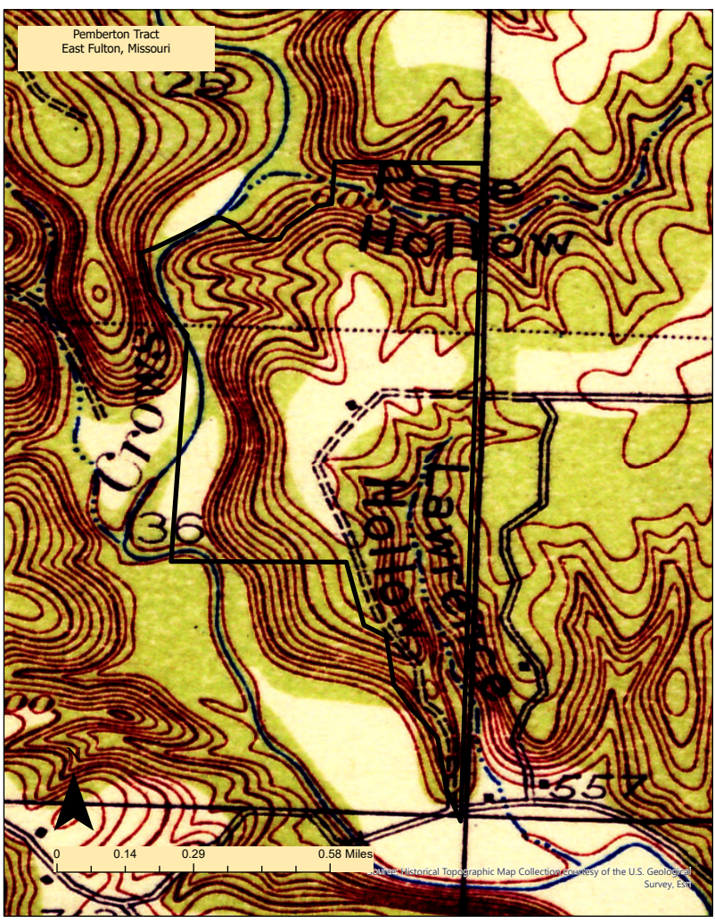
Figure 4: Older USGS mapping displaying potential structure on the property
Forests of Recognized Importance: The tract contains a small amounts of exposed rock outcrops on the shoulders of the ridgetops and areas of potential sinkhole formations as show in Figure 5. These resources will be protected by limiting equipment use and tree removal near these features.
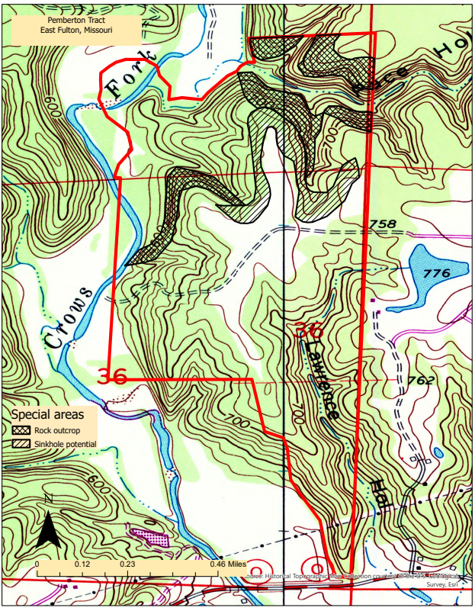
Figure 5: Special areas on the property
Adjacent Stand Ownership Concerns:
As is typical forested land, property boundaries are complicated, confusing, and subject to interpretation on this tract. However, a survey of the property using a licensed surveyor was completed prior to purchase which included marking, restoring or establishing the property corners described in the deed. No known issues related involving adjacent landowners exist. As management is implemented, contact will be made with adjoining landowner as encouraged by state law. Any concerns discovered during management will be addressed prior to implementation.
Before any harvest activities, effort is to be made to contact all adjacent landowners in person and through mail to maintain good neighborly relations or to resolve any potential disputes.
Recreation:
Hunting is the primary recreational use of this tract and that is managed though a hunting lease for the entire property. Maintaining hardwood forest cover is critical for protecting the ability of the site to support this activity. Also, developing treatments to enhance mast production and maintain a diversity of habitats will be enhance this use.
Access:
This tract is well accessed from public roads and internal roads on the property.

Air, Water, and Soil Protection
What goals do you have, or what steps will you take to conserve, protect and enhance your forest’s air, water and soil resources?
Soil and site descriptions
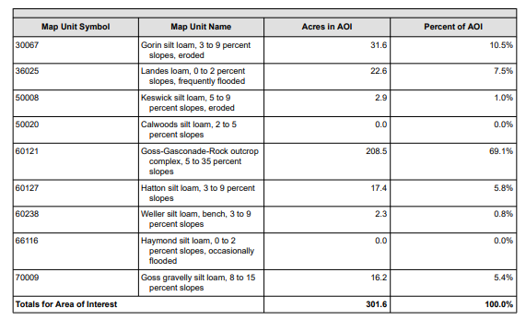
A custom soil resource report was prepared for this property and is provided along with this plan. Figure 6 presents a summary the of mapping units identified on the tract with respects to the amount of the property they cover. Figure 7 displays how the mapping units are arranged spatially on the tract.
Figure 6: Soil types mapped on the tract.
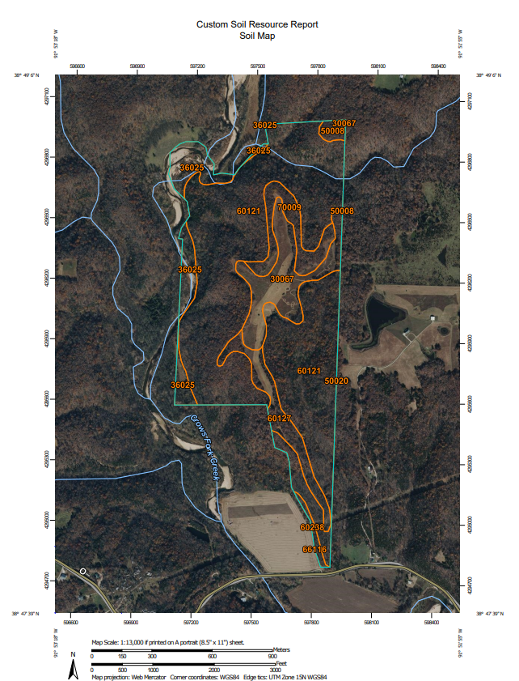
Figure 7: Soil Mapping
The largest portion of the property is mapped with the Goss-Gasconade-Rock outcrop complex, 5 to 35 percent slopes mapping unit which covers 209 acres. The rest of the tract is fairly well split between the eight mapping units. Each mapping unit has unique characteristics. The soil report discusses these in detail and the stand-level discussions will address concerns unique to that location. This section of the plan will summarize those most relevant to forestry and land management activities.
Prime Farmland: Prime farmland, as defined by the U.S. Department of Agriculture, is land that has the best combination of physical and chemical characteristics for producing food, feed, forage, fiber, and oilseed crops and is available for these uses. Due to those characteristics, many of these areas may also be attractive for development as housing or industrial sites and be lost to agricultural uses. These characteristics are assessed and tracked by soil mapping units.
This property contains three soil mapping units that are identified as a Prime Farmland. One (map symbol 66116 in Figure 7) is classed as ‘All areas are prime farmland’ and are mapped covering less than an acre of the property adjacent to the fields located at the southwestern edge of the property. The proposed activities in these areas should preserve the attributes associated with Prime Farmland.
Another (map symbol 60238 in Figure 7) is classed as ‘Farmland of statewide importance’ and are mapped covering 2 acres of the property also adjacent to the fields located at the southwestern edge of the property. The proposed activities in these areas should preserve the attributes associated with Prime Farmland.
The final mapping unit (map symbol 36025 in Figure 7) is classed as ‘Prime farmland if protected from flooding or not frequently flooded during the growing season’. This unit covers 23 acres of the property and is the areas adjacent to Crows Fork Creek that crosses the property. As this soil is very wet there is not a high probability it will be developed in such a way as to remove it from potential agricultural use.
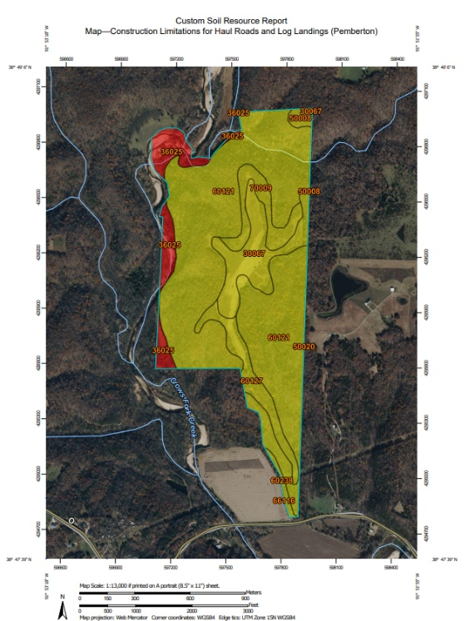
Hydric Soils: Hydric soils are defined as soils that formed under conditions of saturation, flooding, or ponding long enough during the growing season to develop anaerobic conditions in the upper part of the soil profile. Two mapping units where less than 5% of the area meet hydric criteria. These are mapped as 66116 and 70009 in Figure 7.
Figure 8: Soils with limitations related to haul roads and landings by rating.
Construction limitations for haul roads and log landings: Table 1 presents a summary of the amount of area in the tract with limitations on use for haul roads and landings. 7% of this property, displayed in ‘Red’ in Figure 8, was rated “Severe” in relation to construction of haul roads and log landings. This rating is due to flooding, wetness, and low strength. The remaining 93%, displayed in ‘Yellow’ in Figure 8, was rated “Moderate”. This rating is due to low strength.
Table 1. Summary of ratings: Construction limitations for haul roads and landings
Rating | Acres | Percent
Moderate | 279 | 93%
Severe | 23 | 7%
Slight | 0 | 0%
Totals for Area | 302 | 100%
These will be addressed if the need for new construction arises by locating the roads on the locations with design features that address landslide potential (increased drainage, out-sloped roadbeds), minimizing road construction, and applying stone as needed to minimize soil movement.
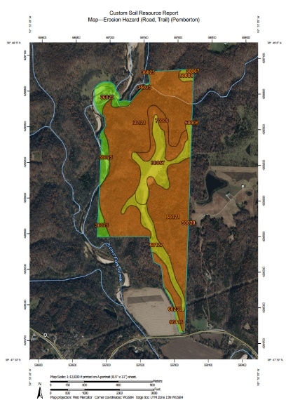
Erosion Hazard (road, trail): Table 2 presents a summary of the rating for erosion hazard for roads and trails during use. 75% of this property, shown as orange in Figure 9, was rated “Severe” due to slope/erodibility. 18%, shown in yellow in Figure 9, was rated “Moderate” due to the same factors. The remaining 7%, shown in green in Figure 9, was rated “Slight”.
Figure 9: Erosion Hazard rating related to use of roads and trails.
Table 2. Summary of ratings: Erosion Hazard for road and trail use
Rating | Acres | Percent
Slight | 23 | 7%
Moderate | 54 | 18%
Severe | 225 | 75%
Null or not rated | 0 | 0%
Totals for Area | 302 | 100%
These will be addressed maintaining design features that address maximize drainage of the roads (stone surfacing, out sloping, cross drainage, etc.) and avoidance of steeper areas for road development where possible.
Roads:
The tract has one main private access road directly off State Highway O and provides access to center of the property, including the fields on the ridge. This road crosses the entire property and leaves on the eastern edge and also accesses the property of adjoining landowners.
Maintenance of these has historically been a shared venture between the landowner, agricultural lease holders, utility owners, and adjoining landowners and has mainly been undertaken as activities require. The road is in good condition.
There are several equipment access routes (skid trails, farm access, etc.) on the property as well as old mineral development roads. These are generally well-healed over and readily opened for use when management needs arise. They are maintained during use by leasees or contractors.
Streams, Wetlands, Ponds, Lakeshore:
The property borders Crows Fork a large perennial stream to the west. There is one pond and two intermittent streams (Lawrence and Pace Hollows) located on the northern and southern ends of the property. Several ephemeral streams are present on the property feeding Crows Fork, Lawrence Branch, and Pace Branch.

These water features will be managed by applying Missouri Best Management Practices to protect and enhance these resources.

Effects of Natural Disasters:
Strong winds from the past have created blow downs and snags.
Rangeland Resources (If applicable)
The property has 36 acres of grassland being managed through an agricultural lease for both hay. This agreement provides for the protection of soil and water by requiring compliance with all relevant laws. The lease areas are monitored for compliance.

Fish, Wildlife, & Biodiversity
Describe the resources on your property and the activities you are planning to accommodate your goals.
Forestland Habitat Index
This property contains both pastureland and forestland. The pastures are primarily managed for hay and cattle grazing. Areas for improvement include invasives management in the fields, creating unmoved buffers between forestland and pasture, and rotating harvests for hay and implementing regular burning as a means of encouraging pasture health.
The forestlands house multiple stages of succession and endangered habitats like cedar glades.
Hard Mast
Hard mast such as hickory nuts, acorns and beech nuts are foods that can be consumed immediately or stored for use during the winter season. They are required by many wildlife species, including bears, squirrels and mice. The stand has 78.3 sq.ft. of trees that produce high-quality hard mast (White oak, Northern red oak, Shagbark hickory, Post oak, Black walnut and Black oak), and 15.8 sq.ft. of other hard mast producers (Sugar maple, Green ash, American basswood and Bitternut hickory). The understory data has two species that produce high-quality hard mast (Northern red oak and White oak) and two of other hard mast producers (Hackberry and Sugar maple).
Soft Mast
Soft mast (fruits), such as cherries and berries are high energy foods required by many wildlife species including bears and many species of migrating songbirds where high energy sources are of key importance during fall migration. The stand has 3.3 sq.ft. of trees that produce high-quality soft mast (Eastern redcedar), and 0.8 sq.ft. of other soft mast producers (American basswood). The understory data has four species that produce high-quality soft mast (Eastern redcedar, Hackberry, Pawpaw and Persimmon) and no other soft mast producing species.
Insects and Nectar
The pasturelands on the property provide abundant potential for pollinator habitat and forage; however, proper management for invasives is essential to ensure pollinator habitat's success. In the forestlands planting of annual grasses, the neighboring landowner has recommended wheat, after harvest will aid in the regeneration of early successional species by birds. Slash management will be essential to ensuring successful regeneration of this habitat following the harvest.
This property has three species that provides exceptional additional wildlife food in the form of insects and nectar totaling a basal area of 63.3 sq.ft. (White oak, Shagbark hickory and Bitternut hickory). Another ten species totaling 90.8 sq.ft. provide some additional food value (White oak, Northern red oak, Sugar maple, Shagbark hickory, Eastern redcedar, Post oak, American basswood, Bitternut hickory, Black walnut and Black oak). The understory has two species that provides exceptional additional wildlife food in the form of insects and nectar (Hackberry and White oak). Another four species provide some additional food value (Eastern redcedar, Northern red oak, Pawpaw and Sugar maple). These additional food resources support many songbirds and pollinators.
State and Federal Threatened or Endangered Species – Plants or Animals
This property hosts several types of habitats for endangered or threatened wildlife. Shagbark and Shellbark hickory on the property provide summertime habitat to maternal colonies of the endangered Indiana Bat. It is advisable to leave mature trees of these species standing.

Management of Forest Resources
Protection from Pests
Tree density, overstory age, and advance reproduction status are the main threats to forest health in the project area. However, due to the history of management on the property, density and age issues are not widespread. Advance reproduction status is still an issue on most of the oak forest adapted sites in the project area. The thinning and regeneration harvests should increase the vigor of the forests on the property thereby make them more resilient in the face of pest infestations. Midstory control should address improving the status and health of advance reproduction. During the tract-specific assessments, each area will be assessed for the risks unique to that area.
Invasive plants, specifically lespedeza sericea, are present in the fields on the property. Recommendations for treating invasives include burning, grazing, mechanical, and chemical treatments. All these recommendations will improve the presence of invasives and open the ground for native plants.
Reforestation and Afforestation
Natural regeneration will be the primary means of ensuring reforestation following management activities. Planting may occur on a limited basis if the tract-specific planning identifies a need for that. None is planned at present. No afforestation is planned at this time.
Prescribed Burns
Prescribed burning on the fields on the property would be advised to control invasive lespedeza. Burning could take place in the late spring (May 15 – June 30) to be followed by intense grazing by goats or cattle, or in the fall (September 1-21) to be followed in the spring by mechanical or chemical treatments.
Burning in the fall would also improve overall pasture health and output for grazing or hay production the following spring.
Prescribed burning is not planned in the forested areas at this time.
Management Plan Implementation Constraints
There are no implementation constraints other than those required by law.

Stand Level Information
For each stand, write what your management objectives are and a brief description of the stand and its current and desired future conditions as well as the management activities. Further detailed inventory/plot data can be included if desired.

Stand 1 Objectives
Stand Acres: 251
Objectives: The objectives for the next decade for this stand to meet the goals for the tract include:
- Harvest commercial wood products where possible while meeting other objectives for the stand.
- Enhance over all stand vigor by removal of less vigorous trees (usually in the larger size-classes).
- Increase stocking and size of oak advance reproduction by increasing light to the forest floor in moderate amounts.
- Reduce the density of mesic species in the mid- and under-story to provide growing space for oak seedlings and saplings.
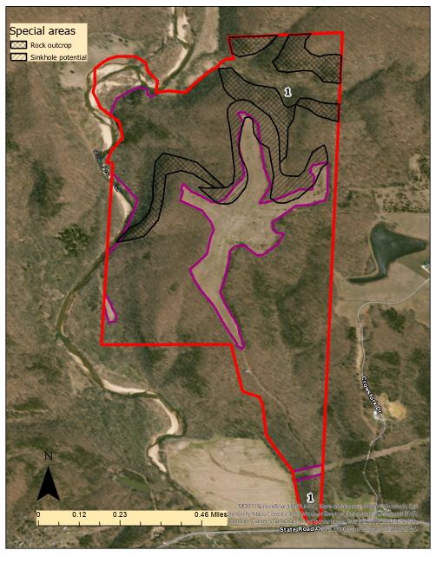
Figure 10: Map of Stand 1 with special areas

Stand 1 Current Conditions
Forest conditions: The current forest type is Mixed oak and includes White oak, Northern red oak, and Shagbark hickory.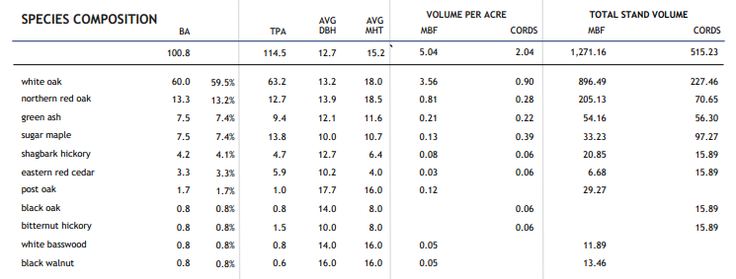
Figure 11: Summary of species composition
This is a medium sawtimber stand, with average diameter of 12.7 inches. The distribution of diameters in the area is pyramidal with a peak at 16 inches in diameter. The tails of the distribution are skewed to the smaller diameters indicating a history of partial harvesting that has resulted in the establishment of younger trees. The data is also sorted by tree quality. 82% of the trees in the stand are considered acceptable growing stock. The Figure 12 displays the distribution in graphical form.
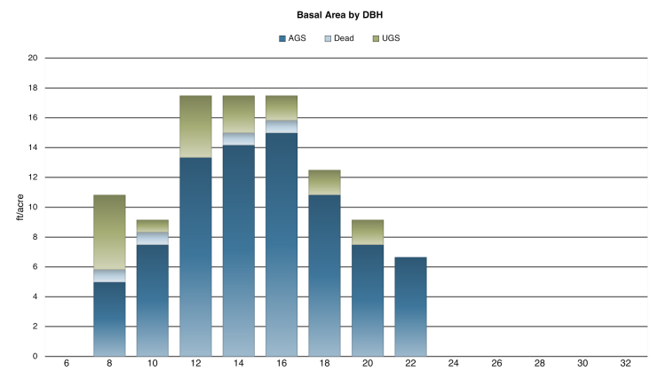
Figure 12: Diameter distribution of trees by quality
Total growing live trees amount to 101 sq. ft. of basal area per acre. Net total volume in all trees, to a 4-inch top, is 26 cords per acre; if divided into pulpwood and sawtimber, the net merchantable volume is 2 cords of pulp wood and 5,040 board feet of sawtimber (Doyle log rule) per acre.
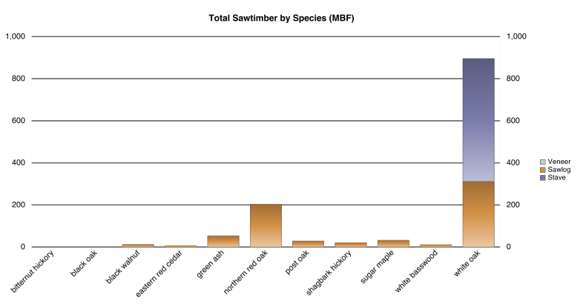
Figure 13: Merchantable volume of trees by estimated product class
Tree density is 81 percent of the average maximum expected in undisturbed forests of similar size and species composition. This density is higher than the optimum range for best individual tree growth. At this density, growth rate of the biggest trees is probably moderate, while growth rate of the medium and smaller-sized trees is probably fair and mortality due to crowding moderate.
Reducing the number of trees per acre to provide more growing space for the better stems is desirable at this time. The largest diameter classes (>18 inches) are reaching maturity for some species and a harvest focused on the removal of stems in those classes and less vigorous stems in all size classes would be beneficial in maintaining vigor. Effective stand age is about 94 years.
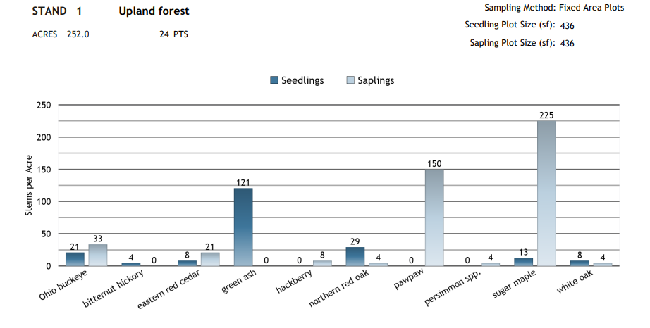
Figure 12: Seedling and sapling populations by species, Stand 1
The seedling and sapling populations in the stand are relatively abundant in number and diversity. This reflects a somewhat open canopy in the larger sizes of trees. However, the species composition of the smaller trees is different than the larger trees. The smaller tree population is dominated by species more tolerant to shading and thrive in moister conditions. In this stand, this condition will generally result in a reduction of the number of different oak and hickory species present in the future. Oaks and other larger seeded species rely upon the presence of smaller trees of their species being present on the forest floor to replace them in the canopy when an opening occurs through management or natural events. Management activities that provide dappled sunlight to the forest floor may allow for the establishment of more oak and hickory species.
Adjacent properties: The properties surrounding this stand are privately owned and are a mixture of forest, pasture, and residential uses. There do not appear to be any limitations to management of this stand.
Soils: Unique soil considerations of this stand are related to the rock outcrops and sinkhole developing soils in the northern portions of the property as shown in Figure 10, these conditions limit the ability to utilize equipment in those areas without causing damage to the resource. This will limit the ability to manage the areas adjacent to Pace Hollow.
Access: Stand is accessed by existing roads. However, the northern most portion of the stand will need to be accessed using roads that begin on the adjacent landowner’s property. Access to that area will need to be secured thought agreement prior to implementation. Due to soil considerations, access to Pace Hollow for commercial harvest may not be possible.
Bird’s-eye view of current stand condition (check one)
Wild stand
Evenly spaced
Evenly spaced with openings
Variable density spaced with openings
☒ ☐ ☐ ☐
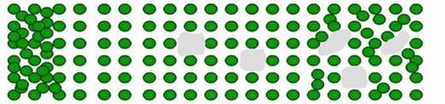
Size and Shape of openings: Most openings in the canopy are the sized of single tree crowns. There are some larger openings that are the size of multiple trees.
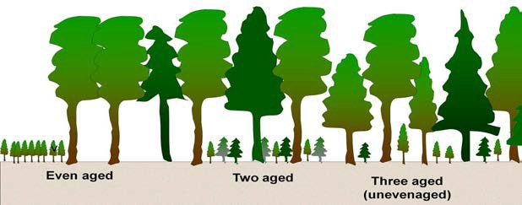
Current Structure:
Uneven-aged

☐One Canopy Layer ☒Two Canopy Layer ☐Multilayer/Uneven aged

Desired Future Stand Conditions: Stand 1
Desired forest type and expected longevity:
Forest Type: White oak–red oak-hickory
Age: Variable (age species based with longer-lived species being left in stand longer than others.
Desired species to naturally regenerate: White Oak, Chestnut Oak, Yellow Poplar
Desired species to plant: White oak (only if natural regeneration is not present.
Bird’s-eye view of desired future stand condition (check one)
☐ ☐ ☐ ☒
Wild stand
Evenly spaced
Evenly spaced with openings
Variable density spaced with openings
Size and Shape of openings:
Shape and size of openings should be determined by the presence and size of advance reproduction of desired species (white oaks, red oaks, and hickory). Where advance reproduction is present opening size could be several crown widths up to two acres. Where advance reproduction development is inadequate, opening size should be limited to no more than two crown widths.
Desired Structure:
Uneven-aged

☐One Canopy Layer ☐Two Canopy Layer ☒Multilayer/Uneven-aged
Other Desired Stand Descriptions: Maximum tree density (5 inches DBH and greater) should be maintained in the 35 to 45 square feet per acre range. Species composition should favor oak species, specifically white oak. Healthy regeneration of white oak on all canopy layers is critical. Target density of trees over five inches in diameter should be around 65 to 75 trees per acre well distributed in a size classes. Seedlings should be larger than 1 inch in root collar diameter to count toward the adequate advance regeneration. Density of desirable advance reproduction should be 50 to 80 stems per acre. A general balance of all supporting species is also desired.
Forest Management Activities
If a subset of the stand is being treated, the general area can either be described or identify the impacted areas on your map.
Treatment description:
Planned treatment is a shelterwood preparation cut with a follow-up midstory treatment if needed (NRCS-CPS-666). Both treatments will be discussed in the following paragraphs.
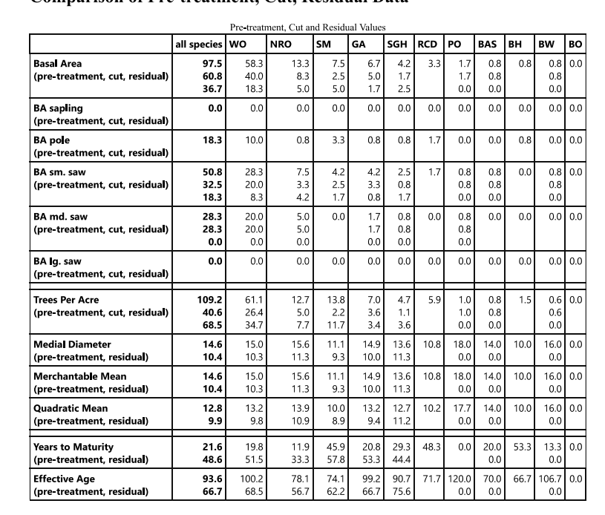
Shelterwood: Harvest should retain 40 to 50 BA of the pre-treatment tree density. The objective is to trees in larger size classes approaching maturity and remove non-vigorous and shorter-lived species occupying space in all canopy layers. The resulting forest will have a more open canopy of trees that will allow the remaining trees to maintain or increase growth and potentially increase seed production in the larger seeded species. The middle and lower canopy will receive additional sunlight to allow for increased growth and establishment of new seedlings. The treatment should be accomplished by removal of all trees in the medium sawtimber class and half the trees
Figure 15: Distribution of treatment by species and size
in the small sawtimber class. Figure 15 presents a summary comparing the current, harvested, and residual make-up of the stand.
Forest Health Management: Forest health threats to this stand are decline due to aging and presence of low-vigor trees in all size classes. These conditions increase the susceptibility of the stand to drought and native insect outbreaks. Harvesting should focus on these maturing and low-vigor trees. Additionally, the removal of mesic species, along with invasive species, will be critical to the future health of this stand. These factors for removal should ensure that the stand is more resilient and be able to resist or recover from potential future stress events.
Harvesting: There are few limits to harvesting within the stand. Ground-based skidding should be possible over almost all of the stand. The rock outcrops and sinkhole forming soils will require special treatment.
The rock outcrop areas will be a no equipment zone. Due to their location and extent, this will mean that the areas located in Pace Hollow will be a no-harvest zone.
The areas will sink hole potential will need to be reviewed periodically during harvest to identify sinkhole locations and define buffer zones on the ground.
Slash management: Generally, slash should be left in the stand for wildlife habitat. However, due to the proximity of this stand to the county road, slash treatment may be needed for maintaining visual quality. The most efficient way to manage large slash piles will be to leave as much non-merchantable material in the place as possible during harvest to minimize concentration near the road, skid material away from road as material is processed, and if needed trim buildups of material to less than 3 feet in height where visible from the road.
Post harvest activities:
Under-midstory Control: Treatment of mesic species in the under-and mid-story will be needed immediately to improve the conditions for oak advance reproduction. Treatment should remove all mesic species in an intermediate crown class or lower. Removal will be done by chemical treatment of the targeted trees. This should be accomplished using the stem injection (hack and squirt) (trees with thick bark or over 6 inches) and basal bark techniques (all other trees). Herbicide to be used will be a 50% mixture of triclopyr with an appropriate surfactant. This treatment may be needed again following harvest.
Site preparation: Following harvest later in the decade, trees of that are of desirable species but have poor form, been damaged by harvest, or are fading in vigor in the mid-story to lower canopy should be cut and allowed to resprout where appropriate. The treatment should be completed as soon after harvest as possible and will be accomplished using chainsaws.
Other activities:
Nonnative invasive plant control: There populations of nonnative invasive plants scattered across the stand, especially near the edges with more open land cover. These populations will need to be treated prior to any other treatment that provides more sunlight to the forest floor. Treatment will involve cutting, herbicide application and other treatments as needed and appropriate to the specie present and its state of development.
Optional tree planting of desired species: The midstory treatment may require supplemental planting of desirable trees as needed if existing seedling sources (seed, seedling, sprouts, and stump sprouts) do not provide adequate numbers of natural seedlings in a desirable amount of time.
Permits: None needed.
Best Management Practices: State required BMP’s will be followed. See the soil and water section for more information.
Estimate of conditions 30-years from current time if no treatment occurs: The following discussion will provide information related to projected changes to the forest over the next 30 years comparing expected changes with harvest and without harvest. Changes in the following factors will be discussed:
- Relative density (percent)
- Mortality (basal area per year)
- Net Growth (basal area per year)
- Volume (thousand board feet, MBF)
- Medial merchantable tree diameter (inches)

Relative density: Relative density is a metric used to assess how crowded the trees are in a forest. It is expressed as a percentage of the available space for tree growth that is currently occupied by living trees. In general, forests with a relative density below 100% have room for trees to grow and be vigorous. Forests with values over 100% are crowded and may experience mortality due to limited site resources (water, minerals, access to sunlight) and a usually more susceptible to damage from insects, disease, ands storm events.
The following graph depicts the relative density expected until 2054 for the property with and without harvest. The current density of the area is 81%. The treatment will reduce the density to 34% and as the graph displays the density will grow to 46% by 2054 at a fairly steady rate. In contrast, with no harvest the relative density of the forest will slightly decrease density to 80% by 2054. The difference in rates indicates that the stand will not really be increasing in vigor or storing increased carbon over the projected period absent a change in stand density.
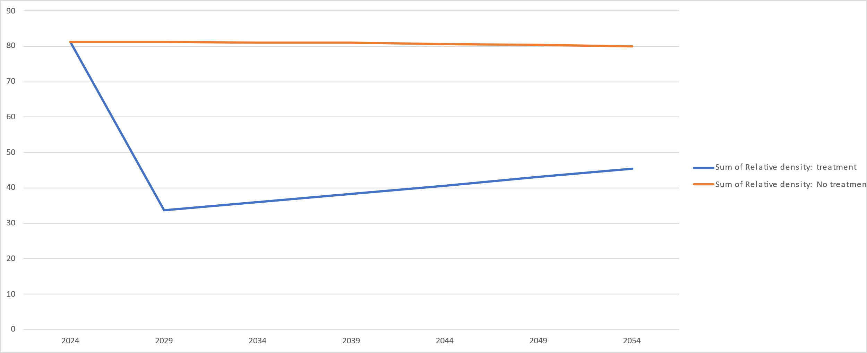
Figure 16: Relative density (percent) changes from 2024 to 2054 with harvest and without treatment
Mortality: Mortality is a measure of the density of trees expected to die due to lack of resources, insects, or disease. As can be seen in the following chart, following harvest mortality is expected to be essentially non-existent follow the removal of trees during harvest until the end of the projected period. The harvest can be thought of as a treatment that removes the at-risk trees before death from other causes. With no harvest mortality will occur in the forest. The rise in mortality after 2029 is due to mortality in older larger trees of all quality experiencing mortality due to maturity.
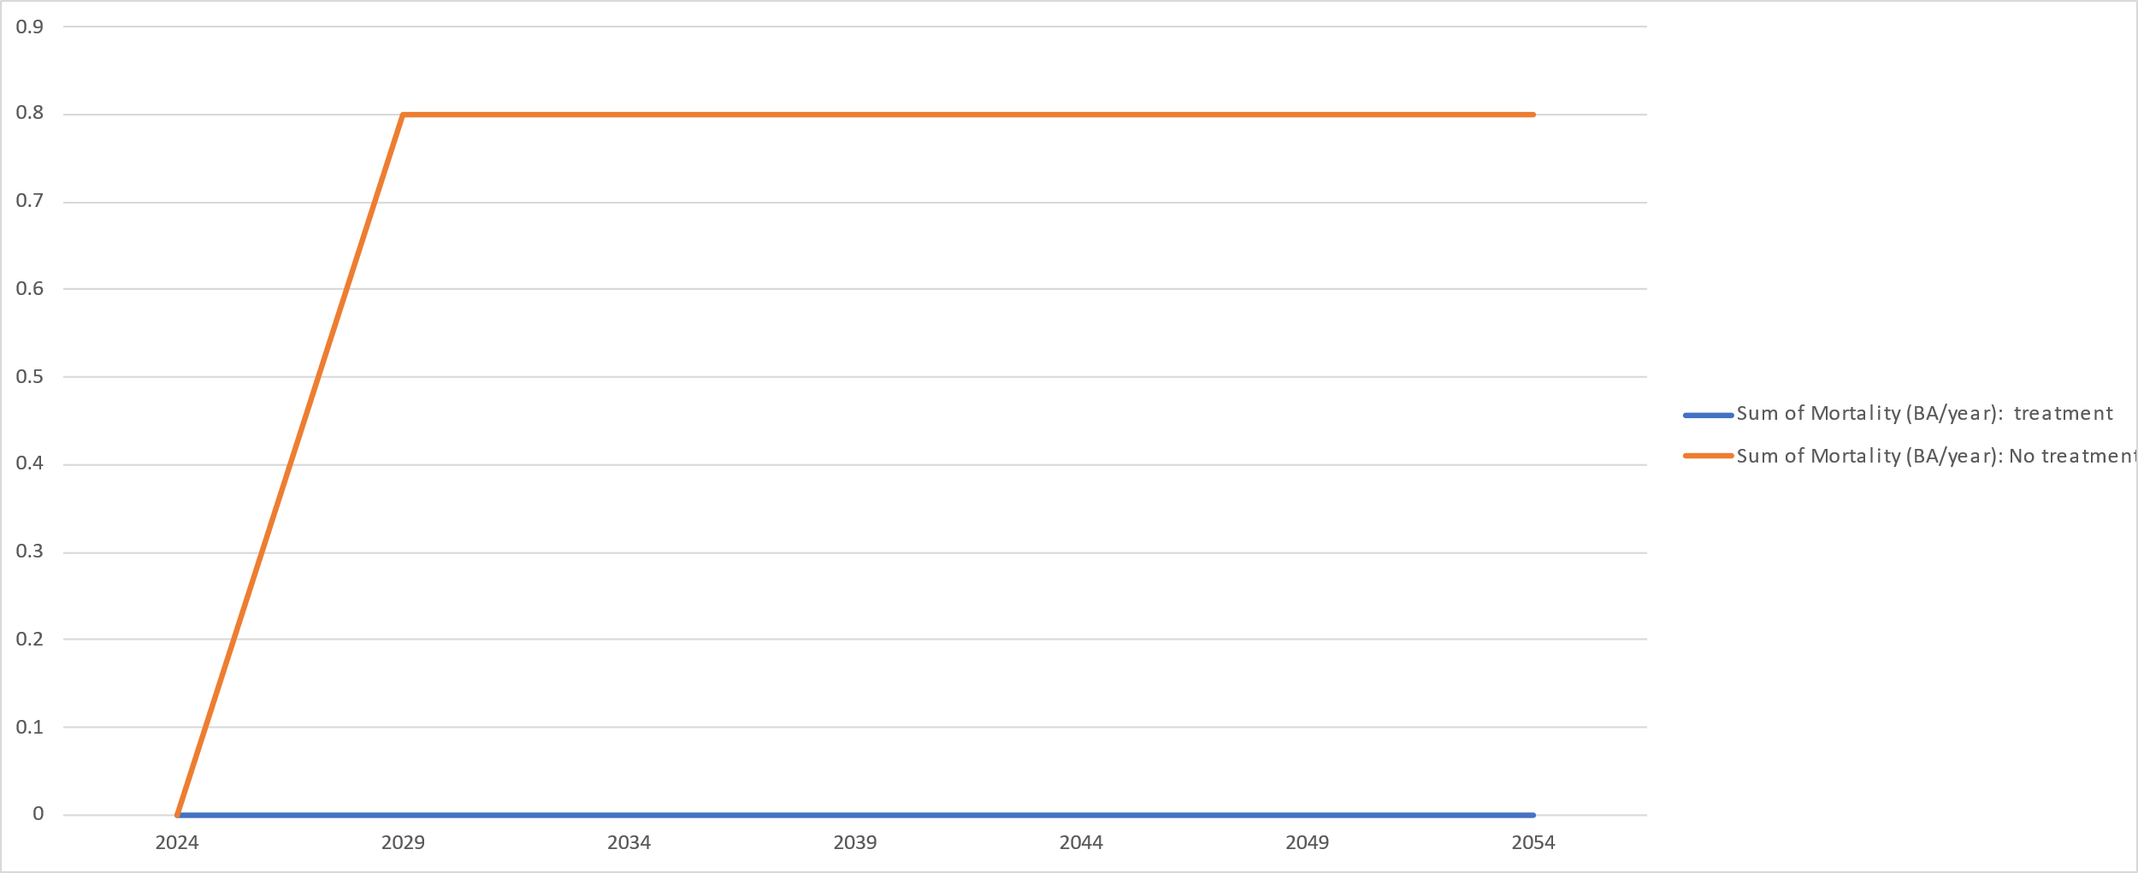
Figure 17: Expected mortality (basal area/acre) from 2024 to 2054 with and without treatment
Net growth: Net growth is a measure of the growth in the forest that considers increases due to ingrowth of new trees and decreases from removals from harvest and mortality. Currently the forest is growing at a rate of 0 feet of basal area per acre. With harvest this rate will decrease due to the removal of trees but will immediately increase to 0.6 feet and will rise slightly to 0.7 feet until the end of the projection. Without harvest net growth is projected to be 0.1 feet of basal area per acre until 2034 when it reduces to 0.0 feet until the end of the projected time.
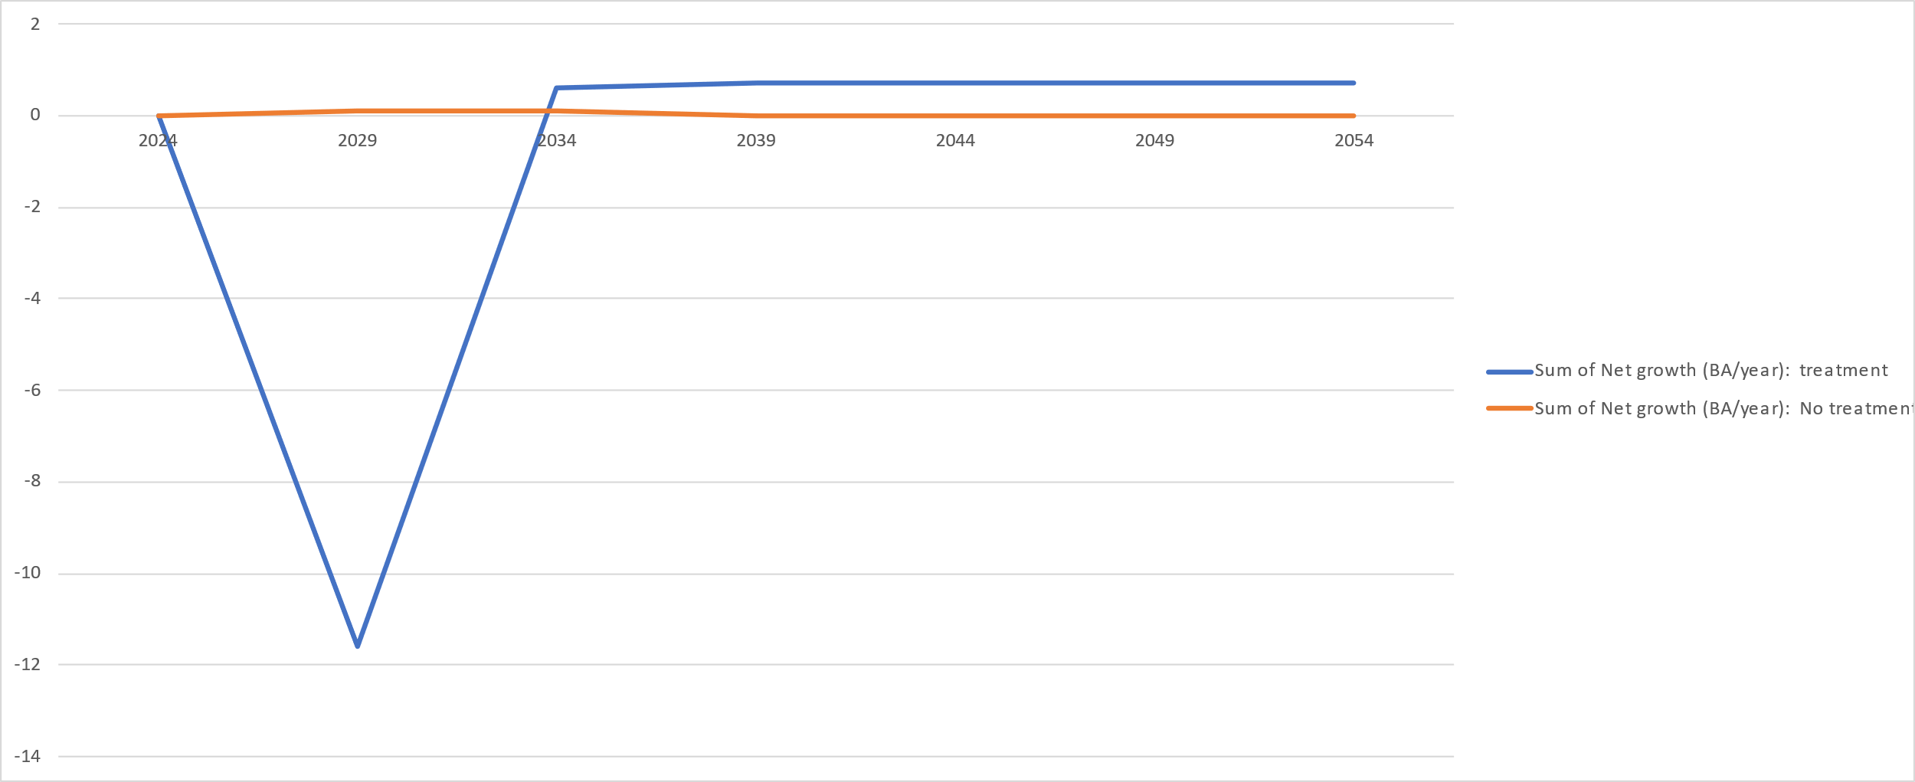
Figure 18: Net growth (basal area per acre) projected from 2026 to 2054 with and without treatment
Volume: The volume of merchantable trees per acre is currently modelled at 7 thousand board feet per acre (MBF) and will be reduced after the implementation of the treatment due to the removal and use of the trees to 0.1 MBF per acre. Following treatment, the volume per acre will increase at a fairly steady rate and will reach 1.6 MBF per acre by the end of the projected period.
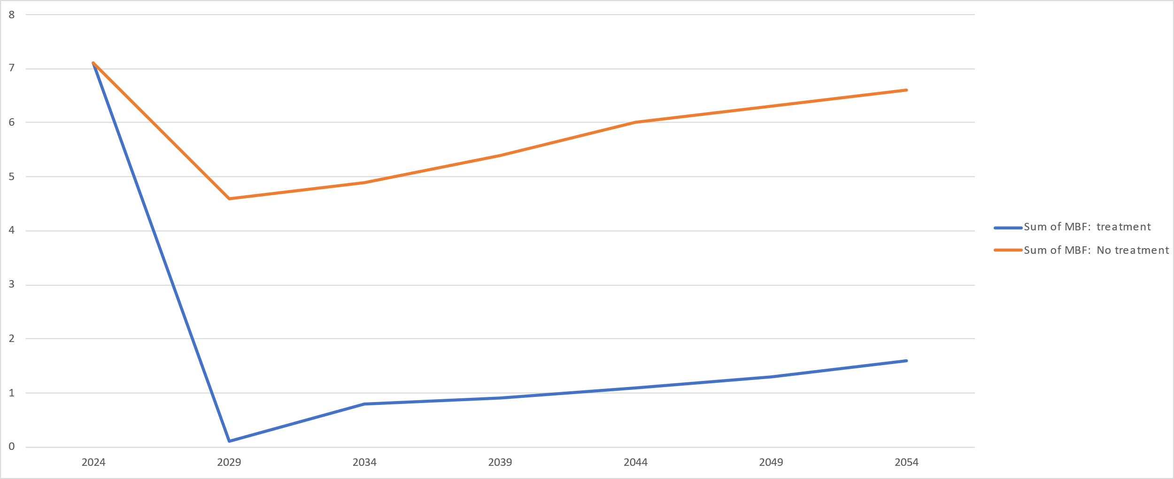
Figure 19: Volume per acre (thousand board feet) projected from 2024 to 2054 with and without treatment
Without treatment volume is projected to reduce to 4.6 MBF per acre in 2025 due to mortality and will increase throughout the projection period reaching 6.6 MBF per acre by the end of the projection.
Merchantable medial tree diameter: Merchantable medial tree diameter is a can be thought of as a measure of the diameter at chest level of the typical tree in the forest that contains harvestable material. These are trees that are at least 12 inches in diameter at chest level. Currently the typical tree diameter is about 14 inches.
With treatment the diameter is project to decrease to 11 inches following due to the removal of larger less vigorous trees. It is projected to continue to grow at a fairly consistent rate until the end of the projection period where it will be 13 inches. Without harvest the typical diameter is also projected to increase throughout the projected period eventually reaching 18 inches.
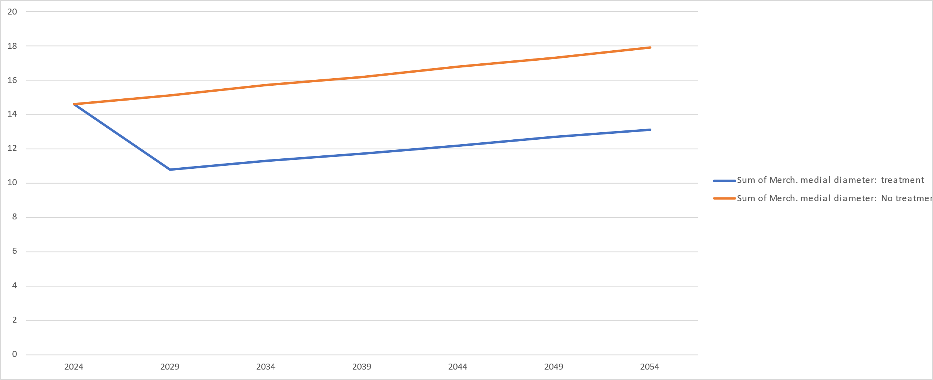
Figure 20: Merchantable medial tree diameter (inches) projected from 2024 to 2054 with and without treatment

Monitoring
The following table presents the site/treatment specific items to focus on for this project. It includes items during the initial treatment (operations) and during the years to follow (maintenance).
Item | Stands | Responsible person | Timing
Operations
Non-commercial treatments: Appropriate trees are treated | All | Owner/forester | At least weekly. More often if work progresses rapidly
Commercial timber sales: Contract provisions (including BMPs) are followed | All | Owner/forester | At least weekly. More often if needed. Site will also be monitored remotely by camera during harvest.
Herbicide
Herbicide stored according to label | All | Owner | When delivered
Herbicide appropriate for treatment and mixed to the correct concentration. Herbicide and concentration written on containers taken to field. | All | Owner/contractor | Daily
Only quantity needed for days work is transported to site. | All | Owner/contractor | Daily
Application is accomplished using appropriate application equipment that is cleaned when work complete. | All | Owner/contractor | Daily
Hand tools
Cutting tools sharp and in good repair. If not, they are not used until repaired. | All | Owner/contractor | Daily
Maintenance
Treated trees are assessed for response to treatment | All | Owner/forester | One month after treatment
Monitor development of advance reproduction | All | Owner/forester | Five years following treatment

Management Activity Schedule for Tracking

Stand | Unit  (Acres/ Feet, etc.) | NRCS  Practice Code* | Treatment Activity Short Description  (or reference to description in Plan) | Dates |  | Assistance Program (s) Used? | Net Cash Flow  (optional)
 |  |  |  | Planned | Completed | Assistance Program (s) Used? | Cost | Income
001 | 240 acres |  | Commercial timber harvest | November 2024 |  | No |  | $1,500,000
001 | 251 acres | 666 | TSI: Under-/mid-story control | March 2024 |  | No | $57,000
001 | 251 acres | 666 | TSI: Site preparation | January 2025 |  | No | $23,000
All | 302 | 530 | Weed control | March 2025 |  | No | $6,396

Signatures and Approvals
Landowner

I have reviewed this plan and believe the management recommendations will help me meet my goals and objectives for my property. I agree to follow this plan to ensure the sustainability of my management.
Landowner Date: 01/22/2024
Forest Stewardship Program
I certify that this Forest Management Plan meets the requirements of the federal Forest Stewardship Program.
Plan Author Date
I certify that this Forest Management Plan meets the requirements of the federal Forest Stewardship Program.
State Forestry Representative Date
Forest Stewardship Tracking Number: (if necessary)
NRCS Assistance Programs
I certify that this Forest Management Plan meets the requirements of the USDA Environmental Quality Incentives Program (EQIP) and/or the criteria for forest activity plans in Section III of the USDA NRCS Field Office Technical Guide.
Technical Service Provider Number Date
District Conservationist Date
American Tree Farm Program
I certify that this Forest Management Plan meets the requirements of meets the requirements of the American Forest Foundation’s American Tree Farm System.
ATFS Inspecting Forester Number Date
Certified Tree Farm Number (e.g. AL 1234) Date of ATFS certification

BA: Basal Area per acre (a measurement of tree density calculated by measuring the area of a stem 4.5 feet above the ground), TPA: Trees per acre ( measurement of density calculated by measuring the number of stems on an acre), DBH: Tree diameter 4.5 feet from ground level, MBF: thousand board feet (a measure of volume of lumber in a tree), CORDS: A measure of the amount of all the volume of wood in a tree, including lumber and other products)
Acceptable Growing Stock (AGS). These trees are suitable for retention in the stand for at least the next 15-year period. They are trees of commercial species and of such form and quality as to be salable for sawtimber products at some future date. Saplings are especially difficult to judge. Most knots, bumps, and stoppers will be confined to a small core if the sapling actually grows to a larger size, so consider most saplings acceptable. If in doubt about the correct quality class for any tree, consider it acceptable. Many acceptable trees will be removed if a partial cutting is prescribed for the stand, so do not consider the quality determination as a cut-leave tally. Unacceptable Growing Stock (UGS). These trees do not have the potential to make salable sawtimber products in the future. They may be high risk trees —trees with disease, damage, or dieback that threatens their survival—or trees of such poor form that they just have to be removed regardless of the effect that removal will have on stand structure and species composition. Dead. These are standing dead trees.
Log rule: a table or formula used to estimate volumes of logs. The Doyle log rule as developed in 1825 by Edward Doyle and is commonly used in the eastern United States in forestry transactions.
Sapling = 1.0” to 5.5”; Pole = 5.5”to 11.5”: Small Sawtimber = 11.5” to 17.5”; Medium Sawtimber = 17.5” to 23.5”; Large Sawtimber = 23.5” or more

