December 14, 2015

Landcaster Craftsman Builder
3120 Old National Pike
Middletown, MD 21769

Re: Subdivision Potential of Tax Map 42 Parcel 109
ZONED: Agricultural as of December 14, 2015

- Origin of the Subject Parcel
This parcel existed as a 83.179+/- acre parcel as of 1966 according to a deed recorded at L743 F708. The prior deed recorded at L662 F266 in 1961 describes a 135 acre parcel.

- Previous Subdivision Activity
A 13 lot Preliminary Subdivision plan titled “Denbrooke Estates” was approved by the County
Planning Department in 1974. A letter from the health department dated May 13, 1974 noted
that only 4 of the 13 lots passed percolation testing. No lots from this subdivision plan were
recorded.

- Major/Minor Subdivision Determination A minor subdivision is defined as 5 or fewer lots off the original parcel since 1965. A major subdivision is defined as 6 or more lots off the original parcel since 1965. Major subdivisions require approval by the Planning Commission and must meet additional Subdivision provisions (such as direct access to a County road that is at least 20 feet wide and paved) and the Adequate Public Facilities Ordinance (APFO).

Firther research must be provided to the County to verify the minor/major status of any future subdivision of this parcel. Sometime between 1961 and 1965 the original 135 acre parcel was divided, creating the subject 83.179 acre parcel. Based on the material submitted with this application it is unknown where the other 51.82 acres is located and the development history of that acreage. If this division occurred after 1965 then these divided parcels will count towards the major/minor subdivision count.

This property is located within a Tire IV area in accordance with Senate Bill 236. Please be advised that in accordance with Senate Bill 236 (“the septic bill”), Frederick County is not permitted to process major subdivisions within the Tier IV area. Therefore only a minor subdivision is permitted at this time.

- Soils Information:

Flooding Soils and Wet Soils located on the property (see map at end of report). Flooding soils require a minimum 25’ protective buffer and cannot be developed. Houses with basements situated in or within 100 feet of wet soils may be restricted or require gravity drainage systems.
The soils on the western half of this parcel are unrestricted. Soils on the eastern half are lower 1/3rd restricted, which means percolation testing may or may not require testing during the wet soils season depending on the topographic location of the proposed septic area.

Contact the Health Department for more information about percolation testing.

- Environmental Features:
Dorcus Branch runs west/east along the southern portion of the property. A unnamed stream also runs along Dorcus Road in the eastern side of the property. Streams require a 100-150 foot wide protective waterbody buffer (width varies depending on the steepness of adjoining slopes). Stream buffers cannot be impacted or developed. Wetlands are likely present along both streams and around the farm pond. Wetlands require a minimum 25’ wide protective buffer.

- Conflicting Easements: No Agricultural Preservation or Forest Resource Ordinance easements were noted on this property.

- Summary/Conclusion

In the Agricultural zone, parcels that existed prior to August 18, 1976 are eligible to subdivide up to three (3) lots, plus a remainder. Additional lots may be approved on parcels that exceed 25 acres in size if the proposal meets the Ag Cluster provisions. This parcel is eligible to apply for 3 lots plus a remainder (conventional) OR up to 5 lots plus a remainder utilizing the Ag Cluster development option. Again, please be advised that no more than 5 lots (counting proposed lots and every lot taken off the original 1965 parcel) are permitted at this time due to the Septic Bill restrictions.

PLEASE NOTE: To qualify for an Ag Cluster subdivision, all lots must be clustered together, the average lot size must not exceed 1.50 acres, and no lot may exceed 2 acres in size. Please see section 1-19-7.300(C) of the Zoning Ordinance for more information regarding Agricultural Cluster requirements.

Please note that all proposed lots must have fee-simple road frontage, approved perks and wells, and must comply with the Frederick County Forest Resource Ordinance, Subdivision Regulations, Zoning Ordinance, and all other ordinances, regulations, and policies. Having subdivision potential does not guarantee that a subdivision of this property will be approved.

An appeal of this decision must be filed within 30 days of the date of this letter. All appeals must include a letter indicating the nature of the disagreement and additional information that supports the appeal. Should you have any questions, please do not hesitate to contact me.

Sincerely,

Michael Wilkins

Principal Planner
File: DEV15-32 (16094)

NOTICE/DISCLAIMER

The information contained in this letter does not constitute legal advice. It is based solely on the documents and information you have provided. The information provided iN this letter is subject to being modified by other FACTS, documents or information that was not provided. Additionally, any subdivision or development of the property is subject to many regulations and requirements including but not limited to - Frederick County Subdivision Regulations, Frederick County Zoning Ordinance, Health Department Regulations, and site plan approval process before the Frederick County Planning Commission. There may also be other laws and regulations (federal, state and local), which apply to any development or subdivision of the property.

Soils (blue=flooding, orange=wet)
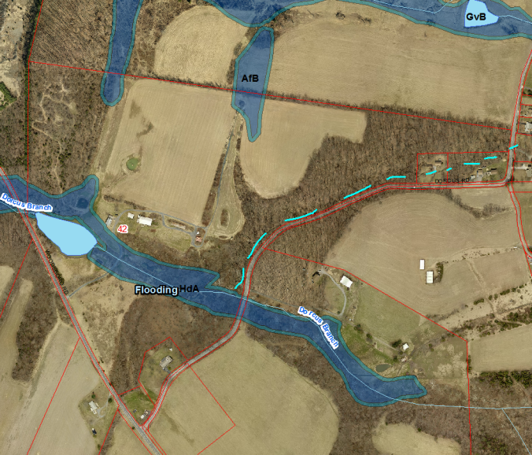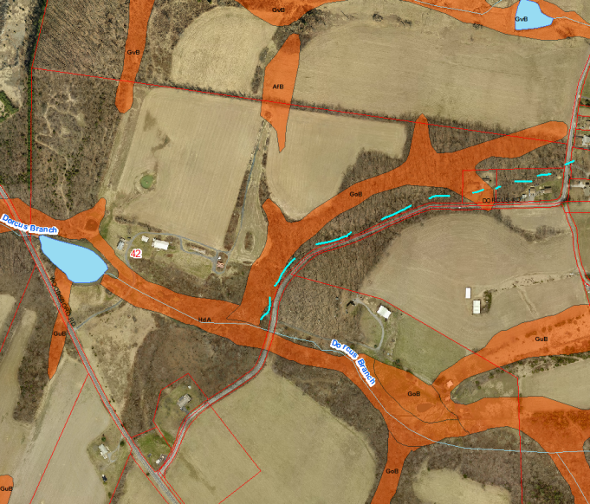

Soils (tan=unrestricted, stripes= lower 1/3rd restricted)
