POPPE REALTY & MGMT LLC
1810 HARLAN ST
FALLS CITY, NE. 68355
402-245-5808 work, 402-245-0866 mobile
bpoppe@popperealty.com
www.popperealty.com

LAND AUCTION
SELLER: FLESKOSKI TRUST
Selling 226.59 Acres +\- in 3 Tracts
Tract 1 80 Acres +\-
Tract 2 146.59 Acres +\-
Tract 3 Combination of Tracts 1 & 2
TO BE SOLD AT PUBLIC AUCTION; NOVEMBER 14, 2025
10:30 AM FALLS CITY ELKS CLUB 1417 STONE ST FALLS CITY, NE

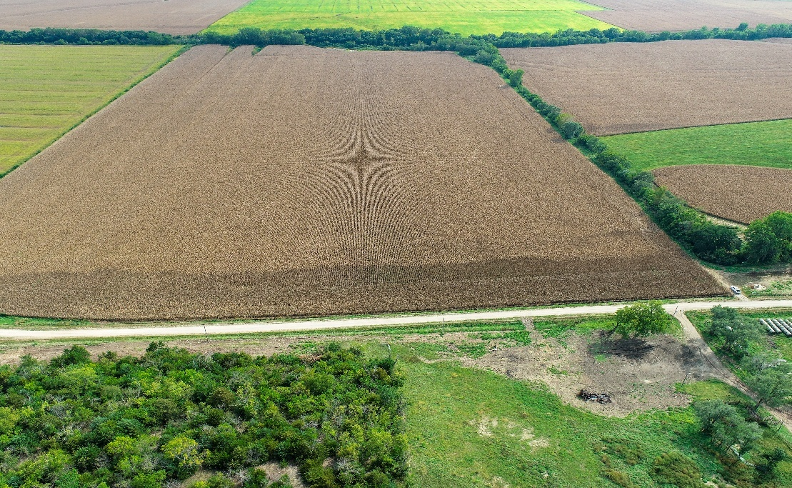

- TRACT 1: 80 Acres more or less
  - E\2 NW\4 Section 9 Township 1 North, Range 15 East
  - 71.31 Certified crop acres
  - Soil Types: Zook, Kennebec, Wabash, and Wymore
  - 2024 Real Estate Taxes: $3,736.64 (estimated using certified acres)
  - FSA Information: Corn Base Acres: 37.89 PLC Yld 140
Soybean Base Acres: 21.44 PLC Yld 49

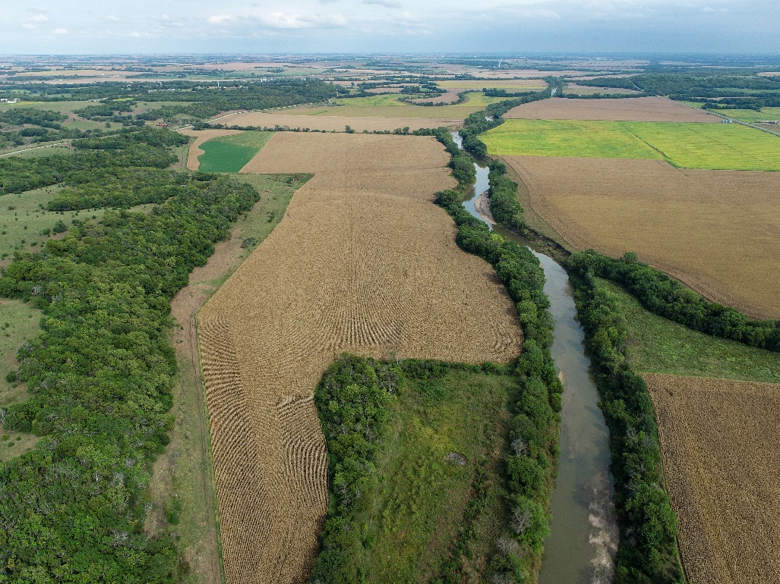

  - TRACT 2: 146.59 Acres more or less
  - W\2 NW\4 Section 9 and Pt of the S\2 Section 8 all in Township 1 North, Range 15 East
  - 127.02 Certified crop Acres;
  - Soil Types: Kennebec, Zook, Wabash, Judson and Wymore
  - 2024 Real Estate Taxes: $6,655.96 (estimated using certified acres)
  - FSA Information: Corn Base Acres: 67.49 PLC Yld 140
Soybean Base Acres: 38.20 PLC Yld 49

- Driving directions
From Salem Nebraska: You will go West on main street then turn left on Chapman Street. This street eventually turns into 707 Road. Go West 1 mile on 707 road to the NE corner of Tract 1. Tract 1 will go 1\4 mile to the field drive. Tract 2 will start approximately 30 feet West of the field drive and goes West to the start of the pasture fence.

- Terms of the Auction:
  - Auction Format: The property will be offered for Sale in 2 Tracts and in combination of Tracts 1 & 2. The seller will pay for the survey to determine the exact acres and legal description if the property is sold in two tracts.
  - Real Estate Taxes: The 2024 real estate taxes for the entire 226.59 Acres are $10,392.60. The estimated taxes for Tract 1 are $3,736.64 and Tract 2 are $6,655.96
  - A 15% non-refundable earnest deposit is required the day of the sale. The balance due will be at closing on December 16, 2025. A cashier’s check, money order, or wired funds will be required at closing. All mineral right owned by the seller will be conveyed to the buyer. The sale is subject to all easements, covenants, and restrictions of record.
  - The property will be Sold subject to seller approval.
  - Possession: The buyer will receive full possession for the 2026 crop year. Possession is subject to the rights of the current lessee until February 28, 2026. The 2025 real estate taxes will be paid by the seller. The 2026 and subsequent years will be paid by the buyer. The seller will provide an owner’s title insurance policy on the property. The cost of the title insurance will be split equally between the seller and the buyer. The buyer is responsible for all loan policies.
  - The information provided was obtained from reliable sources but the accuracy of the information is not guaranteed. All interested parties are encouraged to inspect the condition of the property and rely on their own information. Announcements the day of sale take precedence over printed information. Poppe Realty & Mgmt is the agent for the seller.

