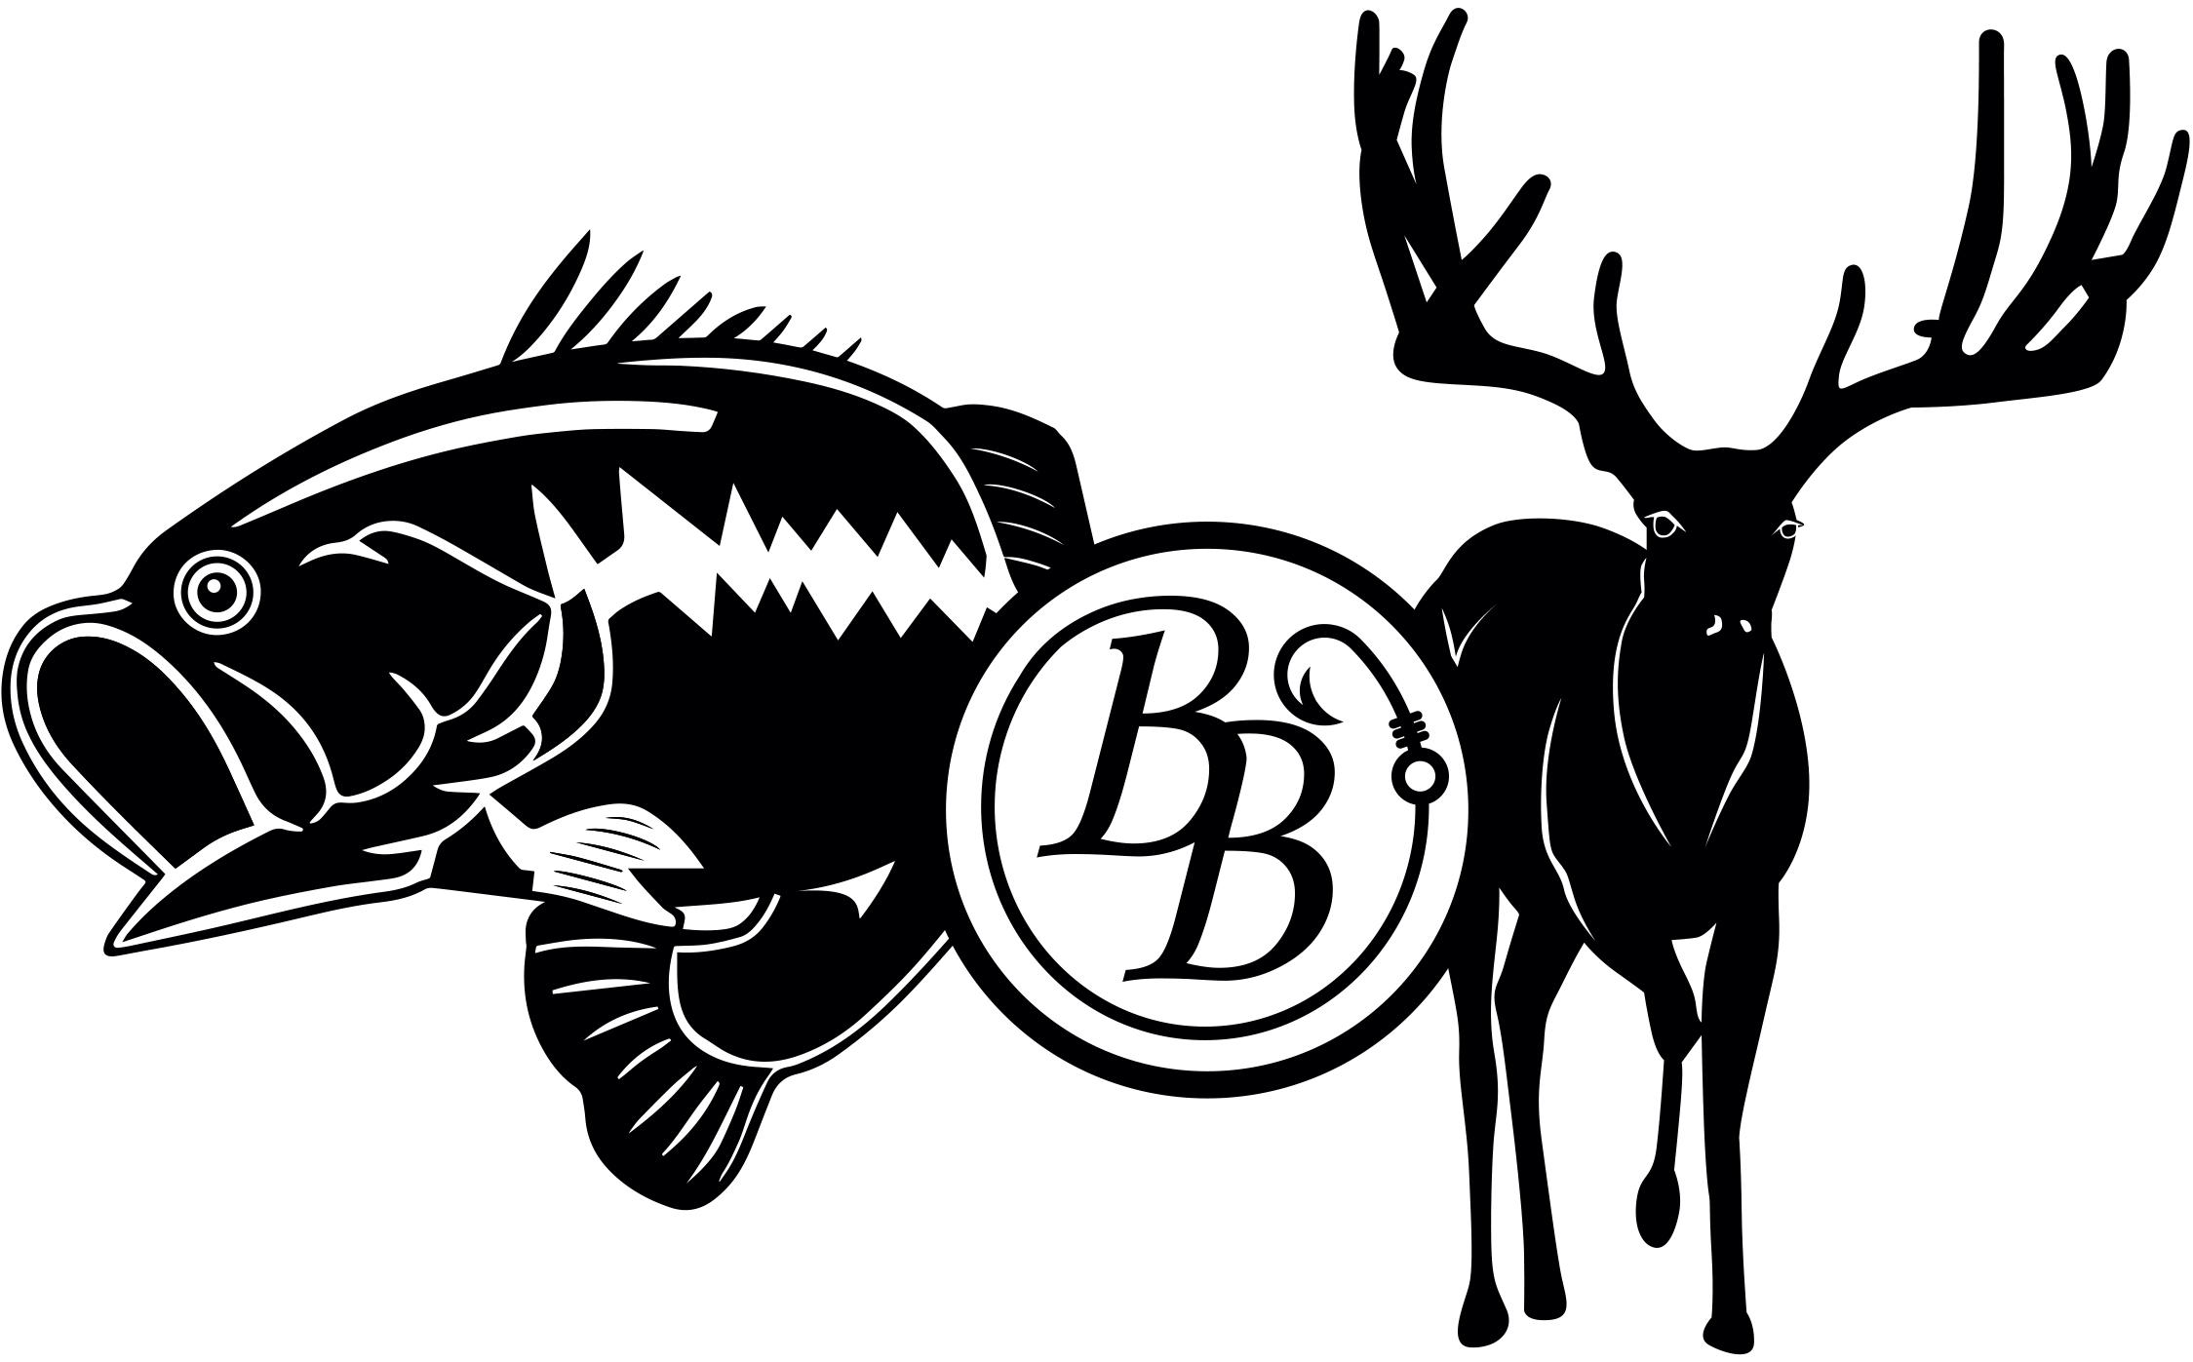

Thompson Trophy Ranch Information
447 Acre Main Lodge Side:
- Wells = 1 Located on Top Pond that supplies top pond & bottom flats water trough
- Blinds = 8 Total
- 4 HB Blinds
- 4 All Season Feeder Blinds (3 are the new Rifle & Bow Chingon 7x7, 2 are 8ft and 1 is 5ft)
- Feeders = 12 Total
- 5 Protein (4 are All Season Gravity Feeders 3=3000# capacity & 1=2000# capacity/)
- (1 is Texas Hunter plastic gravity feeder 1200# capacity)
- 7 Corn Timed Feeders (6 are Boss Buck 4 =350# capacity 2 =1200# capacity)
- (1 is Old metal timed feeder = 300# capacity)
- Ponds = 2
- Water Troughs = 4
- Main Lodge House has Pressure Pump & Booster Pump supply house
354 Acre Exotic Side:
- Wells = 2 Total
- Cabin Well supplies the cabins, washroom, & the back-cabin feeder water trough
- 254 House well supplies 254 house, skinning shed, 254 house black plastic water trough, hayfield black plastic water trough, back pond, & the pond by the facility.
- Blinds = 5 Total
- 4 All Season Blinds ( 2 are the new Rifle & Bow Chingon 7x7, 1 is 8ft & 1 is 5ft)
- 1 HB Blind
- Feeders = 13 Total
- 8 Protein ( 2 are Outback Timed Feeder 3000# capacity/ 4 are Texas Hunter Plastic Gravity Feeder 1200# capacity/ 1 is All Season Gravity Feeder 3000# capacity/ 1 is All Season Gravity Feeder 1000# capacity)
- 5 Timed Corn Feeders ( 2 are Old metal Feeder 350# capacity/ 2 are All Season Timed Feeder 600# capacity/ 1 is old Barrel Timed Feeder 200# capacity)
- Ponds = 2
- Water Troughs = 3 (2 are Black Rubbermaid Plastic Water Troughs 1500 gallon)

60 Acre Deer Facility Side:
- Wells = 3 Total & 1 Windmill
- Pen 12 Well Pump House supplies North & South side water troughs, the cement stock tank, Kaleb’s pond, Deer pens stand on 447 water trough, the new bow blind rock ledge stands water trough, the water trough off the road on 447, main lodge house,
- Facility Well Pump House supplies all the facility, the feed barn, & the north side water troughs)
- New Fake Rock covered Well Pump House supplies the North side water troughs & the facility
- The Windmill in South Side pen supplies the water troughs & the facility extra storage water tank
- Feeders = 26 Total Protein Feeders & 20 Metal Hay troughs
- 15 on Southside Pens & 11 on Northside Pens (Texas Trophy Gravity Feeders 1500# capacity)
- 9 on Southside pens & 3 on Northside Pens (Metal hay troughs)
- Water Troughs = 30 Total
- 19 Southside Pens & 11 Northside Pens
- Shade Structures = 31 Total & new Northside Fawn Pen
- 20 Southside pens & 11 Northside pens
- New Northside Fawn Pen covered shade shelter

