Fenner Branch Stream – highlighted in red
This stream borders approximately 640 feet of the property boundary along M Phillips Rd.

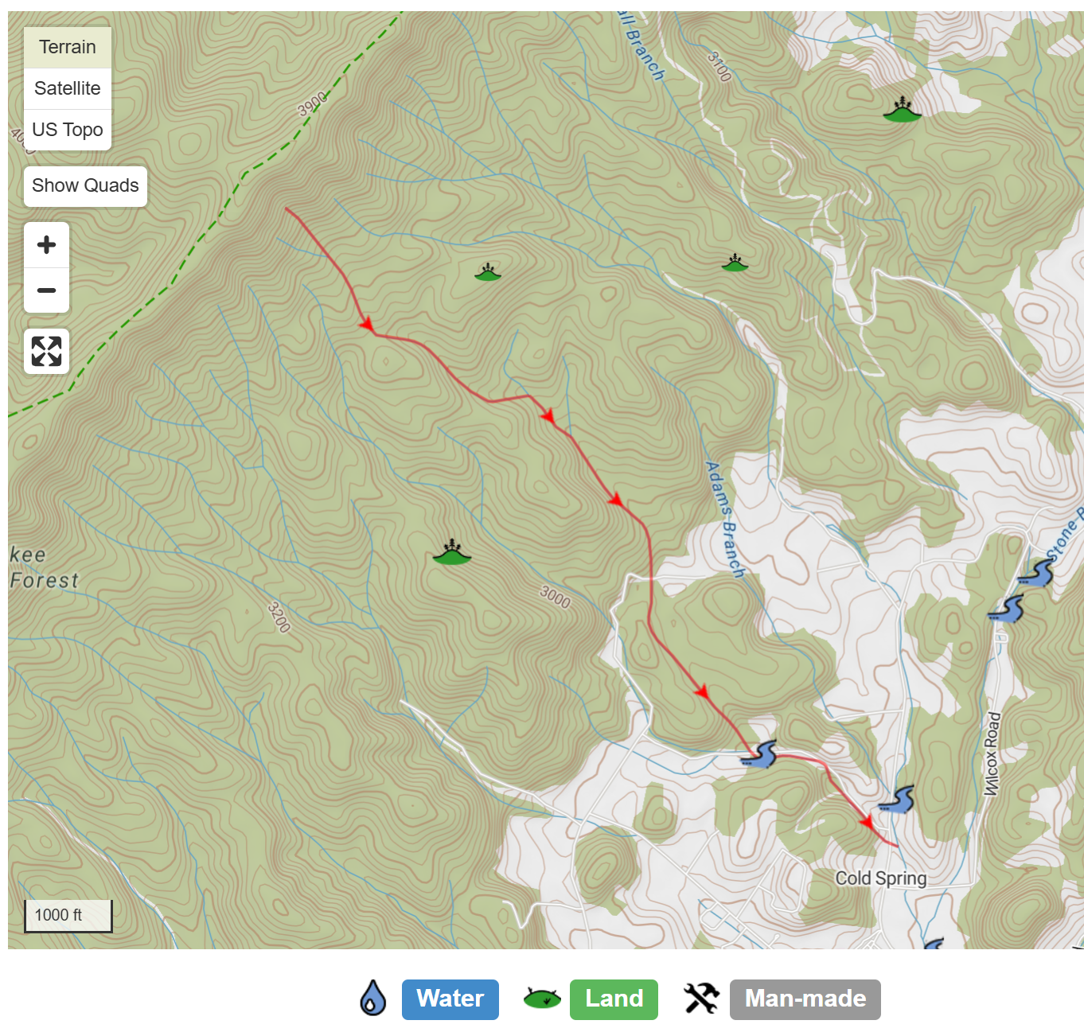
67.01

